New Hampshire
Council on Developmental Disabilities

July 5, 2016

Re: Support for the FDA’s proposed ban of electrical stimulation devices (new & old) used to treat aggressive or self-injurious behavior
Rebecca Nipper
Food & Drug Administration
Center for Devices & Radiological Health
Bldg. 66, Rm. 1540
10903 New Hampshire Ave.
Silver Spring, MD 20993-0002
Dear Rebecca,

On behalf of the NH Council on Developmental Disabilities (NHCDD), and as a certified educator and the mother of a teenager who experiences Autism, I am writing in support of the Food & Drug Administration’s (FDA) proposal to ban electrical stimulation devices used to treat aggressive or self-injurious behavior. The FDA has determined that these devices present an unreasonable and substantial risk of illness or injury that cannot be corrected or eliminated by labeling. We support this ban to include both new devices and devices already in distribution and use.

My name is Jennifer Bertrand and I live in Mont Vernon, New Hampshire where my husband and I are raising our family. My spunky daughter Chloe has a significant developmental disability and experiences complex communication challenges. Chloe, now a junior in high school, uses some sign approximations, a touchscreen speaking device, and vocalizations to express her needs and emotions and connect to others; still communication is incredibly hard for her. Difficulties with language and communication have been her greatest barrier to accessing her education. We rally around her every day, and with a positive belief that anything is possible and her fierce determination, our love, support, and advocacy, Chloe has made some monumental achievements.

The NHCDD consists mostly of volunteer members appointed by the Governor to represent and advocate for people with developmental disabilities. The Council supports programs and policies to further our mission of dignity, full rights of citizenship, equal opportunities and full participation in all areas of life for all NH citizens with developmental disabilities. Education is an important foundation for that. School must be a safe place where our children are free from trauma, and the use of aversive interventions, particularly the use of electric shock devices is arcane and morally repugnant.

When communication breaks down and Chloe becomes frustrated, she uses behavior to desperately attempt to express her fears, needs, wants, and feelings. In the past Chloe used some aggressive behaviors that resulted in broken lamps/furniture/items and physical injuries to herself and others. Since then we have taken a positive human dignity approach to supporting Chloe and helped her to increase her ability to communicate through the use of Alternative Augmentative Communication (AAC). Chloe now has more communication strategies in which to express herself.

We have a moral and ethical responsibility to ensure the dignity and safety of our children, particularly our most vulnerable students who experience behavioral challenges. No matter the nature of the disability every student benefits from support, not control, in order to thrive. More than two decades of peer-reviewed studies have provided strong evidence of positive alternatives for addressing even the most serious behavior challenges, such as self-injury, aggression and property damage, particularly in the school environment. The entire school benefits as well, through higher academic scores, lower staff turnover and higher staff morale. The US Department of Education’s Resource Document for schools makes clear that “any behavioral intervention must be consistent with the child’s rights to be treated with dignity and to be free from abuse.” The Substance Abuse and Mental Health Services Administration’s National Center on Trauma-Informed Care recommends behavioral intervention strategies be guided with the understanding that people with behavioral challenges most likely have a history of trauma. Violent responses to behaviors are not helpful and instead may make behaviors worse.

Please support the FDA’s proposal to ban electrical stimulation devices new and old used to treat aggressive or self-injurious behavior. We have come a long way as a society and have finally recognized that no matter the extent of an individual’s disability they are human and must be treated with dignity.

Sincerely,
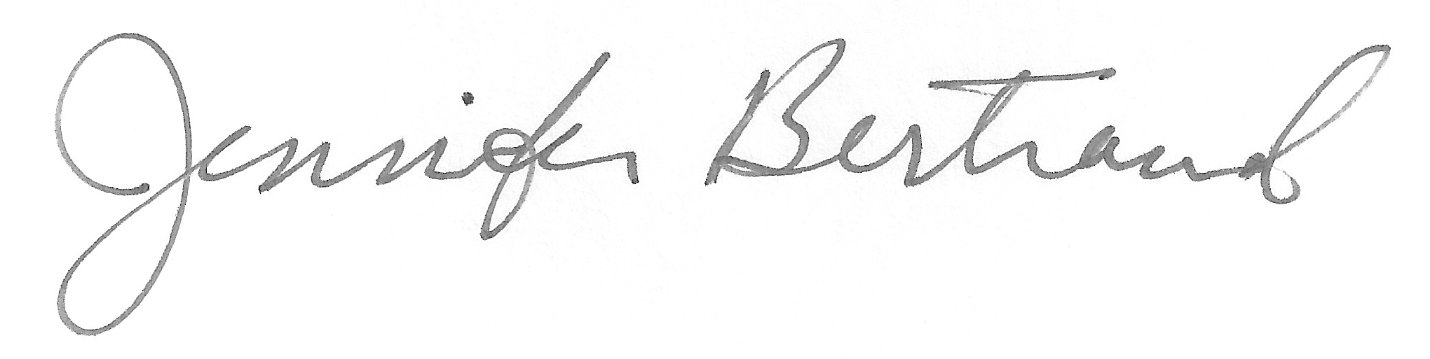
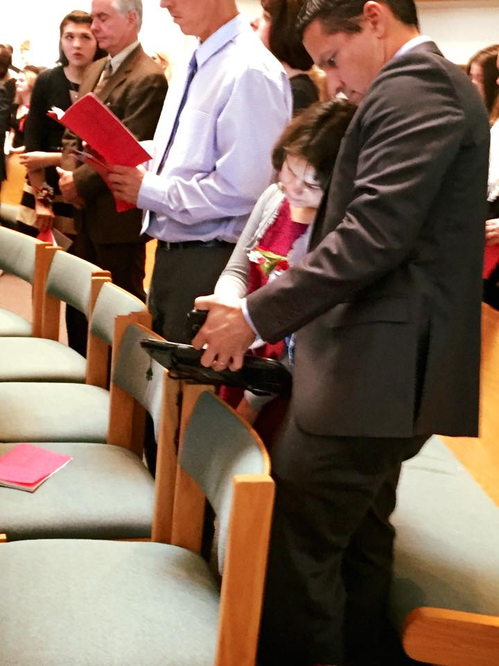
Jennifer Bertrand
NH CDD Policy Chair
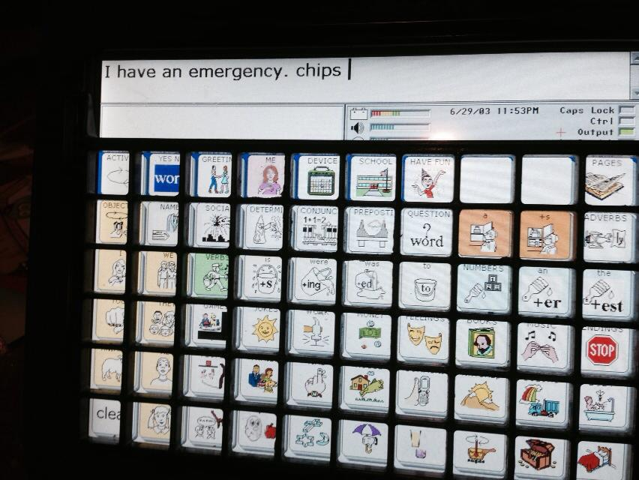
Chloe pictured using her device at Catholic Confirmation. Dad supports the tablet while she finds her words.
Chloe’s device provides her with both the picture and text. Device shown here with a message she created from the core page. This device goes everywhere Chloe goes. It’s her voice.

