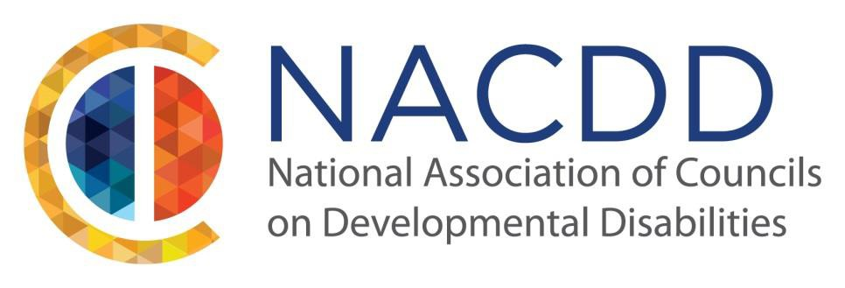

We are pleased to announce our 2018 Annual Conference:

See Me for Me: Connecting with Our Communities

July 11-12, 2018
Gaylord National Harbor
Washington DC

The year’s conference will feature important discussions on how advocates, family members and professionals are interconnected in our communities. Participants will listen to experts, parents, siblings, and self-advocates on topics ranging from education, employment, community building and integration, healthcare and more.

We invite those with knowledge and expertise working in the field of developmental disabilities to submit ideas for presentations related to the theme: See Me for Me: Connecting with Our Communities

Plenary topics at the NACDD 2018 Annual Conference will focus on how people with developmental disabilities are important and active members of our communities. Some speakers may discuss education projects and programs, employment for people with developmental disabilities, community integration and involvement, and self-advocacy.

NACDD encourages your concurrent session submission to fit within the framework of 1 or 2 of these topical areas. Successful submissions should include sessions that highlight best or promising practices; lessons from implementation of federal laws into state policy; and successful strategies, tops and tools for self-advocates.

We are interested in receiving proposals that feature leadership strategies and skill building, self- advocates taking action on issues of importance, and sessions that provide in-depth information and knowledge about specific topics.

If you have a proposal/project/presentation that supports the conference theme, please complete the attached form and send it to Robin Troutman via email, rtroutman@nacdd.org by February 8, 2018.

See Me for Me: Connecting with Our Communities

Proposal Submission Guidelines

Please include the information below. Incomplete submissions will not be considered.

Proposer Contact Information
First Name/Last Name Mailing Address
Phone/Email

Title Affiliation

Title of Proposed Session:

Objectives (3 things attendees will learn): 1.
2.
3.

Description of proposed session (this will be used as the description in the final program)
  - Include why this session is important and
  - How it is relevant to the theme of the conference:
See Me for Me: Connecting with Our Communities

Please indicate if the proposed session features leadership strategies and information, in-depth information on a specific topic, or is geared toward self-advocates taking action.

If the session is about a specific project or research, please provide a description of the project or research and its outcomes (no more than 200 words)

Names and affiliations of presenter(s)
1. Panel submissions should include a unique description for each presenter -including a description of what that person contributes to the panel in terms of knowledge and expertise.

Full bios for each presenter (for inclusion in final program)

Additional Information:

If your presentation is accepted, you will be notified by March 2, 2018 via email. At that point, you will need to confirm the proposal's accuracy and your intent to present. You will also be provided with a speaker packet which will serve as your conference registration and asks for your travel plans, special needs and accommodations, and any technology needs you may have. The speaker packet will also outline the process for having your presentation and handouts included on our conference website, which is the format we distribute session presentations and handouts.

Please note that speakers will not be charged a registration fee to present at the conference for your session only. However, if speakers wish to attend the full conference (sessions and meals), a registration fee will be charged for the days of attendance. All speakers are responsible for their own travel arrangements and lodging in Washington, DC

