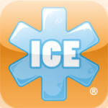ICE: In Case of Emergency
Paramedics and hospital personnel will often look at a patient’s phone for an ICE (In Case of Emergency) number to know who to call for you, so it’s a good idea to have an app clearly labeled ICE on your home page so they can find it. The ICE app can store a list of people to call, insurance information, doctor names and numbers, medications, allergies, medical conditions, and special instructions in case you’re incapacitated.

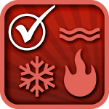Emergency Planner Checklist
Need a little motivation to get prepared? This app is for you then. No one likes to think about emergencies and disasters, but you need to be prepared. This checklist app will help keep you and your loved ones safe by making sure you have everything you need.

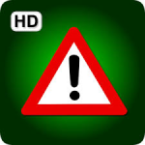Disaster Readiness
Disaster Readiness is an emergency prep guide with more than 175,000 reference guides on how to respond to any disaster situation. Should the power go out, you won’t be able to rely upon the Internet for information. This handy app should have all the info you need, with sections on floods, fires, evacuation, and how to find or create shelter in an emergency.

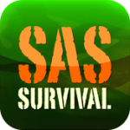SAS Survival Guide
Fully downloaded onto your device, no wi-fi or cell signal is needed. In addition to extremely detailed survival information and checklists, you will find videos, quizzes, a morse code signaling device, and a sun compass. This app will help prepare you for urban disasters, natural disasters, how to survive outdoor situations and much more.

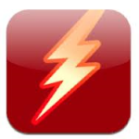StopDisaster
StopDisaster helps walk you through preparedness checklists for hurricanes, earthquakes, blizzards and other natural disasters. It’ll help you build an emergency kit, get your documents in order and store your emergency phone numbers, ready to dial.

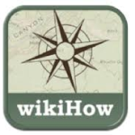wikiHow: How to and DIY Survival Kit
This app covers about every emergency situation you could think of. Explore 140,000+ how-to articles, where you can get help with First Aid, CPR & Choking, Animal Attacks, Vehicle Emergencies, Escapes & Rescues, Natural Disasters, Self Defense, Wilderness Survival, and so much more.

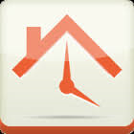Know Your Plan
Use Know Your Plan to be prepared when disaster strikes! Get started by using the preloaded checklists to learn about important mitigation and preparation steps, or create your own lists from scratch. You can set due dates, chart your progress, and include notes with your tasks, and share your checklists with family and friends.

E-Food Storage
E-FoodStorage will make it easy to know what is on your shelves. With an easy “scan-in” and “scan-out” tracking system, this app implements your phone’s camera to scan and recognize the products you buy from their barcodes. E-FoodStorage brings your entire inventory to your fingertips along with multiple tools, tips, and tricks to make keeping food storage easier than you ever thought possible.

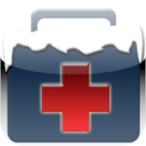Winter Survival Kit
People who live anyplace that gets “real” winters know to keep a winter survival kit in their cars: snow brush/ice scraper, water, food, blankets, and more. This app can help you pack that kit, but it also serves as your virtual survival kit. This app will help you find your current location, call 911, notify your friends and family, calculate how long you can run your engine to keep warm and stay safe from carbon monoxide poisoning.

NATURAL DISASTER PREPAREDNESS:

Each of us are likely to face different disasters depending on where we live, so make sure to download the apps that are relevant for your area.
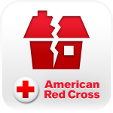Earthquake
Earthquake – American Red Cross app provides step-by-step instructions on what to do before/during/after an earthquake. Get notified when an earthquake occurs, prepare your family and home, find help and let others know you are safe even if the power is out.

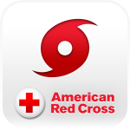Hurricane
Be ready for severe weather with Hurricane by American Red Cross. Monitor conditions in your area or throughout the storm track, prepare your family and home, find help and let others know you are safe even if the power is out – a must have for anyone who lives in an area where a hurricane may strike or has loved ones who do.

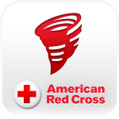Tornado
Tornado by American Red Cross app provides access to local and real-time information on what to do before, during and after a tornado, including an audible siren when NOAA issues a tornado warning even if your app is closed. Get your family and home ready for a tornado. The American Red Cross tornado app is the complete solution you need to understand and prepare for a tornado and all that comes with it.

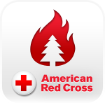Wildfire
Be ready for a wildfire with Wildfire by the American Red Cross. Get notified about active wildfires, as well as fire weather warnings, prepare your family, home and pets, let loved ones know that you are safe even if the power is out – a must have for anyone who lives in an area that is susceptible to wildfires or has loved ones that do.

STAY INFORMED:

One of the best ways to be ready for a disaster is to know what’s going on around you! These emergency apps will keep you up-to-date so you are among the 1st to know of anything that is headed your way.
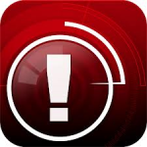iMapWeather Radio
No matter where you are or what you’re doing, even if your phone is in “sleep” mode, iMapWeather Radio will wake up your iPhone and alert you when dangerous weather is on the way. If you’re traveling, the app will automatically update to your current location. It’s also a full-fledged weather app. Keep on top of potentially dangerous conditions with iMapWeather Radio.

Disaster Alert
Disaster Alert (by Pacific Disaster Center) provides a listing and an interactive map of Active Hazards occurring around the globe. Additional information and reports about hazards can be viewed and shared. The term “Active Hazards” refers to a collection of current and real-time incidents (compiled from authoritative sources), which have been designated “potentially hazardous to people, property or assets” by the PDC DisasterAWARE application.
Hurricane Tracker
When a hurricane is approaching, you don’t want a storm-tracker map from three hours ago; you need the latest official maps, data and projections. This hurricane-tracking app is for serious weather junkies and people who want the most accurate information as they make decisions. Hurricane Tracker: Includes video, radar images, alerts and minute-by-minute tracking updates, so that you can follow a storm all in one place. For Android, try the free Hurricane Software app.
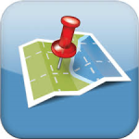Outbreaks Near Me
With HealthMap’s Outbreaks Near Me application, you have all of HealthMap’s latest real-time disease outbreak information at your fingertips. Open the app and see all current outbreaks in your neighborhood, including news about H1N1 influenza (swine flu). If you spy an outbreak, be the first to report it using the app’s unique outbreak reporting feature.

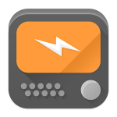Scanner Radio
During a disaster, everyone hears rumors. What’s really going on? The answer might be found on police band radio, which you can pick up using this free app. This isn’t talk radio; it’s an unfiltered feed of cops, firefighters and other public-safety officers. It shouldn’t be your only news source, but it could be worth listening in. For iPhone’s take a look at 5-0 Radio Police Scanner Lite.

NAVIGATE YOUR SURROUNDINGS:

When things get chaotic it’s easy to get lost – or maybe you need to relocate to a safer place. These apps will help you find your way ANYWHERE in the world.
MapDroyd
The MayDroyd has Entire country maps. The GPS and compass work without cell service, so this map app survives even if the internet doesn’t. Use GPS sparingly, as a means to get a fix on the map and to save on battery power.

Google Sky Map
Do you know how to read the stars? All you do with the Google Sky Map app is point it at the sky and it will read the stars.

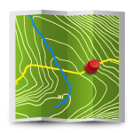Back Country Navigator
Use your phone or tablet as an offroad topo mapping handheld GPS with the Back Country Navigator app! Explore beyond cell coverage for hiking and trekking. Download topo maps for the US and many other countries in advance, so you won’t need cell coverage when navigating.

GPS Grid Reference
GPS Grid Reference: Great app for outdoor sports, running, hiking, site survey, search and rescue, travel and more!!. Many GPS & Compass features, combines with various OFFLINE maps (UK OS map, USGS, OSM, Mapnik, Topo & Cycle and more!).

MotionX GPS Drive
MotionX GPS Drive is a popular app to guide you out-of-town on an unfamiliar route. This app provides navigation and connects you to your local driving community. The software even should work without a cellular signal if you plan ahead and download and save the maps.

SPOT Connect
The SPOT Connect App is a revolutionary satellite messenger engineered to transmit messages via satellite from virtually anywhere in the world, whether you have a signal or not. You do have to buy their hardware and sign up for their service, but it might be worth it if you are often in remote locations.

SURVIVE & RESPOND:

Sometimes there will be no one around to help you when an emergency arises, or maybe you are someone’s only hope. What would you do? These emergency apps will help guide you through saving yourself or the life of someone else. Definitely take time to familiarize yourself with them before you find yourself in a life or death scenario.
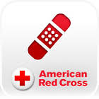First Aid & CPR
The official American Red Cross First Aid app puts expert advice for everyday emergencies in your hand. This emergency app prepares you for whatever life brings with videos, interactive quizzes and simple step-by-step advice. Preloaded content means you have instant access to all safety information at anytime, even without reception or an Internet connection.
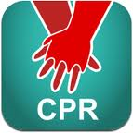Hands-Only CPR
To treat an adult suffering from cardiac arrest, the American Heart Association recommends hands-only CPR. No more mouth-to-mouth resuscitation. But you still have to do it right. The official Hands-Only CPR app walks you through the two-step checklist: Call 911, then start chest compressions. A brief video shows you what to do.

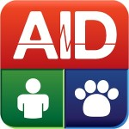GoToAID
With a database of over 400 topics, interactive tools, and report generators, GotoAID brings immediate access to first aid information for you and your pets. It also provides a full disaster preparedness section on what to do before, during and after a disaster.

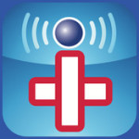iTriage
Find medications, diseases, and medical locations and instantly get answers to your questions right on your phone. If you or your loved ones are hurt, sick, or injured, iTriage will help you determine what the problem may be. This app will also help you find a doctor, in case you do need medical assistance. You can even store your medical history right within the app.

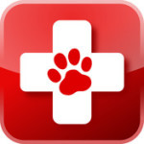Pet First Aid
Emergencies happen not only to humans, but to animals too. Pet First Aid is loaded with detailed videos and step-by-step illustrations so you’ll know exactly what to do when caring for your pet. While GotoAid has some pet information, this one is devoted to it. Get detailed instruction on how to save your dog, cat, puppy or kitten in a medical emergency. In addition, you can store all of your pet’s pertinent medical information in this app.
RepairPal: Auto Repair Expert
Be prepared 24/7 for a car emergency. Get the peace of mind and confidence you need to get behind the wheel of your automobile. Whether it’s an auto emergency, a roadside breakdown, or just a small problem, RepairPal can help. This app tells you the right price to pay for your repair, finds you a great mechanic in the area, tracks all your repairs, and gives you one-touch access to roadside assistance.

LACTMED
If you are a nursing mother take a look at this app. LactMed is a database of drugs and other chemicals to which breastfeeding mothers may be exposed. It includes information on the levels of such substances in breast milk and infant blood, and the possible adverse effects in the nursing infant. Suggested therapeutic alternatives are provided to those drugs where appropriate.

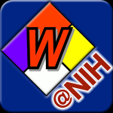WISER
WISER (Wireless Information System for Emergency Responders) is a mobile application designed to assist first responders in hazardous material incidents. Even if you are not a 1st responder, knowing what to do and how to handle hazardous materials might be crucial information in an emergency.

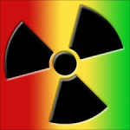REMM
REMM (Radiation Emergency Medical Management) provides guidance about clinical diagnosis and treatment of radiation injuries during radiological and nuclear emergencies.

The Merck Manual
In case the information in GotoAID is not detailed enough for you, there is plenty more in this app. This manual has been written by more than 300 medical experts. It has information on animal bites, burns, chemical burns, fractures, head injuries, nose bleeds, and much more. The app is fully self-contained; no Wi-Fi or cellular Internet connection is needed.

GET HELP:

No matter how prepared you think you are, there are just times we all could use some help. Would you or your family know what to do, or where to go to get help?
Red Panic Button
Allows users to send their GPS location to pre-set emergency contacts with just one touch. If you’re caught in a dangerous situation, getting the word out might be a lifesaver. You just have to set a panic number or email address and the phone will send a message which contains your address and location.

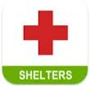Shelter View
When a hurricane or earthquake drives people from their homes, the American Red Cross steps in to provide shelter. This app maps locations across the U.S., and includes details such as the agency managing the shelter, capacity of the shelter and current population, the associated disaster event and the specific shelter address and location.
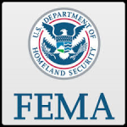FEMA
The Federal Emergency Management Agency (FEMA) app contains preparedness information for different types of disasters, an interactive checklist for emergency kits, a section to plan emergency meeting locations, information on how to stay safe and recover after a disaster and a map with FEMA Disaster Recovery Center locations and shelters.

iWrecked – Auto Accident Assistant
It is a full featured, accident resource for easily logging all details and info after being involved in a wreck. Take unlimited photos of the damage and accident scene with your phone. It can also generate a detailed, professional-looking PDF accident report with images, which you can send directly from the app to your insurance company. Check with your insurance company; many of them offer apps that do the same job but with direct access to your insurer.
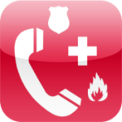!Emergency!
You probably are aware that not all countries use 911 for the Police, Fire Department and Medical Services. If you travel a lot, but do not always have time to find out the important numbers of the country you are in, then this app is for you. Just install this emergency app on your phone and it will detect what country you are in, and dial the correct number in case you should need it.

STAY CONNECTED:

Everyone can probably agree that the top priority in any disaster is finding your family. So whether you are trying to let them know you are ok, or re-uniting with everyone after a catastrophe, these apps will help you do that.
Life360
Life360 can help you find your loved ones, get safety alerts to them or call for help with the tap of a button. It also provides neighborhood safety monitoring. Lets you see family members’ locations and send text messages and emails to them.

Social Alert
Send out a message to your friends and relatives in case of an emergency or crime. Integrating with social networks most of us already use such as Facebook, Twitter and text messages, you can send out a custom emergency message with your exact location, helping authorities pinpoint exactly when and where you are.

Facebook & Twitter
In a crisis, social media can turn from gossip lines to possible lifelines. Whether your friends and family are safe or in danger, they could be posting about it on Facebook and Twitter. Plus, you’ll know about some local businesses that are open after a storm or other natural disaster. Public agencies also post updates on Twitter, so consider following the National Hurricane Center, FEMA and your local transit agency and police department.
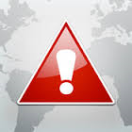ubAlert — Disaster Alert Network
ubAlert is a global social network that operates to save lives by sharing the knowledge of the world’s citizens with those in danger. This app gives you all the information you need when it comes to disasters happening across the world. Alerts contain basic event details, impact statistics, maps, images, videos and more. You can instantly share alerts with co-workers, family members and friends to get them out of harm’s.

OTHER USEFUL APPS:

Here are some basic apps on nearly every phone that can help during a crisis too!
Notepad
A place to jot down quick notes and ideas can come in handy anytime, but especially when preparing for or going through a disaster. It can be a place where you store lists, last-minute things you need to grab, medications, health history, important numbers, things to do, and anything else you can think of.
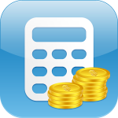Calculator
The calculator isn’t just for helping kids with their homework. You can use it during a crisis to figure out the cost of items when cash registers are down, add up how long you can survive on the food/water you have stored, or even how many zombies you’ve killed ;) – By the way is anyone still reading this post?
Camera
If you don’t have time to jot down notes, a camera is great for remembering things you want to do, make, or add to your preps. The camera can also come in handy for everything where you need visual documentation, like an accident, event, or an agreement.

Games
Sometimes surviving is just trying to keep the kids entertained! You can download books, movies, and thousands of games to keep them occupied during a crisis (or even a dental appointment)!

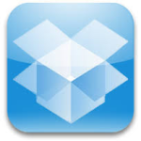Dropbox
You may have all intentions of grabbing your laptop when the house catches fire, but what if you can’t? If you have copies of your important files stored in a Dropbox account, you should be able to access them even if your computer doesn’t make it out.

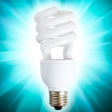Flashlight
If the power goes out, a flashlight app can be invaluable. No more rummaging around your drawers for a flashlight during those first few confusing moments. Remember however, that these apps can result in high battery drain, so you want to make sure your phone is fully charged.

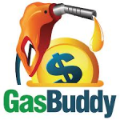Gas Buddy
Gas prices may be high, but they’re not likely to vary much among the gas stations. During a crisis though, that could all change. GasBuddy uses your GPS to display up-to-the-minute gas prices near you.

