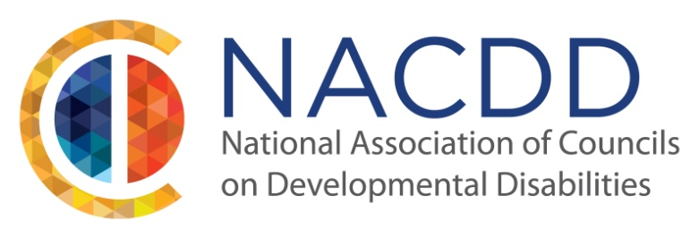
JOIN US AT THE
DISABILITY POLICY SEMINAR 2016

ON SUNDAY, APRIL 10th FROM 3:00-5:00 PM TO ATTEND

NACDD’S POLICY BRIEFING

The briefing will include budget and appropriations
for DD Councils and inclusive emergency management

The Renaissance Hotel, Downtown Washington, D.C.
999 9th Street NW
Washington, DC 20001

To book your hotel room, visit:
https://aws.passkey.com/g/51189599

FOR MORE INFORMATION AND TO REGISTER TO ATTEND:
http://www.thearc.org/dps
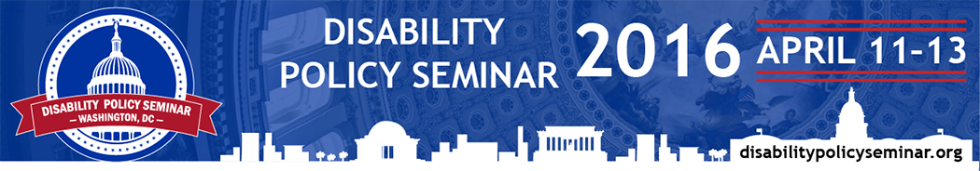
Act fast! Early registration closes March 11

