Creating an Account and Logging in to DD Suite

Creating an Account

You can create an account in just a few seconds!

- From the DD Suite home page, select the “Sign up” link.

- In the “Email” field, enter your full e-mail address (example: joeschmo@council.org)

- In the “Password” field, type the password you will use to login to your account.

*Note: Although there are no forced password requirements on DD Suite, we recommend creating a strong password by a using a combination of capital and lowercase letters, as well as numbers and symbols (Example: DD$uite5)

- In the “Confirm Password” field, re-type the password you entered in the previous step.

- In the next few fields, continue entering the information to customize your account.

- In the “Select Security Question” dropdown menu, choose a question that you will easily know the answer to.

- In the “Security Answer” field, insert the answer to the security question.

*Note: You may have to answer this question in the future in order to verify your identity and change your account information.

- For security purposes, enter the answer to the system-generated question in the “Form Validation” field below the question.

*Note: The correct answer to this question confirms that an actual individual is attempting to create an account on DD Suite.

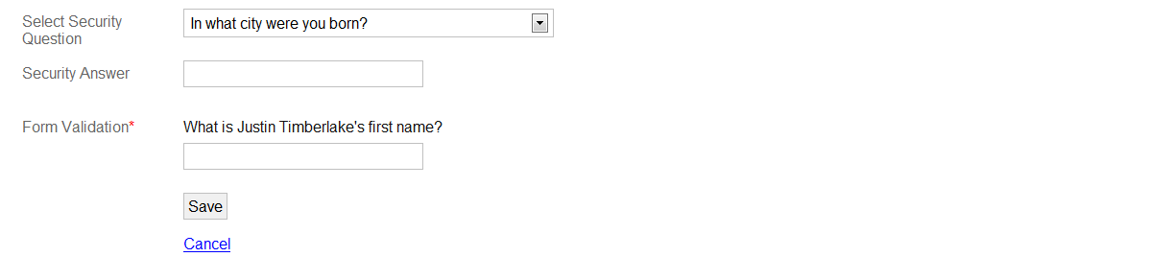

- Select the “Save” button to create your account.

- You will receive a notification e-mail at the address you entered during signup (check all folders including the “Spam” folder.) In order to verify your e-mail and complete the registration process, you must select the link in the middle of the e-mail or paste the URL into the address bar of your internet browser. If you do not receive this e-mail, you will have the option to send another verification e-mail when you login.

*Note: It may take some time before you receive the verification e-mail. If you select this link multiple times, only the newest e-mail will be valid. If you try to continue the verification process using an older e-mail, you will receive this error message:

“An activation problem occurred… a reference code is either incorrect or missing.”

Logging in to DD Suite
- From the DD Suite home page, select the “Login” link.

- Enter your login credentials for your DD Suite account in the “Email” and “Password” fields.

- Select the “Submit” button to log in to your personal dashboard.

Creating an Organization

- On the user account home page, click on the “create” link to create an organization.

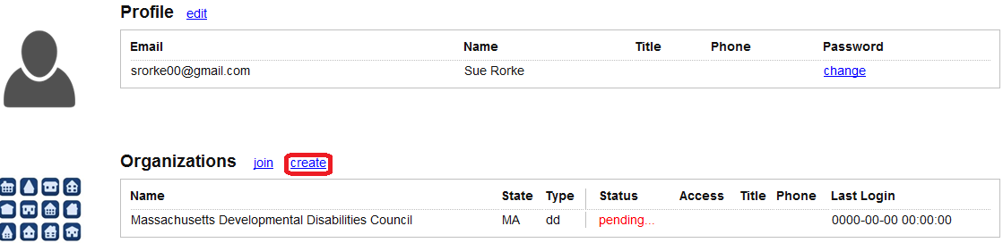

- In the “Name” field, enter the name of your organization.
- Choose the type of organization in the “Type” dropdown menu.
- In the “Address1” field, enter the primary address for your organization.
- If your organization has additional locations, enter them in the “Address2” and “Address3” fields.
- In the “City” field, enter you’re the name of the city where your organization is located.
- In the “State” dropdown menu, select the state where your organization is located.
- In the “Zip” field, insert the zip code where your organization is located.
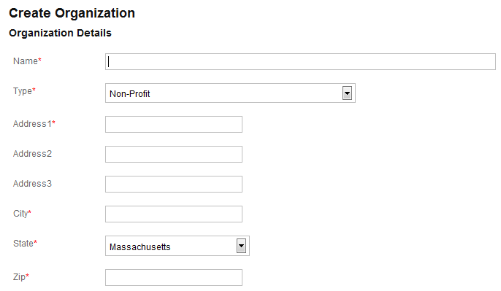

- In the “Phone” field, enter your phone number, including area code.

*Hint: Enter phone numbers in any format that contains the ten numbers. It will automatically be re-formatted to the (111) 111-1111 format on DD Suite
- If you have another phone number at which your organization can be reached, enter it in the “Phone2” field.
- If you have an organization e -mail address at which your organization can be reached, enter it in the “Email” field.
- In the “Website” field, enter the URL (web address) of your organization.
- After inserting all of the information, click the “Save” button at the bottom of the form.

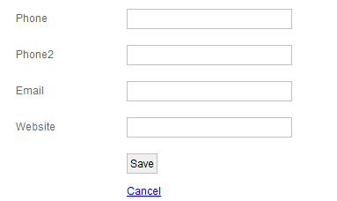

Joining an Organization

A user will need to join an organization in order to access any DD Suite features.

- On the user account home page, click on the “Join an Organization” link to select your organization.

*Hint: Try to find your existing organization first before attempting to add a new organization.

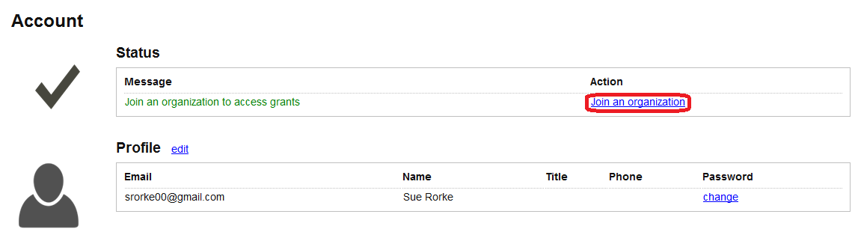

- In the “State” dropdown menu, select the state or territory where the organization is located.
- In the “Organization Type” dropdown menu, select the type of organization.
- In the “Search (like)” field, you can type keywords to narrow down the list of organizations.

*Hint: If you don’t know the exact name of your organization, use the “%” character as a wild card to search for individual words. For example:
- %Arc% will search for any organization names with words that contain “arc” (i.e. The Arc of Massachusetts and Human Services Research Institute)
- %Arc % (space after Arc) will only search for organization names that contain the whole word “Arc” (Arc of Massachusetts)
- % School (space before School) will search for any organization names that end with the word “School” (i.e. UMass Medical School)
- Disability % (space after Disability) will search for any organization names that begin with the word “Disability” (i.e. Disability Law Center)
- Once you have completed setting the search criteria, select the “go” button to display the organizations that meet the search criteria.

- Find and select the “join” link to the right of the page that corresponds to the organization you want to join.

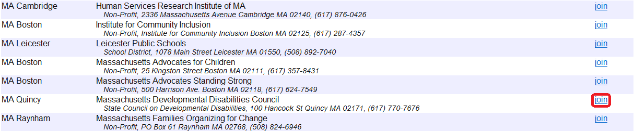

- A pop-up dialog box will appear. Confirm that the organization that appears is the correct organization by selecting the “Ok” button.

*Hint: When you attempt to join an organization, an e-mail is sent to that organization, and the administrator at that organization must approve your account.

Each organization has at least one administrator account, and that account is responsible for setting up access for other users in their organization. If you do not have a user account, or you don’t know what your user account is, please contact your DD Suite organization administrator.

Applicant/Grantee Organization Dashboard
Tasks

‘Tasks’ provides a display of items that require action by the user. The following items are included in the list of tasks.

- Account Messages- notifications about some aspect of your account that has to be changed
- Join Requests- notifications that a user has requested to join your organization and is awaiting approval (Administrators only)
- Applications- grant applications that have been submitted and need to be reviewed
- Program Reports-
- Expense Reports-
- Grant Reports Due-
- Overdue Grant Reports-
- Activity Reports Due- (N/A) not applicable to applicant/grantee organizations
- Overdue Activity Reports- (N/A) not applicable to applicant/grantee organizations

Tasks can be filtered using the drop-down menu.
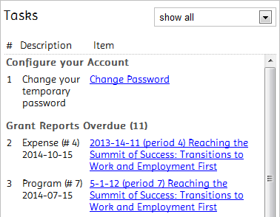

Modules
Modules are icons that re-direct you to various DD Suite system features.

- Applications- Access and maintain applications
- Grants- View awarded grant projects
- Periodic Reporting- View/edit periodic program and expense reports
- Notices of Funds Available- View/apply for available NOFAs
- Organization Administration- View/Change organization information and accounts (Administrators only)

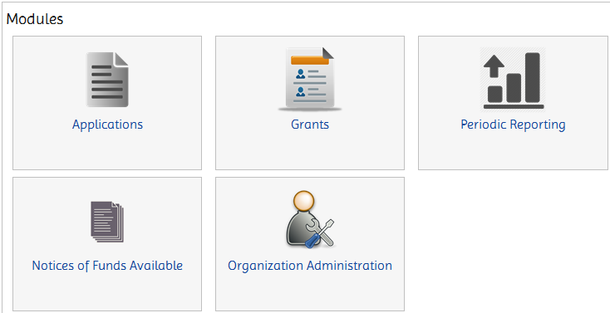

Applying for a NoFA

Many councils post the availability of grant funds on DD Suite through the Notice of Funds Available (NoFA) process. If you have access to a direct link for the NoFA, it is necessary to be logged in before filling out the application. The following instructions detail how to apply for a NoFA.

*Note: You can access available NoFAs by selecting on one of the links in the Notices of Funds Available section on the DD Suite home page.

- On the main dashboard, select the “Notices of Funds Available” button.

- In the Notice of Funds Available page, review all of the available NoFAs and select the “Details” link.

- Review the information for the NoFA and, if applicable, select the “Apply for this Grant” button.

*Note: An actual NoFA screen will include multiple sections with detailed information about the available grant, project specifications and grantee requirements. This screen shot is for instructional purposes only.
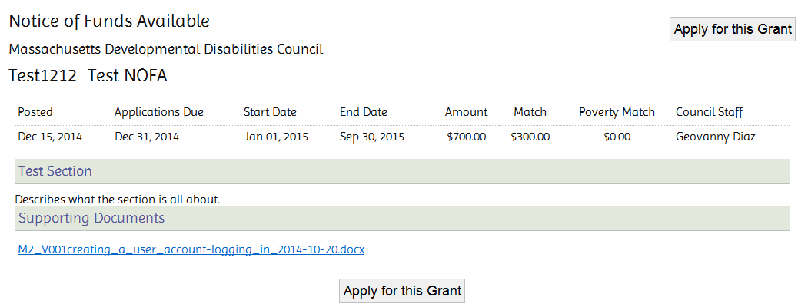

The New Application page appears.

In the following screens, you will be asked to provide information regarding several different aspects of your proposed project.

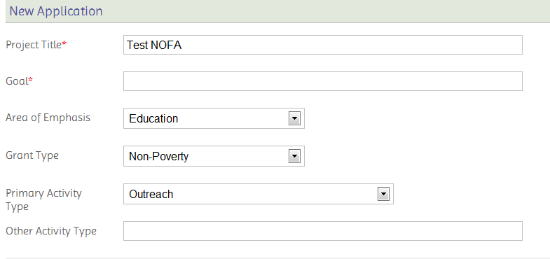
*Note: This screen shot is for instructional purposes only. Many Councils provide specific instructions on what to enter in some fields of an application. Check the application instructions carefully.

- The “Project Title” field will default to the NoFA Title, but it can be edited.

- In the “Goal” field, insert the goal that this project is intended to achieve.

- In the “Area of Emphasis” dropdown menu, select the primary focus area of the grant project.

*Note: Some Councils will instruct you which “Area of Emphasis” to choose. Check the application instructions carefully.

- In the associated dropdown menus, choose the appropriate grant type and primary activity type for this grant project.

- In the “Collaborators” section, select the “State Protection & Advocacy System” and/or the “University Affiliated Program(s)” checkboxes if those organizations are participating in the project. You can also list other collaborators in the field provided.
*Note: Be sure to use commas to separate organizations listed in the “List Other Collaborators” field.
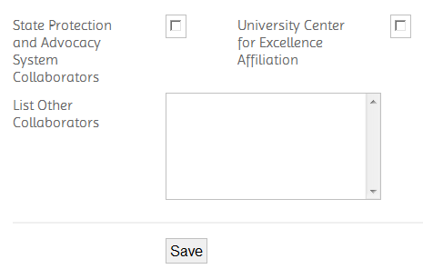

- Select “Save” to save your work.

*Note: Upon saving the initial section of the application, a tab menu appears at the top of the page. Browse from section to section to complete the rest of the required information.

  - Application Info: Contains general information.

  - People: Each application requires members of the organization to be assigned to three roles: Project Director, Financial Officer and Organization Director. You may assign one person to all three roles. You may add additional roles. All people assigned must have an active DD Suite account with your organization.
FYI: Only members assigned to the application and grantee administrators will have access to the periodic reporting if the application is awarded.

  - Outline: If applicable, answer the questions as required.

  - Budget: If applicable, the budget page shows the expense categories defined by the Council publishing the NoFA. Add line items with amounts to each category as appropriate.

  - Objectives, Activities, Performance Measures:
*Note: Councils may use differing terminology for this section. The terms used here are for instructional purposes only. If these tabs are present, your application must include at least one objective with one activity. Once you enter an objective you will be able to add activities and performance measures for that objective.

  - Support Docs: Supporting documents may be added one document at a time. This page also has a section for adding notes to your application. Select “Update Notes” to save your text.

  - Submit Application: Once you have entered all required information, return to the overview page by clicking on ‘Project Name’ in the header section. Review all of your information. If you are ready to submit the application, click on “Validate and Submit” at the top of the page.

  - Validate and Submit: The validation page will show whether you have correctly completed the application or if there are errors. If there are red errors, you will need to return to the relevant section and address the issue before you can submit the application. The pink warnings will not prevent you from submitting the application. When your application contains all required information, you can access the “Submit Application” button at the bottom of the page. Once your application has been submitted, you will not be able to make changes.

  - Guidelines: The Guidelines contain a summary of the instructions detailed in this module.

