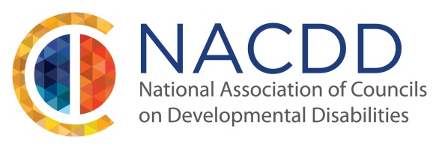
National Leadership Consortium on DD Announces 2016 Opportunity for Leadership Training!
NACDD Will Award Scholarship to 1 DD Council Representative Accepted to NLCDD Training Institute
The National Leadership Consortium on Developmental Disabilities (NLCDD) has opened registration for its 2016 leadership training. We encourage you to apply and attend if accepted! NACDD is again partnering with the National Leadership Consortium on Developmental Disabilities (NLCDD) to sponsor one successful applicant for 2016 who will attend the week-long leadership training. The training will be held January 10-15, 2016. If the successful candidate cannot attend in January we offer you the opportunity to defer your scholarship award to attend the training that will be held in summer 2016.
What is the Training?
The training is a week-long opportunity to join others from across the nation who want to learn from experts in the field of non-profit management relating to developmental disabilities and also build valuable relationships with fellow future leaders of disability organizations across the country. Additionally, it will allow you an opportunity to share lessons learned from the training to impact the operations of every Developmental Disabilities Council across the nation. You can learn more about NLCDD and the week-long training here: www.nlcdd.org
Who Should Apply?
DD Council Executives, staff and Citizen Council members should apply. Successful applicants are those who are now or want to be in leadership roles in their community.
What Does the NACDD Sponsorship Include?
If you are the chosen applicant for 2016, NACDD will cover most costs for attending the leadership institute including registration, materials, most lunches and 2 dinners. The scholarship will also include hotel accommodations arranged by NLCDD. This is a $3,000.00+ value! Transportation and any additional meals must be paid for by the attendee. Successful scholarship candidates must be attending this training for the first time and must also apply directly to NLCDD for acceptance in the training by NLCDD.
In order to be considered for this scholarship please completes these steps:
- Submit an application to NLCDD as found on their site here: https://www.regonline.com/Register/Checkin.aspx?EventID=1726516
- Once you have applied to NLCDD, submit the NACDD Scholarship Application below (scroll down) to NACDD for scholarship consideration. Deadline for application for both the NLCDD and NACDD is November 10, 2016. Materials for NACDD sponsorship consideration should be emailed or faxed to:
Jessica Misilo at jmisilo@nacdd.org
202-506-5846 (fax)

Scroll down for more!

Instructional Application for Consideration of NACDD Scholarship to Attend NLCDD Training (Read this First Before Filling out Actual Application on Next Page)
I have submitted an application to NLCDD to attend the Training Institute ___yes ___no
Your Name:
Please state the name of the DD Council which you are affiliated with and how you are affiliated with that Council: please tell us if you work for a DD Council, serve on a Council or have previously served on or worked for a Council etc.
Your History: including, number of years in field, the various jobs you have held, the number of years you have been with your current organization; and your role in your current organization. (Feel free to copy and paste from NLCDD application)
What Makes You a Promising Leader? Share what impact have you had on the field of developmental disabilities so far. Where do you see your career in the developmental disabilities field progressing? What makes you a strong leader/future leader in the field?
Plans for Sharing Information and Learning with others in the DD Council Network: Tell us how you will share your newly acquired knowledge. Are you willing to organize a breakout session at the next NACDD Annual Conference or speak on a webinar or conference call to others about your opportunity and lessons learned?
Would you be able to attend this Training if you do NOT Receive this Scholarship? Circle Your Answer Please.
Yes
No
Maybe
Additional Information:
Please feel free to share any additional information that speaks to why you should be chosen for this scholarship. You may attach references or letters of support if you wish but they are not required. Please use the blank version of this form on the next page to write your responses and take as much space or as many pages as you need.
Applications are due to NLCDD by November 10, 2015, so act quickly to ensure your application is received! Once you have applied to NLCDD please send completed NACDD application for scholarship consideration to: Jessica Misilo at jmisilo@nacdd.org or fax to 202-506-5846. Please try to send by November 10 or let us know your intent to apply for scholarship by November 10.

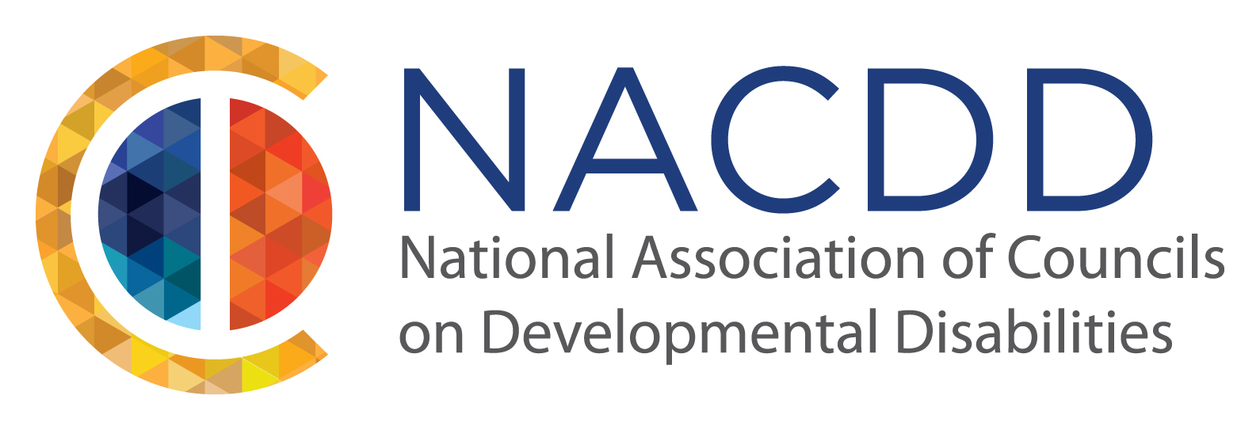

Application for NACDD’s 2016 Scholarship Award to Attend NLCDD Training

I have submitted an application to NLCDD to attend the Training Institute ___yes ___no

Your Name:
Please state the name of the DD Council which you are affiliated with and how you are affiliated with that Council:

Your History:

What makes you a promising leader?

If you are chosen to be NACDD’s Scholarship Recipient, How would you share the knowledge and information you earned with others in the DD Network following your training?

Go to next page

Would you be able to attend this Training if you do NOT Receive this Scholarship? Circle Your Answer Please.
Yes
No
Maybe

Additional Information:
Please feel free to share any additional information that speaks to why you should be chosen for this scholarship. You may share any references or letters of support if you wish but they are not required. Please take as much space or as many pages as needed for this application.
Applications are due to NLCDD by November 10, 2015, so act quickly to ensure your application is received! Please send completed NACDD application for Scholarship consideration to:
Jessica Misilo at jmisilo@nacdd.org or fax to 202-506-5846
Remember – you must apply directly to NLCDD first in order to be eligible to receive NACDD’s Scholarship Award

