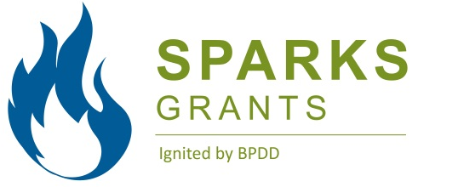 | 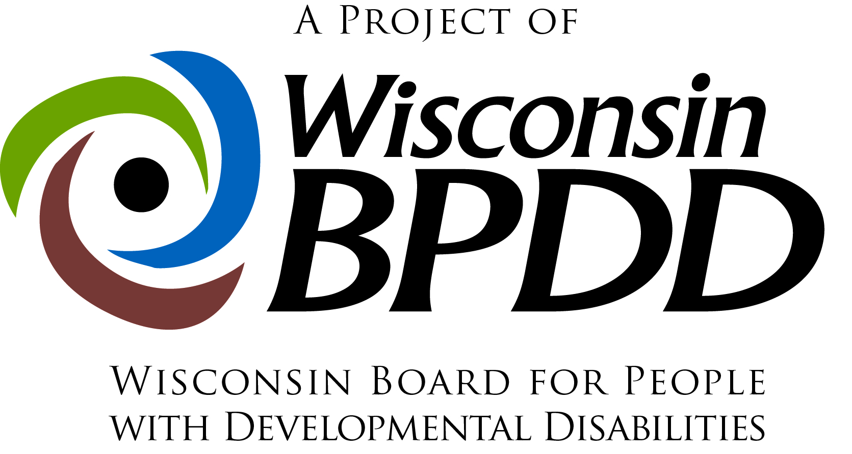

What are SPARKS Grants?
The purpose of SPARKS Grants is to organize local grassroots groups that identify and make changes in their communities that result in a positive impact on the lives of people with disabilities. Grassroots community organizing means groups working for positive community change for individuals with disabilities on issues that are important to them. SPARKS Grants are funded by the Wisconsin Board for People with Developmental Disabilities (BPDD), and are available to people with developmental disabilities and family members in Wisconsin. Priority activities for 2014 SPARKS Grants are:

- Organize a local People First chapter
- Form a local social justice or civic group that includes people with and without disabilities (this could be a school group)
- Local community advocacy (e.g., developing an inclusive park or accessible garden, expanding community employment opportunities for people with disabilities)

What have been some of the accomplishments of past SPARKS Grants?
SPARKS grants started in 2010 and have had many positive results, including:
- Creation of an accessible city park in Oshkosh
- Expansion of the bus transportation system in the Wausau area
- Development of unique employment opportunities at local organic farms in Kickapoo, WI
- Development of an accessible garden, community room and kitchen in Stevens Point

Who can apply? Individuals with developmental disabilities and family members may apply for the grants. These funds are not intended to supplant operational funds by an organization, to purchase equipment, or to pay for staff.

How to apply: complete and submit the SPARKS Grants application packet (application form, budget worksheet, and project work plan). Instructions for how to submit the application packet can be found within the forms. Application materials (i.e., application form, budget worksheet, and work plan) are due by 12:00 p.m. on Friday August 1, 2014. Grant recipients will be notified of their award by Friday, Aug. 22.

How much funding can you request? Individual grants range from $500-$3,000. A detailed budget must accompany all grant proposals (a budget template is included in the application packet).

How will projects be chosen? A review team will score each grant according to several key factors, for example:
- clear and concise project purpose, activities, and outcomes
- the project addresses an important community problem that if addressed will have a significant positive impact on the lives of people with disabilities
- there are sufficient resources to carry out the project activities
The highest scoring grants will be funded.

What can you expect from BPDD? Each SPARKS Grant recipient must participate in SPARKS Kickoff event where you will be given the opportunity to refine your project work plan and share your project ideas with other grant recipients from around the state.

What are you committing to?
- Each team must agree to attend the SPARKS Kickoff event on Monday, September 22. This event will focus on:
  - strategies for projects to be successful
  - reviewing grant expectations
  - signing contracts
- Each team will agree to provide project updates and outcomes to be shared via BPDD’s website (www.wi-bpdd.org), social media platforms, etc.
- Each team will start their project no later than October 1, 2014 and should complete their work plan by September 30, 2015.

If you have any questions, contact:
- John Shaw at 608-266-7707 or john1.shaw@wisconsin.gov
- Ann Sievert at 608-267-9897 or ann.sievert@wisconsin.gov

Glossary of Terms for Project Work Plan

Goal: A goal states the best possible outcome for people. Goals are simple, clear and optimistic – e.g., All people with disabilities will have integrated jobs in their community.

Objective: Objectives are steps needed to reach the goal. They describe a concrete change in people’s actions or condition. Objectives are concrete, measurable, optimistic, but realistic – e.g., The number of people with disabilities working in integrated jobs in the community will double by 2016.

Outcome: Results of an activity, plan process or program, accomplishment/impact – e.g., Increase the number of individuals registered to vote.

Project Work Plan: A project work plan defines the tasks you need to complete in order to fulfill the requirements/deliverables of the project. The written plan includes: project purpose, goals, objectives, specific activities, outcomes, deliverable and target dates.

APPLICATION
FORM

Application materials (application form, budget worksheet, and work plan) are due by 12:00 p.m. on Friday, August 1, 2014.

Applicant Name:

Project Title:

Address:

Telephone:

Email address:

1. What change do you want to make in your community? What problem are you addressing?

2. What action will you take to address the problem and make the change in your community?

3. What people are you going to involve in taking action/making the change in your community?

4. How will your project make the lives of people with disabilities better?

5. How will you know that your project was successful?

6. How will the positive change/impact continue after your grant ends?

Submitting You Application Materials
Application materials are due by 12:00 p.m. on Friday, August 1, 2014. Application materials – application form, budget worksheet, and work plan – can be submitted via email, fax, or regular mail.
- To submit via email, email your application materials to john1.shaw@wisconsin.gov
- To submit via fax, fax your application materials to (608) 267-3906.
- To submit via regular mail, mail your application materials to:
Sparks Grants
c/o WI-BPDD
101 East Wilson Street
Second Floor
Madison, WI 53703

If you have questions, contact:
- John Shaw at 608-266-7707 or john1.shaw@wisconsin.gov
- Ann Sievert 608-267-9897 or ann.sievert@wisconsin.gov

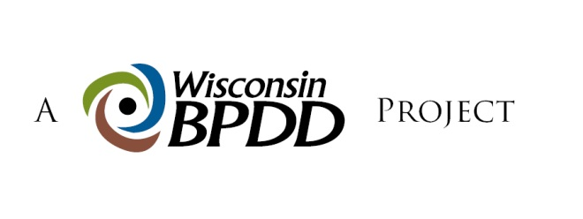
BUDGET
WORKSHEET

BPDD has allocated a total of $20,000 funds for the SPARKS grants. Funding for individual grants ranges between $500-$3,000. A detailed budget must accompany all applications.

Funding cannot be used for infrastructure (e.g., computers, printers).

SAMPLE BUDGET
ITEM (be as specific as possible) | COST
Meeting supplies (wall board, markers, post-it notes, copies) | $150.00
Meeting space rental ($100/event x 2 events) | $200.00
Refreshments ($100 x 2 meetings) | $200.00
Transportation (Cab fare 20 consumers ($25 ea.) x 2 meetings) | $1000.00
TOTAL | $1550.00
In-kind contributions
Volunteers at 2 events (10 people for 4 hours x 2 events) | 80 hours
Event t-shirts (donated from ABC org.) 50 shirts x $5.00 each | $250.00

YOUR PROJECT’S BUDGET
ITEM (be as specific as possible) | COST
TOTAL
In-kind contributions

PROJECT
WORK PLAN

Project Contact Person:  Project Title: |  |  |  | Contact Information (address, phone number, e-mail address):
Project Goal(s):
Project Objective(s):
Project description/rationale:

Sample Work plan
Project Activities: | Target Date: | Outcomes: | Deliverables/Products: |  | Target Date:
Develop a video to teach people their rights under Wisconsin voting law. | 11/12/14 | People will be prepared to vote and know what their rights are | Voting Video, written summary of community conversations and work plan to implement strategies. |  | 1/12/15
Help individuals to register to vote and help them develop a plan on how to get to the polls to vote on election day | 11/12/14 | People will be registered to vote and vote on election day | Names and addresses of individuals who are on the voting list to add to the disability voting block |  | 1/12/15

SPARKS Project Work plan
Project Activities: | Target Date: | Outcomes: | Deliverables/Products: | Target Date:

