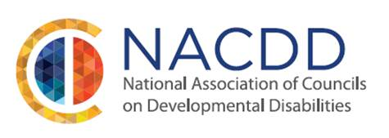
Schedule of Events for Sunday April 12, 2015
NACDD Meetings Pre-Disability Policy Seminar
The Renaissance Washington, DC Downtown Hotel

1:00pm – 2:45pm – NACDD Board of Directors Meeting (NACDD members are welcome to attend and listen to the Board discussions)
3:00 – 5:00 pm - NACDD Special Policy Session
Guest Presenter on NACDD Funding - Ed Long, Ph.D., Vice President, Van Scoyoc and Associates
Edward Long, Ph.D., an expert in health appropriations and policy, assists NACDD in securing its federal appropriation for the DD Councils each year. Ed will join us again this year to share tips and insight into the FY 2016 Appropriation process and discuss how you can help by educating and informing your members of the appropriations subcommittees in the House and Senate understand the work and value of your DD Council. Ed has been a Vice President of Van Scoyoc Associates Inc. since January 2009 following a distinguished and varied career in appropriations and public health consulting and on Capitol Hill.
Guest Presenter on Effective Messaging in the Media Age – Gordon O’Neill, O’Neill Communications
Gordon O’Neill, principal of his eponymous Atlanta-based communications firm has been working with several DD Councils to optimize messaging for the advancement of good policy. Mr. O’Neill will share with us tips and strategies for working to achieve bi-partisan policy that supports full inclusion in community life for individuals with I/DD, how to use ADA25 messaging and your 5-Year State Plan to help forward your mission, and how to work to improve your relationships with local media outlets to get positive and pro-active results in both traditional and social media.
5:00 pm - Networking Reception - continue conversation with our guest presenters and your colleagues in our networking reception. Light refreshments will be served.

1825 K Street, NW, Suite 600 * Washington, DC 20006 * Phone: 202.506.5813 * Fax: 202.506.5846 * www.nacdd.org

