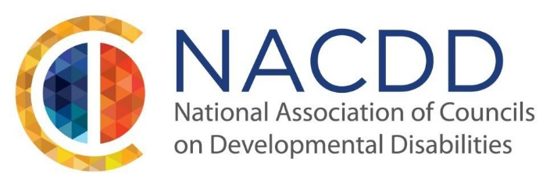

We are pleased to announce our 2024 Annual Conference:
A World of Opportunities
July 24-26, 2024
Capital Hilton, Washington DC

Welcome to the NACDD (National Association of Councils for Developmental Disabilities) Annual Conference: A World of Opportunities! This premier event is a must-attend for disability rights advocates, civil rights professionals, and practitioners. Get ready to dive into a world of endless opportunities as you hear best practices, connect with like-minded individuals, and gain the latest ideas and insights.
The NACDD Annual Conference brings together the brightest minds in disability rights advocacy and civil rights, creating a vibrant platform for knowledge exchange and networking. This event is designed to empower attendees with the latest tools and strategies that will shape the future of disability rights. At this conference, you will hear innovative and promising practices from people who have made significant contributions to our work. These thought leaders will share their invaluable insights, shedding light on the most pressing issues and offering innovative solutions.
Networking is a pivotal part of the NACDD Annual Conference. Connect with fellow disability rights advocates, civil rights professionals, and practitioners from around the states and territories who share your passion for creating a more inclusive society. Exchange ideas, collaborate on new initiatives, and build meaningful relationships that will have a lasting impact on your work.
This conference is a hub of innovative ideas. Be prepared to gain new perspectives and discover innovative strategies that will propel your work forward. Immerse yourself in interactive sessions, workshops, and panel discussions led by experts who have revolutionized the field. Leave with actionable takeaways that you can implement in your own work, making a tangible difference in the lives of those with disabilities.
The NACDD Annual Conference: A World of Opportunities is a transformative event that will equip you with the knowledge and skills needed to drive change and advance the rights of individuals with disabilities. Join us as we explore the endless possibilities that lie ahead and be part of a movement that is shaping a more inclusive future.
Don't miss this opportunity to be part of a community dedicated to inclusion and equity for people with intellectual and/or developmental disabilities. NACDD invites individuals with disabilities, their families, educators, researchers, service providers, employers, policymakers, and others who support individuals with disabilities to submit ideas for sessions related to this year’s theme: A World of Opportunities. We want presentation topics that are innovative, impactful, and inspiring. Topics may include but are not limited to:

- Digital Inclusion and Equity
- Health Equity
- Self-Advocacy/Family Advocacy
- Community Inclusion
- Disability in the greater Civil Rights Conversation
- Disability Policy
- Innovation/Technology
- Engaging Diverse Groups
- Caregiving Workforce and Crisis
- Voting Rights

NACDD emphasizes having presenters who reflect the full diversity of our network of DD (Developmental Disabilities) Councils and other partners in the field. We require proposals to feature advocates that act on issues of importance, demonstrate leadership strategies, and affect the systems that support people with disabilities. In addition, we highly encourage sessions to be facilitated by people with and without disabilities. Your proposal will not be accepted if there are no people with lived experience presenting in your session.

The audience of NACDD’s Annual Conference consists of Council members and Council staff, self-advocates, family members, federal and state government employees, corporations, and businesses, and other organizations and companies in the disability and civil rights communities.

Presenters are required to register for the conference. Accepted presenters are typically responsible for their own transportation, hotel, and registration costs. If you need financial assistance, please contact your State DD Council as they may be able to help. If a presenter intends to participate in the entire conference, registration fees apply.

If you have a proposal that supports the conference theme, please complete the submission form, and send it to conference@nacdd.org by March 16, 2024. For any questions, please reach out to NACDD staff at 202-506-5813.

