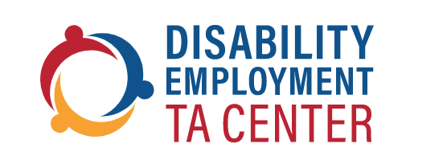

Celebrating Developmental Disabilities Awareness Month: Let’s Partner with Councils on Developmental Disabilities!

Webinar Date: March 14, 2023 | Time: 3:00 pm to 4:00 pm EST

Come join the DETAC as we celebrate Developmental Disabilities (DD) Awareness month in March with our partners from the National Association of Councils on Developmental Disabilities (NACDD). This webinar will provide an overview of the role DD Councils play in leading systems change within communities across the country. Additionally, we will drill down to learn more about the innovative employment initiatives from DD Councils in the states of California and South Carolina. Participants will learn the value of partnering with a DD Council in your state as we work together to advance employment opportunities and outcomes for people with DD.

 | Presenters:
Cherie Moon: TA Manager National Association of Councils on Developmental Disabilities |  | Donna Meltzer: CEO  National Association of Councils on Developmental Disabilities

Registration at: https://bit.ly/DETAC-CoP-Mar-14-2023

