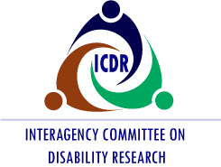

You’re Invited

Please join us for the Interagency Committee on Disability Research (ICDR) Lunch & Learn Webinar Series

Thursday, September 15, 2022

11:00 a.m. – 12:00 p.m. (ET)

Presentation: Understanding and Responding to the Cultural and Linguistic Differences in the Conduct of Disability Research

Presenter
Tawara D. Goode, MA
Director, National Center for Cultural Competence
Director, University Center for Excellence in Developmental Disabilities,
Georgetown University Center for Child & Human Development
Assistant Professor, Department of Pediatrics, Georgetown University Medical Center

Audience

The audience will include a wide range of ICDR stakeholders, federal interagency partners, researchers, practitioners, disability organizations and ICDR Committee members.

Space is limited. Register now to reserve your spot and to receive instructions for joining the webinar. Registration closes September 9. An opportunity to request disability-related accommodations will be provided on the registration form. If you have difficulties registering, please email events@1sourceevents.com.

