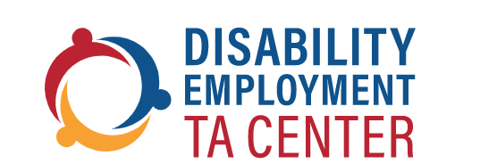

Reflecting Upon the ADA: Soaring to Employment

Webinar: Date: July 12, 2022 | Time: 3:00 pm to 4:30 pm EST
Join the DETAC as we reflect upon the accomplishments of the Americans with Disabilities Act (ADA) and learn how the ADA has supported the goal of competitive, integrated employment (CIE) for persons with disabilities. Pre-recorded remarks will be provided by Acting Administrator Alison Barkoff from the Administration for Community Living (ACL) by highlighting the evolution of the investments that ACL has made in support of CIE. Additionally, a panel comprised of five self-advocates from across the country will talk about how the ADA has impacted and empowered them to achieve employment.

Highlighting the Evolution of Investments that ACL has Made in Support of CIE
BY
Alison Barkoff
Acting Administrator of the ACL and Assistant Secretary for Aging
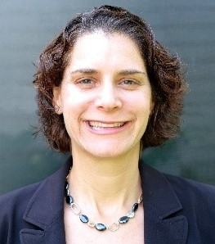
Followed by a panel of self-advocates from across the country

Nicole LeBlanc  Self-Advocate Adviser,  DETAC | Tracy Rackensperger, Ph.D.  Public Service Faculty Member,  Institute on Human Development and Disability, University of Georgia | Katie Lowe  Business Owner, "Cheetah Greetings" Cards | Jack Carfagna  Business Owner, "Mr. C's Old Thyme Scents" Candles | Mikelle Learned  Podcaster & Jewelry Maker,  The Shining Beautiful Series
 | 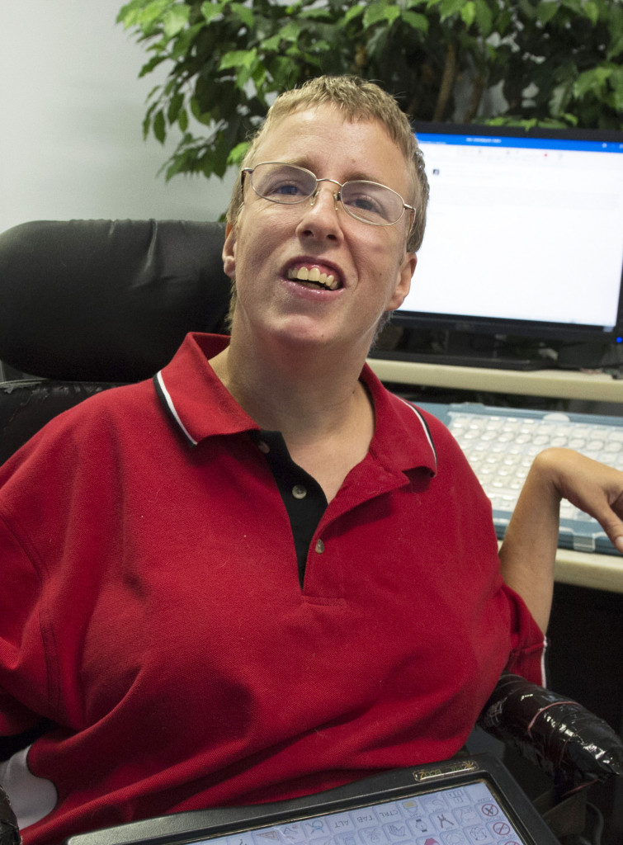 | 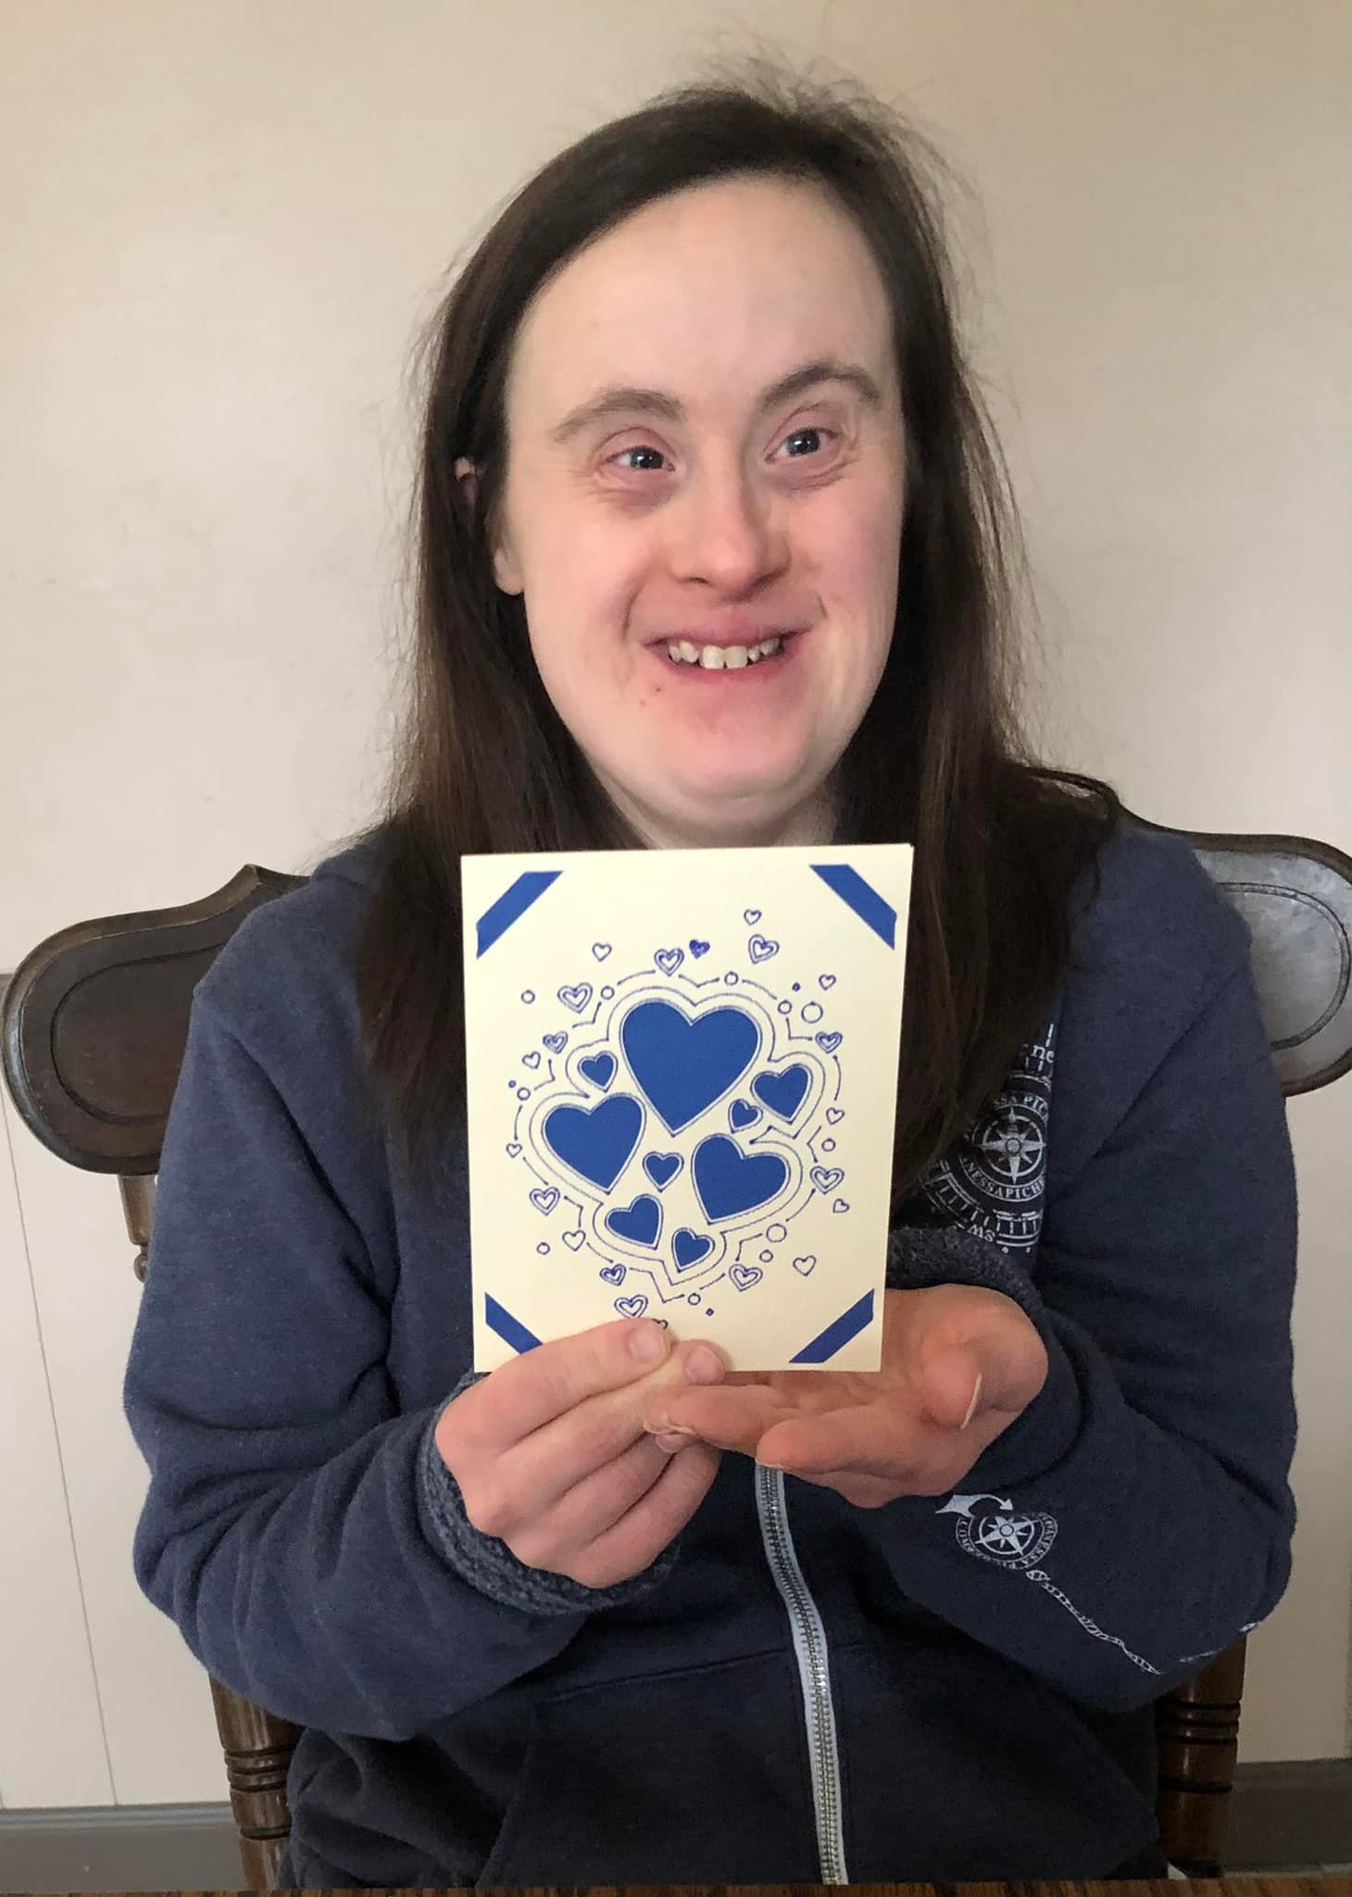

Registration at: https://bit.ly/DETAC-CoP-Jul-12-2022

