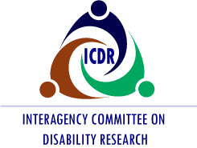

You’re Invited

Please join us for the Interagency Committee on Disability Research (ICDR) Lunch & Learn Webinar Series

Wednesday, July 20, 2022

12:00 p.m. – 1:00 p.m. (ET)

Presentation: Post-COVID Conditions and Information Useful for Those in the Field of Disability Research

Presenter
Elizabeth Unger, Ph.D., M.D.
Chief of the Chronic Viral Disease Branch (CVDB)
Division of High-Consequence Pathogens and Pathology
National Center for Emerging and Zoonotic Infectious Diseases
Centers for Disease Control and Prevention (CDC)

Audience

The audience will include a wide range of ICDR stakeholders, federal interagency partners, researchers, practitioners, disability organizations and ICDR Committee members.

Space is limited. Register Now to reserve your spot and to receive instructions for joining the webinar. Registration closes July 15. An opportunity to request disability-related accommodations will provided on the registration form. If you have difficulties registering, please email events@1sourceevents.com.

