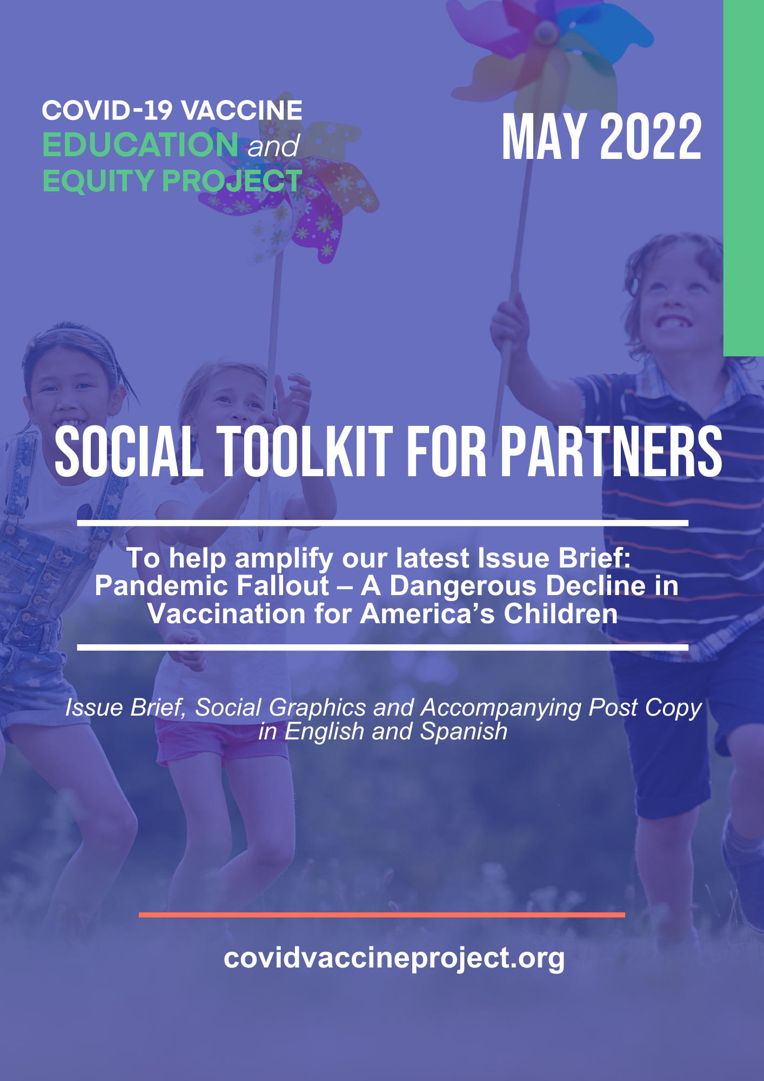
OVERVIEW
Building on themes from our last issue brief, our coalition analyzed COVID’s impact on routine childhood vaccination rates with a focus on the Vaccines for Children (VFC) program for our newly released issue brief, Pandemic Fallout – A Dangerous Decline in Vaccination for America’s Children. This toolkit contains links to the issue brief, social graphics and suggested post copy [in English and Spanish] to use when posting to social channels.

LINKS TO ISSUE BRIEF

Below, please find links to our English and Spanish versions of the issue brief, which are also available on our Resources webpage, under “Access to Vaccines.”

English: https://bit.ly/3lhlWXw

Spanish: https://bit.ly/3sFdLYZ

SOCIAL GRAPHICS

Below, please find downloadable social graphics sized for every platform for use throughout this week.

English – accessible here.
- Facebook
- Twitter
- Instagram
- LinkedIn
Spanish – accessible here.
- Facebook
- Twitter
- Instagram
- LinkedIn
SUGGESTED SOCIAL POSTS

English

FACEBOOK
- We’re working with @COVIDVxProject to integrate #healthequity into vaccine system improvements by raising awareness of the longstanding disparities that disproportionately impact children who are uninsured or on Medicaid. Learn more about key solutions with the latest issue brief: https://bit.ly/3lhlWXw. #COVIDVxEquity

- Prior to the pandemic, children covered by VFC were vaccinated at lower rates than privately insured children. The pandemic has further exasperated these disparities, leaving many kids even more vulnerable to outbreaks of vaccine-preventable diseases like measles, flu and COVID-19. To learn more, read @COVIDVxProject’s latest issue brief: https://bit.ly/3lhlWXw.

TWITTER

- We’re working with @COVIDVxProject to integrate #healthequity into vaccine system improvements by raising awareness of the longstanding disparities that disproportionately impact children who are uninsured or on Medicaid. Learn more: https://bit.ly/3lhlWXw. #COVIDVxEquity

- The #COVID19 pandemic has exasperated vaccination disparities and gaps among children, leaving many kids vulnerable to outbreaks of vaccine-preventable diseases. To learn more, read @COVIDVxProject’s latest issue brief: https://bit.ly/3lhlWXw.

INSTAGRAM
*Note: For Instagram Stories #8 – Use the “Link Sticker” option when posting with the link to issue brief. Instructions available here*

- We're working with @COVIDVxProject to integrate #healthequity into vaccine system improvements by raising awareness of the longstanding disparities that disproportionately impact children who are uninsured or on Medicaid. Learn more about key solutions with the latest issue brief at our #linkinbio. #COVIDVxEquity

(Link to add to your organization’s IG bio or Stories link sticker: https://bit.ly/3lhlWXw)

- Prior to the pandemic, children covered by VFC were vaccinated at lower rates than privately insured children. The pandemic has further exasperated these disparities, leaving many kids even more vulnerable to outbreaks of vaccine-preventable diseases like measles, flu and COVID-19. To learn more, read @COVIDVxProject’s latest issue brief at our #linkinbio.

(Link to add to your organization’s IG bio or Stories link sticker: https://bit.ly/3lhlWXw)
LINKEDIN

- We’re working with @COVID-19 Vaccine Education and Equity Project to integrate #healthequity into vaccine system improvements by raising awareness of the longstanding disparities that disproportionately impact children who are uninsured or on Medicaid. Learn more about key solutions with the latest issue brief: https://bit.ly/3lhlWXw. #COVIDVxEquity

- Prior to the pandemic, children covered by VFC were vaccinated at lower rates than privately insured children. The pandemic has further exasperated these disparities, leaving many kids even more vulnerable to outbreaks of vaccine-preventable diseases like measles, flu and COVID-19. To learn more, read @COVID-19 Vaccine Education and Equity Project’s latest issue brief: https://bit.ly/3lhlWXw.

SPANISH

FACEBOOK

- Estamos trabajando con @COVIDVxProject para integrar #EquidadDeSalud en las mejoras del sistema de vacunas al crear conciencia sobre las disparidades históricas que afectan de manera desproporcionada a los niños que no tienen seguro o tienen Medicaid. Obtenga más información sobre las soluciones clave con el último resumen: https://bit.ly/3sFdLYZ. #COVIDVxEquidad
- Antes de la pandemia, los niños cubiertos por VFC se vacunaban a tasas más bajas que los niños con seguro privado. La pandemia ha exasperado aún más estas disparidades, dejando a muchos niños aún más vulnerables a los brotes de enfermedades prevenibles por vacunación como el sarampión, la gripe y el COVID-19. Para obtener más información, lea el último resumen de @COVIDVxProject: https://bit.ly/3sFdLYZ.

TWITTER
- Estamos trabajando con @COVIDVxProject para integrar #EquidadDeSalud en las mejoras del sistema de vacunas al crear conciencia sobre las disparidades que afectan de manera desproporcionada a los niños que no tienen seguro o tienen Medicaid. Más aquí: https://bit.ly/3sFdLYZ.

- La pandemia de #COVID19 ha exasperado las disparidades de vacunación entre los niños, dejando a muchos niños vulnerables a brotes de enfermedades prevenibles por vacunación. Para obtener más información, lea el último resumen de @COVIDVxProject: https://bit.ly/3sFdLYZ.

INSTAGRAM
- Estamos trabajando con @COVIDVxProject para integrar #EquidadDeSalud en las mejoras del sistema de vacunas al crear conciencia sobre las disparidades históricas que afectan de manera desproporcionada a los niños que no tienen seguro o tienen Medicaid. Obtenga más información sobre las soluciones clave con el último resumen en nuestro #linkinbio. #COVIDVxEquidad

(Link aquí: https://bit.ly/3sFdLYZ)

- Antes de la pandemia, los niños cubiertos por VFC se vacunaban a tasas más bajas que los niños con seguro privado. La pandemia ha exasperado aún más estas disparidades, dejando a muchos niños aún más vulnerables a los brotes de enfermedades prevenibles por vacunación como el sarampión, la gripe y el COVID-19. Para obtener más información, lea el último resumen de @COVIDVxProject en nuestro #linkinbio.

(Link aquí: https://bit.ly/3sFdLYZ)

LINKEDIN
- Estamos trabajando con @COVID-19 Vaccine Education and Equity Project para integrar #EquidadDeSalud en las mejoras del sistema de vacunas creando conciencia sobre las disparidades históricas que afectan de manera desproporcionada a los niños que no tienen seguro o tienen Medicaid. Obtenga más información sobre las soluciones clave con el último resumen: https://bit.ly/3sFdLYZ. #COVIDVxEquidad

- Antes de la pandemia, los niños cubiertos por VFC se vacunaban a tasas más bajas que los niños con seguro privado. La pandemia ha exasperado aún más estas disparidades, dejando a muchos niños aún más vulnerables a los brotes de enfermedades prevenibles por vacunación como el sarampión, la gripe y el COVID-19. Para obtener más información, lea el último resumen de @COVID-19 Vaccine Education and Equity Project: https://bit.ly/3sFdLYZ.

HASHTAG SUGGESTIONS

English
- #COVIDVxProject
- #COVIDVxEquity

Spanish
- #COVIDVxEquidad
- #COVIDVxProyecto

TAGGING CVEEP IN POSTS
If you decide to share our graphics, please tag or mention @COVIDVxProject so that we may be notified and can help amplify. Here are links to our social platforms to follow (if not already following).
- Twitter
- Instagram
- LinkedIn
- Facebook
- TikTok
About the COVID-19 Vaccine Education and Equity Project
The COVID-19 Vaccine Education and Equity Project – a coalition of over 230 patient, provider and public health organizations have come together to advance public education and equity around COVID-19 vaccines. The project’s efforts center around advancing vaccine access and equity within the United States and is convened by the Alliance for Aging Research, HealthyWomen, and the National Caucus and Center on Black Aging.
Together, our members represent a broad and diverse range of stakeholders including nurses, teachers and first responders, who are critical to building confidence in the process and science around COVID-19 vaccines, which is key for authorized vaccines to be a contributor to addressing health inequities.
Not yet a member? Joining is easy – click here to sign-up today!

