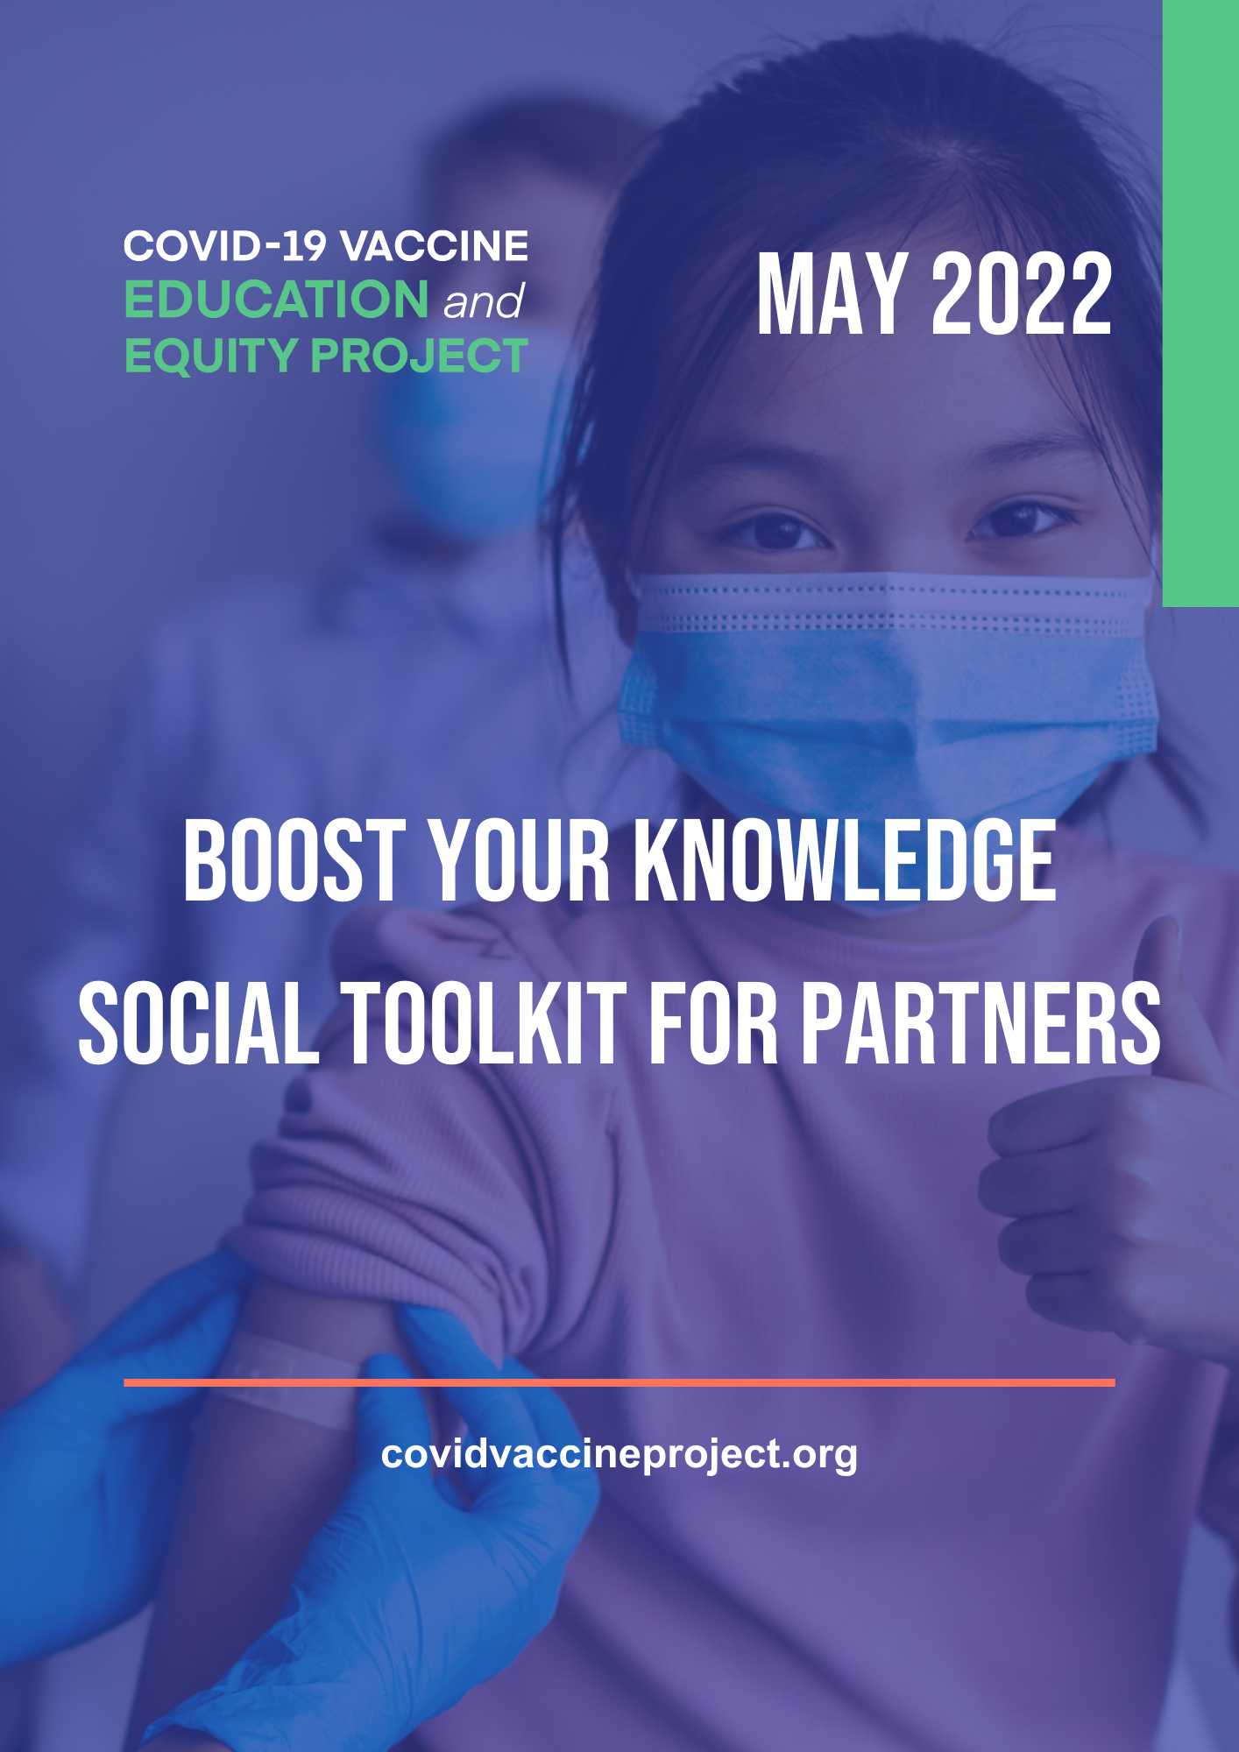
OVERVIEW
Given the recent booster guidance and vaccination rates, our coalition is continuing to provide our partners with resources and materials to help build trust and confidence in COVID-19 vaccines, including boosters. This toolkit contains links to the infographic, accompanying social graphics and suggested post copy [both evergreen and time-sensitive] to use when posting to social channels. To access this toolkit and graphics in Spanish, click here.

LINKS TO INFOGRAPHIC

Below, please find links to our English and Spanish versions of the Boost Your Knowledge Infographics, which are also available on our Resources webpage on our website.

English: https://bit.ly/3Pr4m17.

Spanish: https://bit.ly/3NBr2tX.

SOCIAL GRAPHICS

Below, please find downloadable social graphics sized for every platform, accessible here.
- Facebook
- Twitter
- Instagram
- LinkedIn
Graphics sized for Instagram and Facebook Stories are also available for download, accessible here.
SUGGESTED SOCIAL POSTS

FACEBOOK

Evergreen Content
- Building trust and confidence in #COVID19 #vaccines and #boosters starts by meeting people where they are. That’s why we’re joining @COVIDVxProject to address and dispel common #vaccine myths by sharing the facts. Share this post to help #BoostVxKnowledge and learn more here: https://bit.ly/3Pr4m17.

- Misinformation online continues to be a barrier to equitable access and uptake of #COVID19 #vaccination, including #boosters. We’re working with @COVIDVxProject to reduce these barriers and increase confidence in #vaccines by dispelling myths with reliable and accurate facts. Learn more about ways you can help #BoostVxKnowledge with the latest infographic: https://bit.ly/3Pr4m17.

Time-Sensitive Content
- With #boosters recently authorized for children 5-11, it’s all the more important that we continue to disseminate accurate and reliable #COVID19 #vaccine information. That’s why we’re joining @COVIDVxProject to dispel common myths with resources that #BoostVxKnowledge and trust. Access the full infographic here: https://bit.ly/3Pr4m17.

- Approximately 1 in 3 Americans 65+ who completed their initial vaccination round still have not received a first #booster shot. To address low uptake among vulnerable populations, we’re joining @COVDVxProject to dispel common myths with shareable resources that help improve equitable #COVID19 #vaccine education across all age groups. Share this post to help #BoostVxKnowledge and access the full infographic here: https://bit.ly/3Pr4m17.

TWITTER

Evergreen Content
- Building trust and confidence in #COVID19 #vaccines and #boosters starts by meeting people where they are. That’s why we’re joining @COVIDVxProject to dispel common #vaccine myths. Share this post to help #BoostVxKnowledge and learn more here: https://bit.ly/3Pr4m17.

- Misinformation is an ongoing barrier to equitable access and uptake of #COVID19 #vaccination, including #boosters. We’re working with @COVIDVxProject to increase #vaccine confidence. Learn how you can help #BoostVxKnowledge with our latest infographic: https://bit.ly/3Pr4m17.

Time-Sensitive Content
- With #boosters recently authorized for children 5-11, it’s important that we continue to share accurate and reliable #COVID19 #vaccine information. That’s why we’re joining @COVIDVxProject to #BoostVxKnowledge. Find out more: https://bit.ly/3Pr4m17.

- #DYK? Nearly 1 in 3 Americans over 65 have not received a #booster after completing their primary vaccination series. That's why we're joining @COVDVxProject to dispel common #vaccine myths with resources that promote trust. Learn more: https://bit.ly/3Pr4m17. #BoostVxKnowledge

INSTAGRAM
*Recommendation: Add the link to the infographic to your organization’s link in bio or use as a link sticker in when sharing any Stories.

Evergreen Content
- Building trust and confidence in #COVID19 #vaccines and #boosters starts by meeting people where they are. That’s why we’re joining @COVIDVxProject to address and dispel common #vaccine myths by sharing the facts. Share this post to help #BoostVxKnowledge and learn more with the latest infographic at our #linkinbio.

- Misinformation online continues to be a barrier to equitable access and uptake of #COVID19 #vaccination, including #boosters. We’re working with @COVIDVxProject to reduce these barriers and increase confidence in #vaccines by dispelling myths with reliable and accurate facts. Learn more about ways you can help #BoostVxKnowledge with the latest infographic at our #linkinbio.

Time-Sensitive Content
- With #boosters recently authorized for children 5-11, it’s all the more important that we continue to disseminate accurate and reliable #COVID19 #vaccine information. That’s why we’re joining @COVIDVxProject to dispel common myths with resources that #BoostVxKnowledge and trust. Visit our #linkinbio for the latest infographic.

- Approximately 1 in 3 Americans 65+ who completed their initial vaccination round still have not received a first #booster shot. To address low uptake among vulnerable populations, we’re joining @COVDVxProject to dispel common myths with shareable resources that help improve equitable #COVID19 #vaccine education across all age groups. Share this post to help #BoostVxKnowledge and visit our #linkinbio to access the full infographic.
LINKEDIN

Evergreen Content
- Building trust and confidence in #COVID19 #vaccines and #boosters starts by meeting people where they are. That’s why we’re joining @COVID-19 Vaccine Education and Equity Project to address and dispel common #vaccine myths by sharing the facts. Share this post to help #BoostVxKnowledge and learn more here: https://bit.ly/3Pr4m17.

- Misinformation online continues to be a barrier to equitable access and uptake of #COVID19 #vaccination, including #boosters. We’re working with @COVID-19 Vaccine Education and Equity Project to reduce these barriers and increase confidence in #vaccines by dispelling myths with reliable and accurate facts. Learn more about ways you can help #BoostVxKnowledge with the latest infographic: https://bit.ly/3Pr4m17.

Time-Sensitive Content
- With #boosters recently authorized for children 5-11, it’s all the more important that we continue to disseminate accurate and reliable #COVID19 #vaccine information. That’s why we’re joining @COVID-19 Vaccine Education and Equity Project to dispel common myths with resources that #BoostVxKnowledge and trust. Access the full infographic here: https://bit.ly/3Pr4m17.

- Approximately 1 in 3 Americans 65+ who completed their initial vaccination round still have not received a first #booster shot. To address low uptake among vulnerable populations, we’re joining @COVID-19 Vaccine Education and Equity Project to dispel common myths with shareable resources that help improve equitable #COVID19 #vaccine education across all age groups. Share this post to help #BoostVxKnowledge and access the full infographic here: https://bit.ly/3Pr4m17.

HASHTAG SUGGESTIONS

- #BoostVxKnowledge
- #COVIDVxProject
- #COVIDVxEquity

TAGGING CVEEP IN POSTS
If you decide to share our graphics, please tag or mention @COVIDVxProject so that we may be notified and can help amplify. Here are links to our social platforms to follow (if not already following).
- Twitter
- Instagram
- LinkedIn
- Facebook
- TikTok
About the COVID-19 Vaccine Education and Equity Project
The COVID-19 Vaccine Education and Equity Project – a coalition of over 230 patient, provider and public health organizations have come together to advance public education and equity around COVID-19 vaccines. The project’s efforts center around advancing vaccine access and equity within the United States and is convened by the Alliance for Aging Research, HealthyWomen, and the National Caucus and Center on Black Aging.
Together, our members represent a broad and diverse range of stakeholders including nurses, teachers and first responders, who are critical to building confidence in the process and science around COVID-19 vaccines, which is key for authorized vaccines to be a contributor to addressing health inequities.
Not yet a member? Joining is easy – click here to sign-up today!

