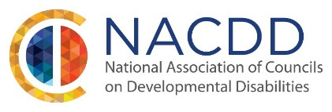
April 28, 2022

Dear Member Councils:

The Nominations Committee is working to develop a list of candidates for the NACDD Board of Directors. To that end, we are seeking qualified individuals from the membership to register their interest in becoming nominees.

Three At-Large Director positions, plus the Secretary position, will be open for a term of two years (October 1, 2022-September 30, 2024). In addition, we have one year terms open for Vice President and Treasurer. Those who are nominated for the VP and Treasurer position will complete one year and then be able to run for a full two-year time in 2023.

The Nominations Committee will review nomination forms to determine that nominees meet the qualifications stated in the organization’s bylaws. A list of nominees will be presented to the Membership Assembly at least 30 days in advance of the upcoming General Assembly meeting. We will be holding the Assembly Meeting on July 20th in Washington DC and online. It is important to please note that nominations may be made on behalf of others or by individuals who seek office themselves.

Individuals interested in being nominated are encouraged to complete and submit the attached form for consideration. The completed forms are due to the NACDD office by C.O.B. June 1, 2022. Please send by email to rtroutman@nacdd.org.

Enclosed is a description of the responsibilities of the various Officers and Board member positions. Please note that while the Board’s business is generally conducted on conference calls (at no cost to the Members or their councils), there is a need for councils to provide full support to the nomination of their council member or staff. A simple indication of this on the completed form is sufficient.

The Nominations Committee is charged with developing a list of nominees that represents the diversity of state and territorial councils. Further, the Committee encourages council members with developmental disabilities and council members who are family members to seek nomination.

On behalf of the Nominations Committee, we encourage all interested and qualified individuals to indicate your interest to serve in these important leadership positions. We look forward to the elections at the July meeting.

Sincerely,

NACDD Nominations Committee
Steve Gieber, Chair
Nancy Cronin Charles Hughes
Daintry Bartoldus
Val Bishop cc: Donna A. Meltzer, NACDD CEO

