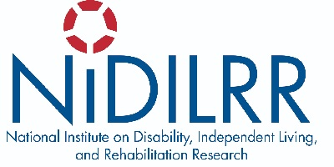

WEBINAR: Using the National Survey on Health and Disability (NSHD) to Explore the Experience of Social Isolation and Loneliness Among Rural and Urban People with Disabilities

Thursday, September 9, 2021

2:00 p.m. - 3:00 p.m. (ET)
Since the start of the COVID-19 pandemic all of us have experienced the changing nature of social connections, and many of us have gained personal insight into what it means to be socially isolated, lonely, or both. These are not new concepts that have resulted from the pandemic. However, the pandemic has likely made worse our experiences of social isolation and loneliness and challenged our beliefs about who is socially isolated and lonely. This is the third of a four-part national webinar series on research related to social isolation and loneliness for people with disabilities hosted by the National Institute on Disability, Independent Living, and Rehabilitation Research (NIDILRR). Join NIDILRR grantees Dr. Catherine Ipsen and Dr. Gilbert Gimm for a discussion on how barriers to social participation result in social isolation and loneliness for rural and urban people with disabilities.

Presenters:
- Catherine Ipsen, Ph.D.
Director, Research and Training Center on Disability in Rural Communities (RTC:Rural)
University of Montana Rural Institute

- Gilbert Gimm, Ph.D.
Associate Professor
Department of Health Administration
George Mason University

Webinar Registration closes September 3, 2021. Space is limited.

The webinar will include real-time captioning and American Sign Language remote video interpreting. Presentation slides will be emailed to attendees prior to the webinar. If you need other disability-related accommodations, please specify your needs on the registration form. If you have difficulties registering, please email events@1sourceevents.com.

#CommitToConnect

ACL.gov/CommitToConnect

