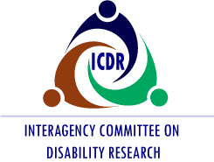 You’re Invited

Please join us for the Interagency Committee on Disability Research (ICDR) Lunch & Learn Webinar Series

Thursday, July 22, 2021

11:00 a.m. – 12:00 p.m. (ET)

Presentation: Getting Older is Not for the Weak; An Evidence-Based Approach to Improving Mobility

Objectives:
- Appreciate how medical deconditioning in older adults impairs functional mobility and increases rehospitalization risk
- Recognize the practical application of walking speed in predicting hospitalization risk and mortality
- Understand the benefits of high-intensity approaches to rehabilitation to improve patient outcomes and optimize value

Presenter
Jennifer Stevens-Lapsley, P.T., Ph.D.
Professor, Rehabilitation Sciences PhD Program Director
Department of Physical Medicine and Rehabilitation
School of Medicine
University of Colorado Anschutz Medical Campus

Audience
The audience will include a wide range of ICDR stakeholders, federal interagency partners, researchers, practitioners, disability organizations and ICDR Committee members.

Space is limited. Register now to reserve your spot and to receive instructions for joining the webinar. Registration closes July 16.

The webinar will include real-time captioning and American Sign Language remote video interpreting. Presentation slides will be emailed to attendees prior to the meeting. If you need other disability-related accommodations, please specify your needs on the registration form. If you have difficulties registering, please email events@1sourceevents.com.

