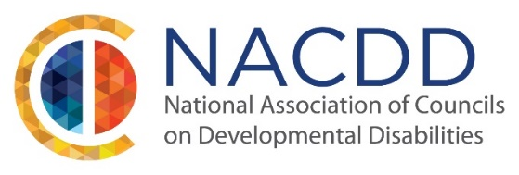
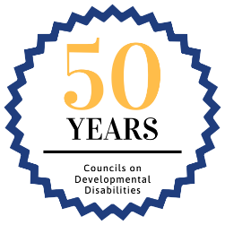

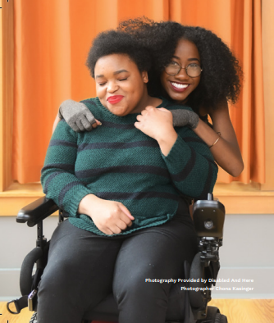
State/Territorial Councils on Developmental Disabilities work within state systems to promote community living free from discrimination for people with intellectual and developmental disabilities and their families. Authorized by the Developmental Disabilities Assistance and Bill of Rights Act, Congress created State/Territorial Councils on Developmental Disabilities (DD Councils) so people with intellectual and developmental disabilities (I/DD) and their families could identify problems or gaps in state and federal support systems and create innovative solutions with community partners to improve outcomes for people with I/DD in long term supports and services, healthcare, employment, transportation, education, housing and more. DD Councils have over fifty years of success in investing in person-centered and family-centered innovations so people with I/DD can live their fullest lives in the community.

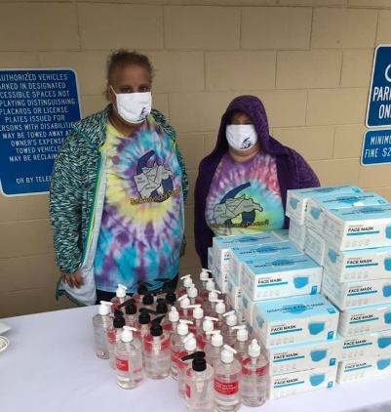
DD Councils were called upon by states to respond to COVID-19. During the pandemic, states were not prepared to meet the needs of people with I/DD who are at greater risk of illness and death due to COVID-19. States looked to DD Councils for solutions. DD Councils provided immediate support including: creating “plain language” public health information; advocating for non-discrimination in COVID testing, treatment and immunization; providing personal protective equipment (PPE) to people with I/DD and caregivers; providing subgrants for internet connection and devices to access telehealth; and more. For example, the California DD Council worked with over 400 community groups to distribute over 100 million pieces of PPE to people with I/DD including people in rural, tribal and immigrant communities.
Funding History:
Fiscal Year | FY15 | FY16 & FY17 | FY18 & FY19 | FY20 | FY21 | FY22 (Request)
Appropriations | $71.692M | $73M | $76M | $78M | $79M | ($85M)

FY 2022 Funding Request: NACDD requests that Congress appropriate $85 million for the DD Councils for FY 2022 within the Administration for Community Living (ACL) in the Labor-HHS-Education appropriations bill.

Report Language Request: NACDD also requests report language stating: “Technical Assistance – The Committee provides not less than $700,000 for technical assistance and training for the State Councils on Developmental Disabilities. The Committee requests that ACL report back to the Committee within 90 days upon enactment on implementation of this language.”

Justification: The past year underscored the critical role of the DD Councils to meet the needs of people with I/DD so they can live safely in the community and free from discrimination. States called on DD Councils to create life-saving solutions to problems faced by people with I/DD during the pandemic. Many of the problems exposed systemic failures that must be fixed. This funding request reflects the increased need for direct resources through partnerships with local non-profits, businesses and state and local governments, to provide innovative and cost-effective strategies so more people with I/DD can become independent, self-sufficient and integrated into the community.
DD Councils’ COVID-19 Response And
Promoting Community Living in the States
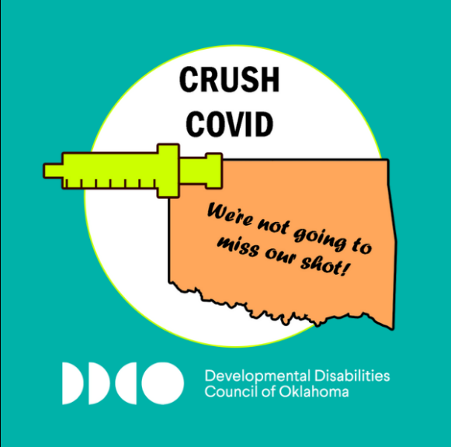
Oklahoma DD Council
The Developmental Disabilities Council of Oklahoma provided education, guidance, and resources for people with I/DD and their families throughout the course of the COVID-19 pandemic. They created and shared with their vast networks “plain language" documents in multiple languages with tips helping people with I/DD ‘FACE’ the pandemic together and used multiple media to promote encouraging thoughts, healthy routines, dealing with emotions, connecting through technology, and more. They continued a partnership with OKStable to inform people about COVID relief checks and the benefits of using ABLE accounts to protect their eligibility for federal benefits -- resulting in more Oklahomans getting ABLE accounts. Another COVID campaigns was to encourage people with I/DD to get vaccinated.
Washington State DD Council
In response to the hardship that COVID-19 has placed on people’s ability to stay connected and engaged, the Washington State DD Council invested in grants including: providing laptops and prepaid data cards for internet access for those without technology; promoting healthy living during COVID; and combating social isolation. ”Getting Healthy with Eric” is a DD Council funded video series for and by people with I/DD that explains the importance of nutrition and healthy habits during and after the quarantine.

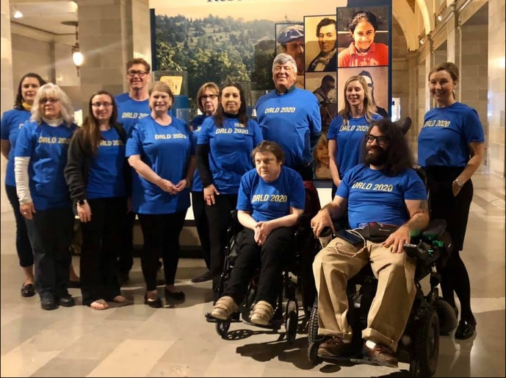
Missouri DD Council
The Missouri Developmental Disabilities Council has a mission "to assist the community to include all people with developmental disabilities in every aspect of life." Affordable and accessible housing is an essential need for people with I/DD. The Council supports community initiatives that result in persons with developmental disabilities having opportunities for housing. Missouri Inclusive Housing Development Corporation (MoHousing), a DD Council initiative supports individuals in their search for safe, affordable, quality housing. In March 2020, the DD Council advocated to members of the state legislature on the need for affordable housing, access to long term supports and more.
For more information on DD Council work in your state, visit www.nacdd.org or
contact Erin Prangley, Director, Public Policy at eprangley@nacdd.org.

