Developmental Disabilities Assistance and Bill of Rights Act (DD Act) Programs

Coronavirus Challenges, Response, and Needs

The coronavirus pandemic has altered the lives of American’s with intellectual and developmental disabilities in big and small ways. The developmental disabilities (DD) system nationally and in every state and territory has pivoted to meet crisis-related needs and are continuing the critical work to meet the needs of people with disabilities in all parts of life - health, education, employment, and community living.

Challenges
The World Health Organization and the Centers for Disease Control and Prevention have both articulated the increased risk of contracting COVID-19 for people with disabilities. Despite the lack of national data collection and reporting on rates of infection and death, we are now seeing news stories that reflect the disproportional impact from across the nation. People with disabilities often rely on a complex network of services to remain in their homes and communities. These systems are crumbling. People are rightfully being asked to stay home, yet this results in avoiding the community organizations that serve them. It also creates additional risks when direct support professionals enter their homes without proper personal protective equipment. Our networks are hearing from and responding to the impact of the COVID-19 pandemic on people of all ages with disabilities and their family members. The common challenges outlined below show what people with disabilities and their families are trying to navigate.

Services and supports have disappeared
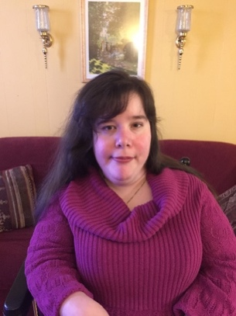
“Due to my condition, I am unable to care for myself. Prior to the Covid-19 pandemic, I received multiple support services. They included home health aide care (seven days a week, for 10 hours a day). Since the outbreak of COVID-19, our lives have changed drastically. My parents have to become my health care aides- leaving their own paid work because my home health aides are not coming to work as they fear contracting the virus, and it is impossible to get any replacements. This worries me greatly, because my mother suffers from a multitude of medical conditions, that makes taking care of me alone extremely difficult. They are also are now serving as my temporary physical and occupational therapists, since the center where I regularly receive treatment has temporarily closed. Now, my therapy sessions are 30 minutes each, and streamed through Facebook or Skype, while my therapist guides them through various stretches and activities to help keep me functional. While this is helpful given the situation, it is no replacement, for one on one in-person treatment!” - Danielle Lanzetta, Bronx, NY, person with cerebral palsy spastic quadriplegia

Educational support and therapy eliminated
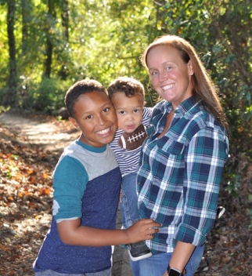
“The COVID-19 emergency has stopped all in-school sessions, Applied Behavior Analysis (ABA) services, speech, and occupational therapy and additionally rescheduling crucial in person doctors’ appointments for my son. I am worried about how much regression he will develop with the loss of services as some has already developed. Things we have worked years upon years to help him with that are slowly starting to appear again; which I can only guess will get worse as time goes on.” - Mandelyn Chelsea Cook-Jones, Dover AFB, DE, mother of ten-year-old Reagan, who has Autism Spectrum Disorder

Community activities and day programs shuttered
“I am a creative and active person who deeply values my friendships and family time. The COVID-19 emergency has stopped my opportunities to engage in sports, attend classes, show my artwork in art shows, spend quality time with my family and see my friends. I am worried about when I can see my friends again and when I can resume the activities that are most important to me in my life.” - Rich Mason, Laramie, WY, person with an intellectual/developmental disability

Lack of access to in-home or community support (Direct Support Professionals, aides, personal assistants, nurses)
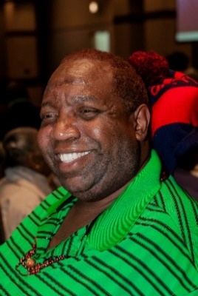
“I use a motorized wheelchair for mobility. I am a co-president of Project ACTION! an advocacy group in DC. Before the COVID-19 crisis, I received personal support services from a direct service provider (DSP) five (5) days a week from 8am-4pm, but haven’t received services lately, except for 4-6 hours once every 2 weeks. I do still receive periodic visits from a nurse to monitor my medical conditions. I’ve been told that the DSPs won’t come to my home because I live in senior housing and they’re afraid of being infected with COVID-19. I feel very isolated. This situation is extremely hard on me. I am forced to do tasks at home (such as bending and lifting while straightening up my apartment), which makes my back spasms worse. I don’t go outside of my apartment, except to get groceries, because no one is here to help me, and moving in my wheelchair hurts me. It is difficult to go out anywhere, including the lobby of my building, because everyone is afraid to interact with each other, for fear of becoming infected with the virus.” - Thomas Mangrum, Jr., Washington, person with a disability and other serious medical conditions

Medical appointments, therapy and others being canceled
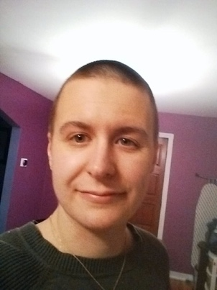
“I am caring for my partner, who has a brain injury, through his brain cancer treatment. Due to the COVID-19 emergency, my partner has been laid off. I work from home as a university professor. We are surviving on my graduate school stipend and unemployment compensation. My son had to go stay with grandparents because my partner and I are particularly vulnerable to the virus. Usually I get treated for my chronic illness every two weeks, but now my doctors won't treat me. The social isolation is also worsening my PTSD. I am worried that my chronic illness and PTSD will flare so badly that I won't be able to take care of my partner.” - Angela Adler, Pittsburgh, PA, person with chronic illness and post-traumatic stress disorder

Job loss and equitable access to financial assistance
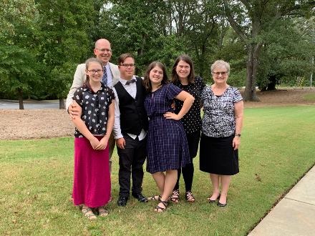
“Andy is an Eagle Scout, a high school graduate, and is usually an active member of our community. Before the COVID-19 emergency, he was volunteering in local food pantries about 18 hours per week, coaching lacrosse at the local high school about 10 hours per week, working 5-10 hours per week at the local grocery store, and starting a career as a photographer and just launched his website. The COVID-19 emergency has made it unsafe for him to continue working at his grocery store job and food pantries, the lacrosse season was cancelled, and he is selling very few photos with people needing to be conservative with their money. In addition, he has lost his community support staff member who helps him develop life skills because she is no longer able to visit our home. I am worried about our finances as both Andy and my self-employed husband have lost vital income. The pressure is largely on me to make up the difference, and I’m breaking.” - Stephanie Meredith, Canton, GA, mother of 20-year-old Andy, who has Down syndrome

Race and disability discrimination
“As a person of color and an immigrant, even though I am a legal immigrant, I fear there may be repercussions for sharing my struggles. I am a parent of a teenager with learning disabilities and emotional challenges. My partner and I do not speak English fluently and have struggled with understanding how, when, and where to get appropriate support for my child’s learning needs. Since my son was young, it was quite a challenge for us to secure help for his learning given the cultural, language, and knowledge barriers. We did not know about or even heard of an IEP. It took years for us to finally “catch up” and understand what types of rights we have. With the current COVID-19 situation, we are struggling all over again. Also, with my child’s anxiety, coupled with the level of discrimination Asian Americans have been receiving all over the country in New York, Texas, California, etc., ranging from receiving death threats to actual attempted murder, we are all struggling from crippling anxiety. It is no longer a struggle only exhibited by my child. My entire family, neighbors, friends are all anxious and living in fear.” - Anonymous by request

Mental health and Isolation
“The COVID-19 emergency has made it even harder for me to get services. I have anxiety and get very depressed and I cannot get a ride to get help or medication. I am worried about dying from COVID-19 and my mom died last year. I am afraid and sad. People were coming to see me but now they do not. I am very lonely.” - Mitch Simmons, Mechanicsburg, VA, person with an intellectual disability

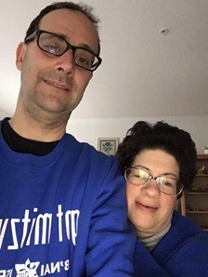
Not understanding information being shared about pandemic
“The COVID-19 emergency has me working from home. I am worried about getting help from staff coming into my home while ’stay home, saves lives.’ I need information about COVID-19 to be in plain language as it’s hard for me to understand and feel safe during these hard times if information is not accessible.” - Phil and Liz Weintraub, Rockville, MD, people with intellectual and developmental disabilities

Crisis Response
As the three networks mandated to coordinate activities under the Developmental Disabilities Assistance and Bill of Rights Act (DD Act) of 2000, University Centers for Excellence in Developmental Disabilities (UCEDDs), State Councils on Developmental Disabilities (Councils), and Protection and Advocacy Systems (P&As) operate in every state and territory. A foundational and intentional feature of these three programs is that they function as a developmental disabilities (DD) network drawing upon their unique roles to work in coordination and collaboration to respond to state and local needs. For decades, the DD Act has mandated that our members collaborate at the state and local level to advance our collective goals. Thus, our networks are being called upon by state and local systems to step in offering disability expertise, training, and direct service. These responses show what the DD network is doing to support people with disabilities and families navigate the common themes shared above.

University Centers for Excellence in Developmental Disabilities (UCEDDs)
Currently, there are 67 UCEDDs-at least one in every US state and territory-that are in a unique position to facilitate the flow of disability-related information between community and university. Centers work with people with disabilities, members of their families, state and local government agencies, and community providers in projects that provide training, technical assistance, service, research, and information sharing, with a focus on building the capacity of communities to sustain all their residents. During this pandemic, UCEDDs have continued to implement their core functions in this new environment. This is a snapshot and examples of work that is being done in every state and territory:

Provide Training
The Wyoming Institute for Disabilities (WIND) has addressed topics related to COVID-19 in their ECHO for Families learning community to teach families about resources, online learning and more.

Technical Assistance
The Wyoming Institute for Disabilities (WIND) has connected with state and local COVID-19 response teams to coordinate and collaborate with organization that work in public health and healthcare surrounding the response to COVID-19. Similarly, the Texas Center for Disability Studies serves on the Texas Department of Emergency Management Taskforce’s Disability Taskforce.

Service
The North Dakota Center for Persons with Disabilities bought WiFi hotspots to send home with staff and clients to make sure work can continue due to broadband access issues in rural areas of the state.

Research
The Idaho Center on Disabilities and Human Development, in partnership with the Council on Developmental Disabilities, Disability Rights Idaho, and the state Independent Living Center created a phone and online survey, to check-in with people with disabilities that they know. From simple questions of "How are you doing?” to “Do you need any help?”

Information Sharing
Multiple centers have developed and are disseminating information to communities and people with disabilities and their families. The University of Cincinnati University Center for Excellence in Developmental Disabilities created this Fact Sheet: Safeguard Against Discrimination. The Florida Center for Inclusive Communities developed the My Health Passport. The Center on Disability and Community Inclusion completed a white paper on Remote Use of Paraprofessional Supports for Students with Disabilities During COVID-19. The Carolina Institute for Developmental Disabilities created a package of social stories called Supporting Individuals with Autism through Uncertain Times.

State Councils on Developmental Disabilities (DD Councils)

State Councils on Developmental Disabilities are federally funded, and governor appointed entities that are made up of at least 60 percent people with developmental disabilities and families. For fifty years, DD Councils in every state and territory have worked with governors, state agencies, and self-advocates to improve the lives of people with developmental disabilities. In addition to serving as trusted advisers to governors and state agencies on matters of policy, the DD Act confers federal grant-making authority to DD Councils so they can put federal resources directly in the hands of both for-profit and non-profit local partners, as well as individuals and families, to create innovative solutions in the areas of health, employment, caregiving and more.
DD Councils are designed to maneuver quickly to identify immediate needs and administer targeted grants much faster and at less expense than it would take to set up new federal or state programs. In the past few weeks, DD Councils have repurposed their limited funds to provide emergency grants and cooperative agreements to trusted local organizations (for-profit and non-profit) to meet urgent needs. Here are a few examples of how the DD Councils are able to quickly respond to local needs.

Accessible Information
DD Councils in 34 states worked with state agencies to create or provided funding for accessible and plain language information for individuals with intellectual and developmental disabilities and their families (e.g. fact sheets, videos, and webinar) to fill communication gaps in public health information about COVID-19. These documents were also provided in different languages in 22 of these states. DD Council networks continue to develop more resources to get this critical information to individuals and families through their sub-grantee networks of hundreds of community-based organizations.

Emergency Funding to Community Organizations
Several DD Councils repurposed funds to support local needs. For example, the Illinois Council on Developmental Disabilities (ICDD), worked with trusted stakeholders to identify gaps in services for people with developmental disabilities and families due to the COVID-19 pandemic, complete a due diligence selection process and successfully award over $260,000 in mini-grants to 33 community-based organizations in just three weeks. The projects funded by this initiative are time-limited demonstration projects to assist in filling gaps in emergency services and disruption of home and community-based support in areas including supporting caregivers (providers and family supports) and bridging the digital divide to combat social isolation and facilitate access to services.

Access to Personal Protective Equipment
DD Councils also identified supply chains for PPE and distributed them to families with children with medical needs, individuals with intellectual and developmental disabilities and their families, and home and community- based service providers to make the community safer. For example, the Nebraska Council on Developmental Disabilities, located within the Division of Public Health in the Nebraska Department of Health and Human Services, received an urgent request for personal protective equipment (PPE) from local service provider who needed the PPE to continue care for their clients with disabilities but did not have access to the state supply chain. Because the DD Council is independent from the state, they were able to quickly provide funding and procurement of 5,000 PPE for the provider. As a bonus, the provider received the PPE quicker than if they had been eligible for the more bureaucratic state supply chain that took weeks to procure PPE.

Protection and Advocacy Systems (P&As)
Protection and Advocacy agencies comprise the nationwide network of congressionally created and mandated, legally based disability rights agencies. P&A agencies have the authority to provide legal representation and other advocacy services, under federal laws, to all people with disabilities.

In these uncertain times, the work of the P&As to ensure that people with disabilities have access to needed services and supports and that their rights are not violated is more important than ever and P&As are working to fulfill this critical mandate and support the disability community. For example, P&A agencies around the country have been working to ensure that people with disabilities maintain access to medical care and are not discriminated against based on their disability. Additionally, P&A agencies have been working to ensure access to protective equipment for staff and individuals with disabilities who continue to live and receive services in congregate settings.

During this pandemic, additional funding is vital to ensure that P&A agencies across the country can continue to protect and advocate on behalf of all people with disabilities. Rights violations are and will happen under the emergency declarations as many policies are not taking people with disabilities into consideration. Only the P&As will be there to advise and protect people with disabilities.

Critical Needs
This pandemic has shined a light on the fragility of the DD service systems in our nation. It has resulted in increased demands and rapid response, new services that are currently entirely unfunded. Our network leverages federal funds for state-level funding through contracts, grants, and cooperative agreements. As state governments continue to struggle and our economy continues to plummet, state budgets are freezing putting at risk existing funding for all current work happening by the DD act state partners. Our networks have quickly shifted to offering much of their work remotely via virtual platforms, tele-health, etc. The missions of our networks is to advance policies and practices that improve the health, education, social, and economic well-being of all people with developmental and other disabilities, their families, and their communities through research, education, health, and service. This work has never been more critical. Our network is on the front lines in every state and territory. We must meet these critical needs through investments in the following ways:
- Fund Home and Community Based Services to meet the emergency needs of people with disabilities living in the community.
- Fund the systems that support people with disabilities, especially those with intellectual and developmental disabilities, including UCEDDs, Councils, and P&As.

Nearly half of developmentally disabled at state home infected with coronavirus; Group homes for disabled adults grapple with the spread of coronavirus; Illinois National Guard activated for COVID-19 response at Park Forest developmental center with more than 100 cases; It’s time to recognize the essential value of direct support professionals; ‘It’s Hit Our Front Door’: Homes for the Disabled See a Surge of Covid-19; Coronavirus Hits Texas Living Center For Disabled Persons

