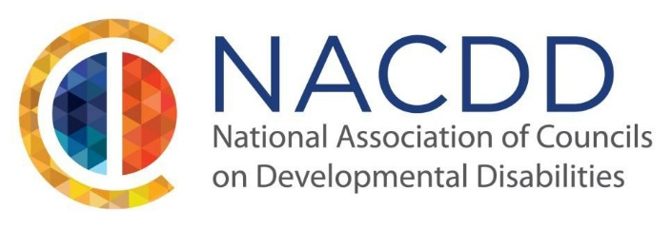

We are pleased to announce our 2020 Annual Conference:
Driving Disability Advocacy for the Next 50 Years
July 8-10, 2020
Capital Hilton, Washington, DC

2020 is an important year for the State and Territory DD Councils. We are celebrating 50 years of driving disability advocacy. What better way to celebrate our accomplishments than at the NACDD 2020 Annual Conference.

NACDD invites individuals with disabilities, their families, educators, researchers, service providers, employers, policymakers and others involved in supporting individuals with disabilities to submit ideas for sessions related to this year’s theme: Driving Disability Advocacy for the Next 50 Years. We are looking for presentation topics that are innovative, impactful, and inspiring. Topics may include, but are not limited to:

- Employment
- Education
- Self-advocacy/Family advocacy
- Community inclusion
- Leadership strategies and skill building
- Disability policy
- Innovation/technology
- Transportation
- Caregiving workforce and crisis
- Dual diagnosis

NACDD places an emphasis on having presenters that reflect the full diversity of our nationwide network of DD Councils. We encourage proposals that feature advocates taking action on issues of importance, demonstrating leadership strategies, and affecting the systems that support people with disabilities. In addition, we highly encourage sessions to be facilitated by people with and without disabilities.

The audience of NACDD’s Annual Conference consists of Council members and staff, self-advocates, family members, federal and state government employees, and other members of the disability and civil rights community.

Presenters are required to register for the conference. Accepted presenters are responsible for their own transportation, hotel, and registration costs. If you are in need of financial assistance, please contact your state or territory DD Council, as they may be able to offer assistance. If a presenter intends to participate in the entire conference, registration fees apply.

If you have a proposal that supports the conference theme, please complete the submission form and send it to conference@nacdd.org by March 13, 2020. For any questions, please reach out to NACDD staff at 202-506-5813.

