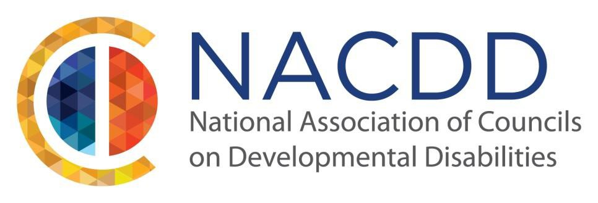

We are pleased to announce our 2019 Annual Conference:

Jazz it Up! Building on Our Potential

July 10-11, 2019
The Sheraton
New Orleans, LA

NACDD invites individuals with disabilities, their families, educators, researchers, service providers, employers, policy makers and others involved in the disability community to submit ideas for sessions related to this year’s theme: Jazz it Up! Building on Our Potential. We are looking for presentation topics that are innovative, impactful and inspiring. Topics may include, but are not limited to:
- Employment
- Education
- Self-advocacy
- Community integration
- Leadership strategies and skill building
- Disability policy

NACDD places an emphasis on having speakers that reflect the diversity of our nationwide network of 56 DD Councils. We encourage that proposals feature advocates taking action on issues of importance, demonstrating leadership strategies, and impacting the systems that support people with disabilities.

The audience of NACDD’s Annual Conference consists of Council members and staff, self-advocates, family members, federal and state government employees, and other members of the disability and civil rights community.

Presenters are required to register for the conference. Accepted presenters are responsible for their own transportation, hotel and registration costs. If you are in need of financial assistance, please contact your state or territory DD Council as they may be able to be of some assistance. If a speaker intends to participate in the entire conference, registration fees apply.

If you have a proposal that supports the conference theme, please complete the Submission Form and send it to conference@nacdd.org by March 8th 2019

