Understanding Advocacy

through the DD Council Lens

NACDD/ITACC, in collaboration with AIDD, and NACDD’s Self-Advocacy Committee (SAC) developed a resource designed to enhance the understanding of advocacy from the unique perspective of DD Councils.

Dear Colleague:
To continue our efforts in supporting advocacy across all states and territories, NACDD/ITACC has, in collaboration with AIDD, and NACDD’s Self-Advocacy Committee (SAC) developed a resource designed to enhance the understanding of advocacy from the unique perspective of DD Councils. The “Understanding Advocacy through the DD Council Lens” provides Councils with clear guidance on the three mandated self-advocacy requirements in the DD Act, outlines examples of the many ways that Councils impact advocacy, and offers a complimentary glossary and resources list.
Each individual best defines advocacy/self-advocacy and to that end; this is not a “definition” of self-advocacy but rather is a resource that can be used in collaboration with state self-advocacy organizations to develop work plans, new Council member orientation, and so much more. The resource is being offered in an editable format as well to accommodate each individual state and territory with regard to accessibility, formatting and diversity.
NACDD offers its sincere gratitude to all committee members, self-advocacy organization leaders and Andrew Morris, MPD, Administration for Community Living, US Department of Health & Human Services for their diligent work on the priority area of advocacy and self-advocacy. Please utilize this resource, customize it for your state or territory and share your feedback. As always, we welcome your input.
Sincerely,

Understanding Advocacy through the DD Council Lens
There are 56 Councils on Developmental Disabilities in the United States and select territories. The Councils are funded through grants authorized under Subtitle B of the Developmental Disabilities Assistance and Bill of Rights Act of 2000. (DD Act)
NACDD’s Self-Advocacy Committee (SAC) was formed to support Developmental Disabilities Councils (Council) in their efforts to increase the participation of advocates in advocacy activities that are important to them, their families and the broader society.
The Understanding Advocacy through the DD Council Lens resource was developed to provide examples of advocacy activities that align with the three requirements of the DD Act, offer additional advocacy activity examples for families and other stakeholders and supply Councils and advocates with resources related to self-advocacy and leadership.
The Understanding Advocacy through the DD Council Lens is a resource for planning with advocates and advocacy organizations on ways to support and strengthen the advocacy movement in their states and territories and/or to provide examples of advocacy activities to Council members and the general public.
Please note, this resource does not cover all the different examples of how DD Councils can support advocacy. There are many advocacy-related activities that could be supported by DD Councils; this document only names a few.
The Understanding Advocacy through the DD Council Lens can be edited and personalized by your individual state/territory. Some examples include:
- Plain language
- Pictures and graphics
- State or territory specific advocacy activity examples
- Translation into other languages to reach diverse population

In order to further the use of this resource as a teaching tool, there are terms and phrases in bold and hyperlinked text throughout this document. Definitions and resources start on page 11.

Developmental Disability Councils cannot support lobbying, fundraising or activities that are strictly social in nature.
At a minimum, all Councils are mandated by the DD Act to support self-advocacy with the following three requirements:
- Establish or strengthen a program for the direct funding of a State self-advocacy organization led by individuals with developmental disabilities;
For states/territories that already have an established State self-advocacy organization, Councils can strengthen State self-advocacy organizations in a variety of ways, including but not limited to funding, in-kind support, training and technical assistance, or other supports. It is expected that the state self-advocacy organizations be developmental disability focused.
- Support opportunities for individuals with developmental disabilities who are considered leaders to provide leadership training to individuals with developmental disabilities who may become leaders; and
For this mandate to be met, people with developmental disabilities must provide the training to an audience of people with developmental disabilities. Opportunities may include, but are not limited to, conferences, workshops, leadership programs or other grant related activities/events.
- Support and expand participation of individuals with developmental disabilities in cross-disability and culturally diverse leadership coalitions.
DD Act, Section 124 (c)(4)(ii)(I-III)
Identify cross-disability and culturally diverse leadership coalitions and inform people with developmental disabilities of the opportunities to participate. Support for participation may include, but is not limited to, information about transportation resources, mentorship and training, public speaking resources, etc.
Cross-disability coalition = representation of individuals with multiple disabilities, not just developmental disabilities. Primary focus should not deter self-advocates from participating in other coalitions. Refer to the Administration for Community Living for other programs in your state.
Culturally diverse coalition = participants who represent a variety of ethnicities, nationalities or geographic region.
Leadership coalitions may include advocacy and/or policy boards, advisory committees, and other governing bodies.

(1) STATE SELF-ADVOCACY ORGANIZATION
Examples of Council support:
Provide funding and/or technical assistance to a State self-advocacy organization to support its members to advocate for policies that remove barriers to the full inclusion of people with developmental disabilities and their families.
Activity example #1: Council supports a coalition for supported decision making that includes the State self-advocacy organization, developmental disability provider agencies, State Independent Living Centers and other stakeholders to educate advocates and families through outreach, policy initiatives and an educational website.
Activity example #2: Council supports a meeting facilitator to collaborate with a State self-advocacy organization and other stakeholders to identify and develop system change activities for three areas important to people with developmental disabilities. (For example, employment, housing and transportation)
RESULT: State self-advocacy organization has the resources necessary to support bringing people and communities together to advocate for common issues. Self-advocates have the support they need to create change and improve upon services that impact important areas in their lives.

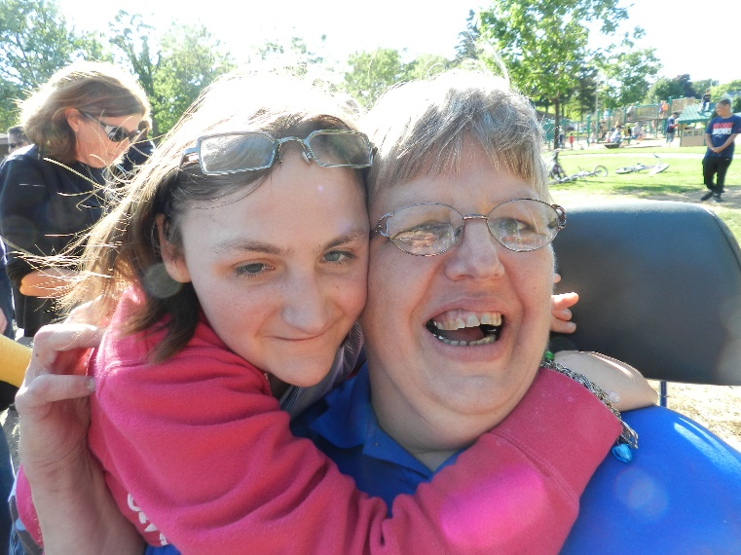

(2) OPPORTUNITIES FOR LEADERSHIP DEVELOPMENT AND TRAINING
Examples of Council support:
The Council supports a leadership training course where leaders with developmental disabilities train other advocates with developmental disabilities to become leaders in their own lives and communities.
Activity example #1: Local Leadership Model – Through a competitive process, Council awards funding for three leadership training initiatives in different parts of the state. Contractors provide hands on training during 6 workshops on varying leadership skills. Each participant is supported to complete a community project with lasting results.
Activity example #2: The Council provides opportunities for leadership training by people with developmental disabilities through sponsoring an advocacy and leadership break out session during a State self-advocacy organization’s annual conference.
RESULT: The self-advocacy movement is strengthened by increasing the leadership, advocacy and self-determination skills of people with developmental disabilities to engage in advocacy activities that support full inclusion in all facets of community life.

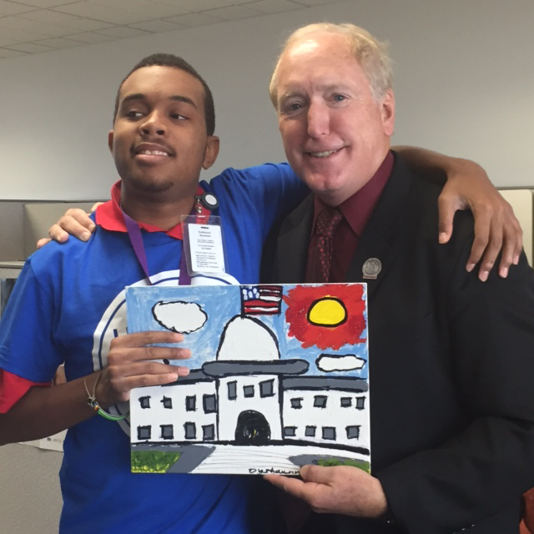

(3) CROSS-DISABILITY AND CULTURALLY DIVERSE LEADERSHIP COALITIONS
Examples of Council support:
The Council supports a State self-advocacy organization to train and educate local advocacy group members on the communication skills necessary to participate on cross-disability and culturally diverse leadership coalitions.
Activity example #1: Council supports State self-advocacy organization to collaborate with the Community Leadership Academy (CLA) to train people to be work group and coalition members by:
- Increasing advocate’s understanding of how be an active member
- teaching Roberts Rules of Order and other meeting procedures
- strengthening public speaking skills and other skills as needed to ensure meaningful productive participation
Activity example #2: The Council creates an Advocate Involvement Fund (AIF) to provide resources, access and opportunities for advocates to participate in cross-disability and culturally diverse coalitions, committees and other meetings. The AIF promotes productivity, advocacy and community inclusion by supporting advocates to meaningfully participate in the design of policies and services that impact their everyday lives.
RESULT: People with developmental disabilities and their families benefit from programs, services and supports that meet their needs and foster independence, productivity and success.

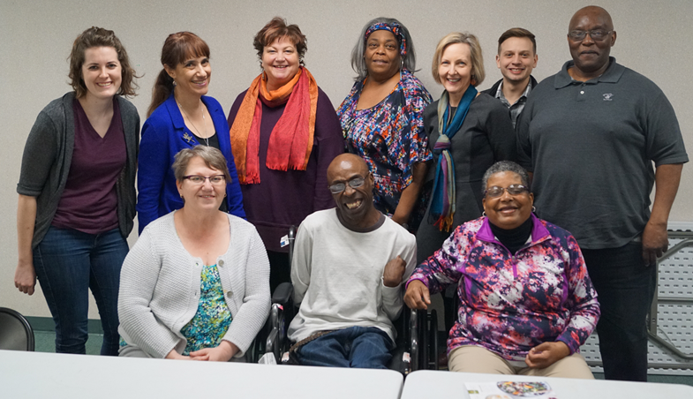

“Other” Ways that DD Councils Impact Advocacy
In addition to the three mandated advocacy requirements, Councils use many different ways to empower people with developmental disabilities and their families to advocate for themselves and others. Below is a list of just some of the other ways Councils support people with developmental disabilities and their families with regard to advocacy, capacity building and systems change.
INDIVIDUAL ADVOCACY: INCREASING SELF-ADVOCACY & SELF-DETERMINATION (Advocacy activities)
Example of Council support:
Support a Youth Leadership Program to work with community-based organizations to provide leadership training for young adults.
Activity example #1: Fund the development of a comprehensive curriculum for youth with and without developmental disabilities to learn side by side about self-advocacy, self-determination and leadership skills.
Activity example #2: Use curriculum to educate youth advocates and provide advocacy opportunities for youth to practice their newly learned skills. Track the advocates efforts after completion of the curriculum.
RESULT: Youth of all abilities, have skills to use their voices to advocate for themselves and others which strengthens the civil rights/disability rights movement, increases awareness and promotes community inclusion.
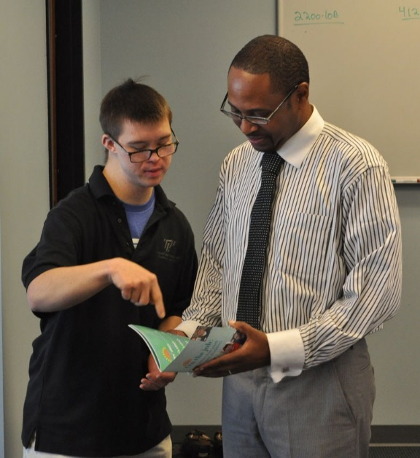

FAMILY ADVOCACY: INCREASING FAMILY ADVOCACY SKILLS
Example of Council support/Targeted Disparity: (Unserved/underserved)
Support an initiative that increases the advocacy skills of Hispanic parents of children with developmental disabilities.
Activity example #1: Council grantee provides culturally competent training and education for Hispanic families of children with developmental disabilities who use English as a second language to increase their ability to advocate for inclusive education services.
RESULT: Hispanic family members have the skills they need to advocate for inclusive education for their children.
Activity example #2: Council facilitates interagency collaboration among education systems and Hispanic community organizations to reduce cultural barriers to resources and information about education rights. For example, collaboration leads to written materials on the Individuals with Disabilities Education Act (IDEA) being provided in the family’s native language and dialect.
RESULT: School systems and cultural organizations increase their ability provide access to community services and supports to Hispanic families of children with developmental disabilities.

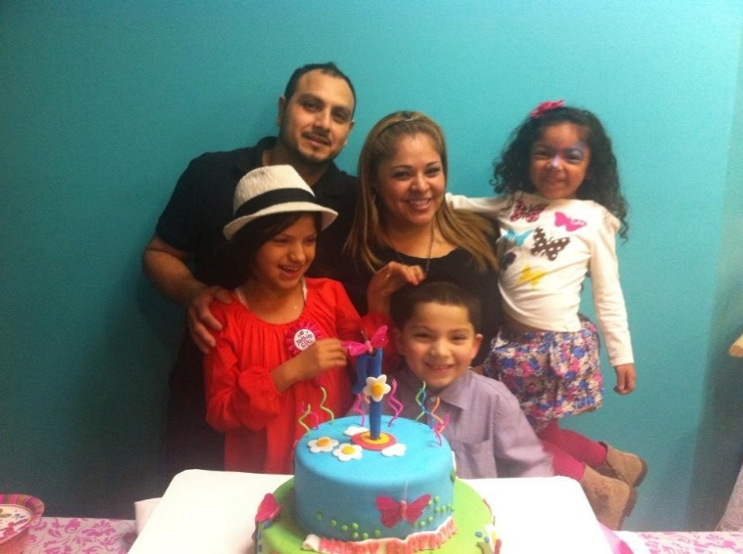

ADVOCACY THROUGH CAPACITY BUILDING: INCREASING EMPLOYMENT OUTCOMES (Capacity building)
Capacity building can be achieved on an individual level, group level or organizational level.
Example of Council support:
Empower advocates to learn about inclusive employment options and how to advocate for their employment wants and needs.
Activity example #1: Educate people with developmental disabilities on how to self-direct their careers and advocate for the advancement of paid, integrated employment. (Capacity building individual)
RESULT: There is an increase in the number of people with developmental disabilities who have the knowledge and skills to advocate for supported employment or self-employment in the community.
Example of Council support:
Support an initiative that builds the capacity of service providers to increase employment outcomes for people with developmental disabilities.
Activity example #2: Use training and technical assistance to support organizational change for service providers to offer community integrated employment services and supports for people with developmental disabilities.
Activity example #3: Facilitate the development of a Learning Community to engage in peer-to-peer support between service providers to collaborate and share successes, challenges, strategies and best practices. (Capacity building organizational)
RESULT: Service providers have the capacity to make sustainable changes to their organization that promotes integrated employment.
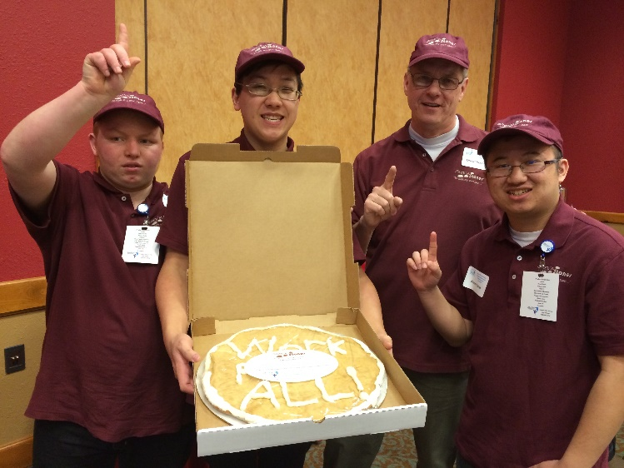

ADVOCACY THROUGH SYSTEMIC CHANGE: IMPACTING POLICIES AND SYSTEMS (Systemic change activities)
Example of Council support:
Utilize Council members, staff and other advocates to monitor legislation and organize advocacy activities that result in long-standing changes of systems important to people with developmental disabilities and their families.
Activity example #1: In collaboration with the statewide self-advocacy organization, people with developmental disabilities, their families and others, develop and share a policy agenda that expresses their position on priority legislative issues.
RESULT: Policymakers at all levels have the resources they need to make informed decisions about policies, practices and systems that include the needs and desires of people with developmental disabilities and their families.
Activity example #2: People with developmental disabilities and their families will participate in legislative visits and other activities that directly connect them with policymakers. For example: Annual events such as Policy Advocacy Day at the Legislature and Take Your Legislator to Work Day.
RESULT: Legislators directly engage with people with developmental disabilities and their families to include them in the design and redesign of systems that impact their full inclusion in community life.

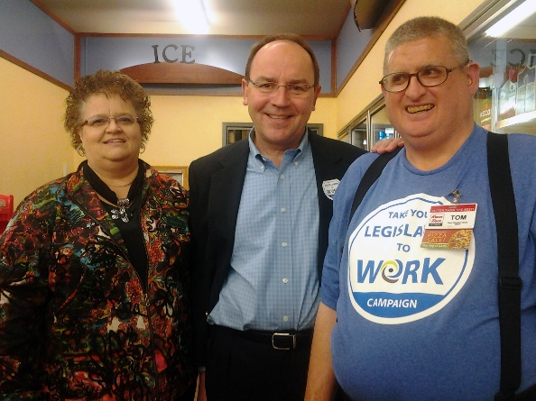

Definitions and Resources
This is not meant to be an exhaustive list of terms and resources. It is a specific list of items that support the “Understanding Advocacy through the DD Council Lens” accompanying document.
DEFINITIONS
DEVELOPMENTAL DISABILITY:
- IN GENERAL. —The term “developmental disability” means a severe, chronic disability of an individual that—
  - is attributable to a mental or physical impairment or combination of mental and physical impairments;
  - is manifested before the individual attains age 22;
  - is likely to continue indefinitely;
  - results in substantial functional limitations in 3 or more of the following areas of major life activity:
  - Self-care.
  - Receptive and expressive language.
  - Learning.
  - Mobility.
  - Self-direction.
  - Capacity for independent living.
  - Economic self-sufficiency; and
  - reflects the individual’s need for a combination and sequence of special, interdisciplinary, or generic services, individualized supports, or other forms of assistance that are of lifelong or extended duration and are individually planned and coordinated.
CULTURALLY COMPETENT: The term “culturally competent”, used with respect to services, supports, or other assistance, means services, supports, or other assistance that is conducted or provided in a manner that is responsive to the beliefs, interpersonal styles, attitudes, language, and behaviors of individuals who are receiving the services, supports, or other assistance, and in a manner that has the greatest likelihood of ensuring their maximum participation in the program involved. DD Act, Sec. 102 (7)
CROSS-DISABILITY COALITION: Representation of individuals with multiple disabilities, not just developmental disabilities. Primary focus not to deter self-advocates from participating in other coalitions. Refer to the Administration for Community Living for other programs in your state
CULTURALLY DIVERSE COALITION: Participants who represent a variety of ethnicities, nationalities or geographic region.
INCLUSION: The term “inclusion”, used with respect to individuals with developmental disabilities, means the acceptance and encouragement of the presence and participation of individuals with developmental disabilities, by individuals without disabilities, in social, educational, work, and community activities, that enables individuals with developmental disabilities to—
- have friendships and relationships with individuals and families of their own choice;
- live in homes close to community resources, with regular contact with individuals without disabilities in their communities;
- enjoy full access to and active participation in the same community activities and types of employment as individuals without disabilities; and
- take full advantage of their integration into the same community resources as individuals without disabilities, living, learning, working, and enjoying life in regular contact with individuals without disabilities. DD Act, Sec. 102 (15)
ADVOCACY ACTIVITIES: The term “advocacy activities” means active support of policies and practices that promote systems change efforts and other activities that further advance self-determination and inclusion in all aspects of community living (including housing, education, employment, and other aspects) for individuals with developmental disabilities, and their families. 45 C.F.R. § 1385.3 2015
SELF-DETERMINATION ACTIVITIES. —The term “self-determination activities” means activities that result in individuals with developmental disabilities, with appropriate assistance, having—
- the ability and opportunity to communicate and make personal decisions;
- the ability and opportunity to communicate choices and exercise control over the type and intensity of services, supports, and other assistance the individuals receive;
- the authority to control resources to obtain needed services, supports, and other assistance;
- opportunities to participate in, and contribute to, their communities; and
- support, including financial support, to advocate for themselves and others, to develop leadership skills, through training in self-advocacy, to participate in coalitions, to educate policymakers, and to play a role in the development of public policies that affect individuals with developmental disabilities. DD Act, Sec. 102 (27) (A-E)
CAPACITY BUILDING ACTIVITIES: The term “capacity building activities” means activities (e.g. training and technical assistance) that expand and/or improve the ability of individuals with developmental disabilities, families, supports, services and/or systems to promote, support and enhance self-determination, independence, productivity and inclusion in community life. 45 C.F.R. § 1385.3 2015
SYSTEMIC CHANGE ACTIVITIES: The term “systemic change activities” means a sustainable, transferable and replicable change in some aspect of service or support availability, design or delivery that promotes positive or meaningful outcomes for individuals with developmental disabilities and their families. 45 C.F.R. § 1385.3 2015
UNSERVED AND UNDERSERVED: The term “unserved and underserved” includes populations such as individuals from racial and ethnic minority backgrounds, disadvantaged individuals, individuals with limited English proficiency, individuals from underserved geographic areas (rural or urban), and specific groups of individuals within the population of individuals with developmental disabilities, including individuals who require assistive technology in order to participate in and contribute to community life. DD Act, Sec.102 (32)

RESOURCES
- Developmental Disabilities Assistance and Bill of Rights Act of 2000
- Administration for Community Living
- National Association for Councils on Developmental Disabilities (NACDD.org)
  - Advocacy, self-advocacy and leadership page
- The Art of Impact (startyourjourney.org)
- “Nothing About Us Without Us” Best Practices for Supporting Statewide Self-Advocacy Organizations was developed by NACDD’s Self-Advocacy Committee and numerous self-advocate leaders from advocacy organizations around the country. Accessible PDF
- Take Your Legislator to Work Day (ASPE.org)
- Information and Technical Assistance Center for Councils on Developmental Disabilities (ITACCHELP.org)
- Association of University Centers on Disabilities (AUCD) (AUCD.org)
- National Disability Rights Network (NDRN.org)
- Self-Advocacy Resource and Technical Assistance Center (SARTAC) (selfadvocacyinfo.org)

