U.S. Department of Homeland Security FEMA Region VII
9221 Ward Parkway
Kansas City, MO 64114

Stakeholder Toolkit

2017 Severe Weather Awareness

Severe Weather Awareness
The Federal Emergency Management Agency (FEMA), the America’s PrepareAthon! and the National Weather Service (NWS) will be highlighting the importance of preparing for severe weather during the spring.

Severe weather can happen during any season and impact any part of our country. Spring is a time of transition, when late-season snowstorms can impact the East Coast and the Northern Plains, thunderstorms rip across the South and Midwest, rivers overflow their banks and heat waves begin in the Southwest. Don’t let this dangerous season catch you unaware. Get ready for spring with just a few simple steps: Know Your Risk, Take Action and Be an Example.

In addition to asking Americans to learn their risks and take action to prepare through their own outreach channels, FEMA Region VII is encouraging everyone to get the word out and help the Whole Community prepare for severe weather.

This toolkit is designed to provide you and your organization easy to use tools to promote this campaign and help your stakeholders be better prepared for disasters.
Should you have any questions on this document, please contact Brenda.Gustafson@fema.dhs.gov.

Table of Contents
Talking Points 3
National Severe Weather Awareness 3
Quick Tips to Prepare 6
Make a Plan 7
Press Release Template 8
Online Resources 9
Logo and Poster 9
Download America’s PrepareAthon! Hazard Specific Posters and Promotional Tools 9
FEMA App 10
Social Media 11
Social Media Messaging 11
Severe Weather Awareness Tools 16

Talking Points

National Severe Weather Awareness

Key Message
- Know Your Risk: Droughts, floods, tornadoes, thunderstorm winds, hail, lightning, heat, wildfires, snowstorms – severe weather impacts every part of the country. The first step to becoming weather-ready is to understand the type of hazardous weather that can affect where you live and work, and how the weather could impact you and your loved ones.
- Take Action: Make an evacuation plan, build an emergency kit or update your existing kit and keep important papers and valuables in a safe place, and get involved in helping others prepare. You can begin by visiting Ready.gov.
  - PrepareAthon! is an opportunity for individuals, organizations, and communities to take action and prepare for specific hazards through drills, group discussions, training and exercises. The revamped website has forums, resources and built-in games that enhance the overall experience.
- Be an example where you live: Be a helpful influence on your community by sharing your weather preparedness story. Be a Force of Nature by letting your friends and family know what you did to become weather-ready and the steps they can take to do the same.
  - Register your actions at Community.fema.gov to officially be a part of America’s PrepareAthon!

Know Your Risk

- In 2016, there were several weather and climate disaster events, each with billions of dollars in losses. These events included a drought, floods, severe storms, wildfires, and a hurricane. Overall, these resulted in the deaths of over 100 individuals and had significant economic effects.
- What you can do:
  - Visit Ready.gov/be-informed to learn about the hazards that may impact your area.
  - Bookmark weather.gov to get the latest forecast information.
  - Follow @FEMAregion7 on Twitter.
  - Follow FEMA on Facebook and Twitter.
  - Follow the National Weather Service on Facebook and Twitter.
  - Read the State of the Climate reports to discover historical trends.

Take Action
- Make sure that you and your loved ones are prepared for severe weather. This includes creating a disaster supplies kit and making sure you can receive emergency messages.

- Here is what you can do;
  - Obtain a NOAA Weather Radio.
  - Download the FEMA smartphone app.
  - Learn about Wireless Emergency Alerts.
  - Think ahead of the weather and have a plan for traveling and staying in touch during emergencies
    - Plan out with your loved ones what to do in case of an evacuation.
    - It is essential to go over how everyone can communicate during emergencies.
  - Build an Emergency Kit and keep your supplies up-to-date.
    - An emergency supply kit is simply a collection of basic items your household may need in the event of an emergency.
    - Visit ready.gov/kit for a basic list of suggested items.
    - Try to assemble your kit well in advance of an emergency and make sure you have a way to take supplies with you easily.
    - You may have to evacuate at a moment’s notice and take essentials with you. Once a disaster hits, you will not have time to shop or search for supplies.
- Join the PrepareAthon! and take action by holding a drill, exercise, or preparedness discussion with the hazard specific playbooks available for the whole community. Register your actions to officially join America’s PrepareAthon!
  - Take action against Earthquakes
  - Take action against Floods
  - Take action against Tornadoes
  - Take action against Wildfires

Be an Example

- Be a Force of Nature and inspire others.
- Be a positive influence on your community by sharing your preparedness story.
- Building a nation of preparedness requires the action of all of us. Each and every person across the country has the potential to be an example and be ready.
- Studies show that individuals need to receive messages a number of ways before taking appropriate action.
- Many people are more likely to act when the messages they receive are from a trusted source - family, friends, or community leader.
- Share the actions you’ve taken to be prepared with your family and friends by posting your story on your social media site.
- Tweet that you’re prepared with the hashtag #MidwestReady, #RedCross, #Prepareathon, and #NWS
- Have an emergency plan, and know what to do before a disaster strikes. Post your plan in your home or business where individuals can see it.
- Find out from local emergency management how you can be notified for each kind of disaster and sign up for additional alerts through social media and local news.
- Using the America’s PrepareAthon! materials, you can lead a preparedness discussion, drill, or exercise in your home or workplace. Help others get informed and take action with you.

Quick Tips to Prepare

- Pick up some canned goods when your store has a sale, they’ll last a long time and ensure you’ll have something to eat. Remember: “Two is one and one is none”.
- Clean empty two-liter soda bottles and fill them with water or use bottled water.
- If it’s been 6 months since you got fresh water for your kit, rotate fresh water in.
- Write the date you bought items for your kit on them, it’ll help you keep everything fresh.
- Around the dinner table, talk to your loved ones about where you would meet in the event of different weather emergencies, both within and outside of your immediate neighborhood. Use the Family Emergency Plan to decide these locations before a disaster.
- Identify some pet-friendly hotels in case you have to evacuate.
- Program “In Case of Emergency” contacts into your phone and label them ICE in front of their name.
- Teach friends and family members to text on their cell-phones. Text messages can often get through when phone calls cannot.
- Make copies of important documents for your emergency kit (medications, medical info, proof of address, passports, birth certificates, insurance policies, etc.). Consider putting them on a flash drive as well.
- Get an extra set of house and car keys made for your emergency kit.
- Download the FEMA smartphone app.
- Teach everyone how to turn off the utilities in your house (electricity, gas, water, etc.) so they can do so in case of an evacuation.
- Make a checklist of everything that needs to be done in a disaster. Divide tasks up amongst your family. That way everyone has a responsibility and nothing gets missed.
- Sign up to receive text messages from FEMA and your local response officials.
- If you have a car, keep a full tank of gas in it if an evacuation seems likely. Keep a half tank of gas in it at all times in case of an unexpected need to evacuate. Gas stations may be closed during emergencies and unable to pump gas during power outages. Plan to take one car per family to reduce congestion and delay.

- Become familiar with alternate routes and other means of transportation out of your area. Choose several destinations in different directions so you have options in an emergency.
- Leave early enough to avoid being trapped by severe weather.
- Follow recommended evacuation routes. Do not take shortcuts; they may be blocked.
- Be alert for road hazards such as washed-out roads or bridges and downed power lines. Do not drive into flooded areas.
- If you do not have a car, plan how you will leave if you have to. Make arrangements with family, friends or your local government.

Make a Plan
- Background
  - It is important to plan in advance: how you will get to a safe place; how you will contact family and friends; how you will get back together; and what you will do in different situations.
  - Winging it is not an emergency plan. Sit down with your loved ones and talk through what to do in a disaster.
    - Discuss important factors like who to call, where to meet, and what to pack.
- Emergency Plan
  - Identify three places to meet family and friends in the event of an emergency. One in your neighborhood, one in your town, and one out of town.
  - Learn how you will get to your out of town location; determine your evacuation routes.
  - Write down information on important locations like workplaces, schools, daycares, houses of worship, etc.
  - Make sure you take into account everyone’s needs, such as any medical concerns, communications, etc.
  - Know how you will learn important information after a disaster (radio, warning sirens, reverse 911, etc.)
  - Share contact information with everyone (friends, family, and out of town contacts).

Press Release Template
<ORGANIZATION> is Encouraging Everyone to “Be a Force of Nature”
<Date>

Take the Next Step Severe Weather Awareness

<CITY, St.> – <INSERT ORGANIZATION> is proud to join and promote the campaign to spread the word and encourage <employees or residents> and the rest of the community to Be a Force of Nature by knowing your risk, taking action, and being an example where you live.
<INSERT ORGANIZATION> is <INSERT EVENT INFORMATION HERE> or <committed
to being a leader for emergency preparedness>.

The Federal Emergency Management Agency (FEMA), the Ready Campaign, PrepareAthon! and The National Oceanic and Atmospheric Administration (NOAA) are teaming up again to highlight the importance of preparing for severe weather before it strikes. During this spring take time to learn what hazards may impact you, taking action by making a kit and having a plan, and become an example where you live by sharing your actions.

Taking preparedness actions can save lives and protect property anywhere - at home, in schools, in your neighborhood, and in the workplace. In 2016, there were many weather and climate disaster events, each with losses exceeding $1 billion. These events included a drought, floods, severe storms, wildfires, and a hurricane. Overall, these resulted in the deaths of over 100 individuals and had significant economic effects.

Know your risk: Learn what hazards pose a risk where you live and work and their potential impact on you, your loved ones, and your community. Once you understand your risk, you are better equipped to take preparations. You can learn more about hazards in your area by talking to local officials or going to Ready.gov/Be-Informed. The National Weather Service has a great website explaining the basics of severe weather at Weather-Ready Nation and eye-opening statistics.

Take action: Develop an emergency plan and practice how and where you will evacuate if instructed by your emergency management officials. Post your plan in your home where visitors can see it. You can also take action with America’s PrepareAthon! by using the hurricane, tornado, flood, winter weather playbooks to conduct drills, group discussions, and exercises.

More information can be found at <INSERT ORGANIZATION WEBSITE or http://www.nws.noaa.gov/os/thunderstorm/ >. Information on the different types of hazards is available at Ready.gov or the Spanish-language web site Listo.gov.

# # #

Online Resources
FEMA, Ready, and NOAA recommend using social media tools as a way to promote “Be a Force of Nature”! You can promote the campaign and general preparedness through your own channels, or by promoting messages posted by the FEMA, Ready and NOAA accounts.

We have included some sample messages below that you can post on your own social media accounts to engage your friends/followers as part of the Be a Force of Nature campaign. More information and ideas on how to take action and be an example can be found on FEMA’s official Facebook, Twitter or Instagram accounts, Ready’s official Facebook or Twitter accounts, America’s PrepareAthon’s Twitter account, NOAA’s official Facebook or Twitter, National Weather Service’s official Facebook and Twitter account or FEMA Region VII’s Twitter account.

Logo and Poster

Download the Be a Force of Nature graphic for your website

- Use this square graphic to promote Severe Weather Preparedness
- http://www.nws.noaa.gov/com/weatherreadynation/files/force_of-Nature_icon.jpg

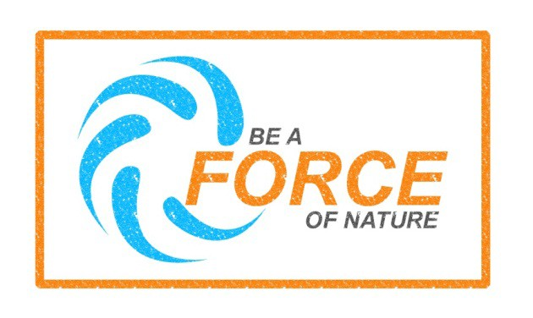

NOAA’s National Weather Service (NWS) National Seasonal Safety Campaign Badge for Spring Weather Safety. http://www.nws.noaa.gov/com/weatherreadynation/spring_safety.html

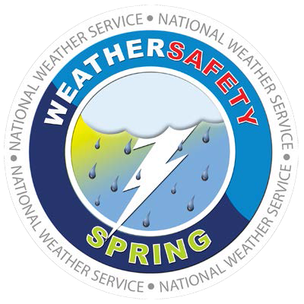

Download Hazard Specific Posters and Presentational Tools

- Tornado Promotional Materials
- Flood Promotional Materials
- Earthquake Promotional Materials

FEMA App (smartphone app for mobile devices)

The FEMA App contains disaster safety tips, interactive lists for storing your emergency kit, emergency meeting location information, and other disaster-specific information. The app is free to download through your smart phone provider’s app store on Android and Apple devices.

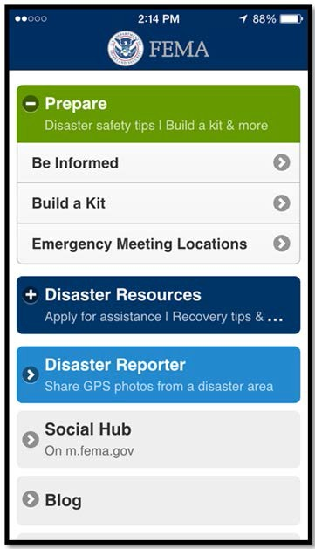

Social Media
FEMA, NOAA, and FEMA Region III will have messages on their Facebook and Twitter accounts throughout the spring.

You may follow and echo the messaging from these accounts.

- FEMA Region VII
  - Twitter
- FEMA HQ
  - Facebook
  - Twitter
- Ready
  - Facebook
  - Twitter
- America’s PrepareAthon!
  - Twitter
- NOAA
  - Facebook
  - Twitter
- NWS
  - Facebook
  - Twitter

Social Media Messaging

National Severe Weather Awareness
These messages are designed to be posted at any point during the spring. Feel free to adapt the messages to suit your needs.

General
- #severeweatherprep makes sense! Take your first steps today. www.ready.gov
- Weather-Ready Wednesday! Stay safe from spring hazards! http://1.usa.gov/1vjpwh8
#SpringSafetyPrep #WRW
- 39% of Americans live in areas of high-susceptibility to high-impact weather
#severewxprep http://go.usa.gov/cyKXR
- Need a widget? We have them for hurricane preparedness, flood insurance & more at http://www.fema.gov/widgets
- FEMA urges the use of weather radios. For programming information, visit @NOAA. http://go.usa.gov/h9sC

- #prepping makes sense for people who have special needs. http://go.usa.gov/cyKTk
- Why is your phone buzzing with weather warnings? Find out http://go.usa.gov/cyKTG
#SevereWxPrep #BeAForce #BePrepared

- If you use a power wheelchair, keep a light-weight manual wheelchair available for emergencies. http://www.ready.gov
- We can’t say it enough: know your evacuation routes! http://go.usa.gov/cyKYR
- Preparing your pets makes sense. #petlovers http://www.ready.gov/animals
- Don’t let bad weather sneak up on you! Check weather.gov every morning before you go out. #SevereWeatherPrep
- Know your risk: Be a force of nature by understanding the hazardous weather where you live! http://go.usa.gov/ybD #BeAForce @FEMA
- Be a force of nature & sign up for localized weather alerts by city, state or zip code http://go.usa.gov/ybD #BeAForce
- Severe weather takes many forms – What do you do to #prepare www.ready.gov/severe- weather #BeAForce
- Get a @NOAA weather radio to notify you of impending severe weather while you are indoors! #severewx #imprepared http://go.usa.gov/h9sC
- #TakeAction: Develop a family plan, make an #emergencykit & get involved in
#preparedness #BeAForce #GoBag
- www.Ready.gov/severeweather is your one-stop-shop for information to keep you and yours safe before, during & after #severewx!
- Do you have the basics in your emergency kit? Pledge to prepare and check this list: http://www.ready.gov/kit #prepping
- #Home #Work or #Car – build a #disasterkit http://go.usa.gov/yb0 Be a force of nature!
#BeAForce
- In #severewx, listen to @NOAA Weather Radio for comprehensive weather and emergency info. Learn more: http://go.usa.gov/yb9 #BeAForce
- Take action and be a force of nature – listen to your @NOAAWeather Radio http://go.usa.gov/yb9 #BeAForce
- Be an Example: Did you register your actions at www.ready.gov/prepare? Tell us your story and help others. #PrepareAthon #BeAForce
- Lightning Myths Busted in a Flash! http://go.usa.gov/cyKkw

Twitter Microburst

You can help The National Weather Service (NWS), The American Red Cross, and the Federal Emergency Management Agency (FEMA) Region VII by promoting Severe Weather Week (SWXW) on Social Media via a Microburst. A Microburst is a localized version of a Thunderclap, where all participants of SWXW will use the same identifying hashtag on multiple social media accounts and platforms, creating an impact on their immediate social media environment.

We’re planning on holding the Microburst on March 22, 2017 at 10:00am CDT to introduce SWXW across FEMA Region VII’s four state region; Iowa, Kansas, Missouri, and Nebraska. Please tweet/post (or have someone in your organization tweet/post) a message using the hashtags; #MidwestReady, #RedCross, #Prepareathon, and #NWS at 10:00am, using your organization’s official Social Media accounts? This will give SWXW the social media presence it deserves and drive attention to the importance of being prepared.

Using #MidwestReady as a search, you’ll be able to find others tweeting/posting similar messages. If everyone retweets/reposts each other’s’ messages, the Microburst’s affects will grow even larger. The idea is to generate a conversation between all of our participating organizations for a few minutes at the same time on March 22, 2017 at 10:00am CDT.

Feel free to use the hashtags in other tweets before and after March 22nd as well. We will continue using these hashtags during the entire month of March, culminating on March 31, 2017; using the hashtags throughout that entire time as well as the specified date and time will go a long way in increasing cross-recognition of all severe weather events, social media, and programs.

Specific Messages

Flood
- Prepare before a #flood by installing a water alarm in your basement. More tips: http://1.usa.gov/1poPE5S #PrepareAthon #BeAForce

- 30: The number of days it takes for #floodinsurance to begin. Don’t wait until it’s too late! http://1.usa.gov/15vEcTH #BeAForce
- Spread #flood awareness in your community with these creative promotional tools! http://1.usa.gov/1tylAZ2 #PrepareAthon #BeAForce
- Get your organization prepared for a #flood with the @PrepareAthon flood playbook: http://1.usa.gov/1tylCzY #PrepareAthon #BeAForce
- Flooding is an increased risk if you live close to sea level! Know your risk and prepare: http://www.community.fema.gov/hazard/flood/be-smart #PrepareAthon #BeAForce
- Anywhere it rains, it can #flood #beprepared #beready #BeAForce http://go.usa.gov/cyKTG
- What would you do if you have to evacuate? #knowbeforeyougo http://go.usa.gov/cyKYR
- Don’t wait until it’s raining cats and dogs to get #petprepared #petlover #catsanddogs http://www.ready.gov/animals
- Lack of flood preparedness got you down in the dumps? Never fear! #PrepareAthon has what you’re looking for! http://go.usa.gov/cyK4w
- Looking for a better way to get prepared? Go to #PrepareAthon for your #flood-prep toolkit needs! Read more at http://go.usa.gov/cyK4w
- How experienced are you in a flood situation? #CERT performs drills to ready the community! Read more at 1.usa.gov/1cowrMd #PrepareAthon
- Do you have a flood toolkit? Don't get washed away! #beprepared! Find your flood resources at http://go.usa.gov/cyK4w #PrepareAthon

Tornado
- Don't get it twisted! Tornadoes can occur with almost no warning; #getprepared w/
#PrepareAthon https://www.ready.gov/tornadoes #BeAForce
- Information can get twisted but click here for the truth! #justthefacts #BeAForce
#Tornadosafety http://go.usa.gov/cyK8j
- Lightning and hail are common in tornado weather. Learn what else to expect. http://go.usa.gov/cyK8j #BeAForce #PrepareAthon
- #Lightning #storms can be very striking. #BeAForce and #learnthetruth http://go.usa.gov/cyKkw
- Every state has some risk for tornadoes. Prepare today for what may come tomorrow.
#BeAForce https://www.ready.gov/tornadoes
- Live in a tornado-prone area? Practice going to your protective location often.
#PrepareAthon #BeAForce https://www.ready.gov/tornadoes

- Be sure that your loved ones are safe and sound after a #tornado! Have a meeting place or communication plan! www.ready.gov/make-a-plan
- Get your #tornado toolkit together today #knowledgeispower https://www.ready.gov/build-a-kit
- Get your #tornado warnings earlier when you register through America’s #PrepareAthon! Get your info here at https://community.fema.gov/
- #SafetyTip of the Day: Practice what to do if a tornado strikes by getting involved with
#PrepareAthon at https://community.fema.gov/

Facebook Messaging
- Be Smart. Take Part. Prepare. Register now to participate in America’s PrepareAthon! and provide details about the activities you’re planning for #SpringSafetyPrep. Share the steps you are taking to get yourself and your community prepared. Visit www.ready.gov/prepare for more information!
- It’s Weather-Ready Wednesday and spring has sprung! Stay safe from spring hazards including tornadoes, floods, thunderstorms, hail, lightning, heat, wildfires, rip currents and tsunamis. http://1.usa.gov/1vjpwh8 #SpringSafetyPrep #WRW
- Are you registered for America’s PrepareAthon? America’s PrepareAthon! is a national, grassroots campaign for action to increase community preparedness and resilience through hazard-specific drills, group discussions, and exercises. #SpringSafetyPrep www.ready.gov/prepare.
- Floods can happen at any time. Take simple steps to protect your family and property from the damaging impact of floods. Stay afloat by participating in America’s PrepareAthon! grassroots campaign by registering at: www.ready.gov/prepare
- Floods can occur during any season, especially if you live in a low-lying area, along a coast, or downstream from a dam or levee. Take action to prepare for flooding today by visiting the America’s PrepareAthon! website to access “How To Prepare” guides, toolkits, and creative materials to organize a preparedness event in your area: www.ready.gov/prepare
- Get ready for the next America’s PrepareAthon! Visit www.ready.gov/prepare today to register and take action to prepare your community for wildfires, floods, or tornadoes.
#SpringSafetyPrep #PrepareAthon

Instagram

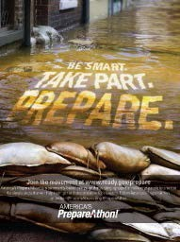
Flood
- #Flooded with so much preparedness information you don’t know what to do? Make it simple and register with America’s #PrepareAthon!
#fightfloods #beprepared #prepping #BeAForce
- Not sure what measures to take before a #flood happens? Register with America’s #PrepareAthon! to get in the know! #BeAForce #floodprep
#prepper #Fightfloods
- #Swimming in a flood of regret can be avoided if you sign up for America’s
#PrepareAthon! We can give you proper flood preparation tips!

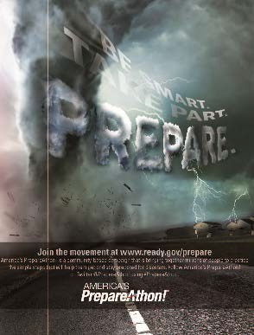
Tornado
- What would you do in a #tornado? #Beprepared and register for America’s #PrepareAthon!
- Don’t be swept away in #tornado confusion! Keep your feet firmly planted and sign up with #AP! America’s #PrepareAthon!
- Think of America’s PrepareAthon! as your Oz. If you sign up and follow our yellow brick road, we are sure to lead you to proper tornado preparedness!

Severe Weather Awareness Tools:

NOAA:

- Be a Force of Nature
- National Seasonal Safety Campaign

Articles
    - Lightning Myths
    - Tornado Myths

Presentation

Severe Weather

Weather Safety Web Sites
    - Severe Weather
    - Floods
    - Lightning
    - Heat
    - Wildfires

Ready:

- Ready.gov/Severe-Weather

What is severe weather? (Click for more information on each hazard)

- Tornadoes, Thunderstorms, and Lightning
- Floods

