Building Financial Independence: The ABLE Age Adjustment Act and Tools to Support Financial Empowerment

Webinar Date: April 14, 2026 | Time: 3:00 to 4:30 p.m. Eastern Time
Registration: https://us06web.zoom.us/webinar/register/WN_9B7JxJxqSg25hmk3loqGlg
Celebrate #ABLEtoSave, financial capability, and Autism Acceptance Month by joining the Disability Employment Technical Assistance Center and our partners for an empowering webinar on financial independence for people with disabilities. Hear from National Disability Institute’s ABLE National Resource Center (ABLE NRC) about recent updates to ABLE accounts and what they mean for individuals considering opening an account. The LEAD Center, a technical assistance provider funded by the Office of Disability Employment Policy, will highlight the Secure Your Financial Future toolkit, featuring financial literacy tools and resources designed to help all Americans, including individuals with disabilities, achieve greater financial stability at every stage of their employment journey. Plus, two ABLE ambassadors will share how using their ABLE accounts and the toolkit has helped them advance their independence within their communities.
Learning Objectives
- Understand the changes to ABLE, including the ABLE Age Adjustment Act, new contribution limit, and expanded age eligibility, and gain access to timely resources.
- Learn how to use the Secure Your Financial Future toolkit for informed financial decision-making in the current stage of your employment journey.
- Hear insights from ABLE ambassadors on how they use their ABLE accounts and the toolkit to support their financial independence.
Presenters
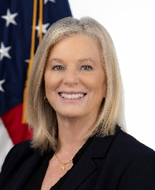 | 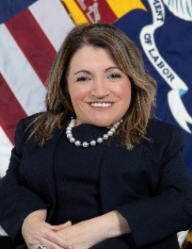 | 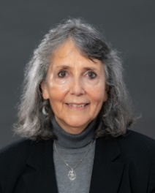
Rebecca Hines, PhD  Commissioner  Administration on Disabilities  Administration for Community Living | Julie Hocker, MBA  Assistant Secretary of Labor for Disability Employment Policy  U.S. Department of Labor | Rebecca Salon, PhD  Senior Advisor  LEAD Center  National Disability Institute
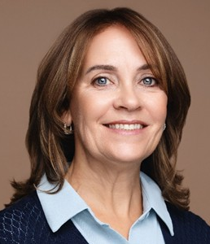 | 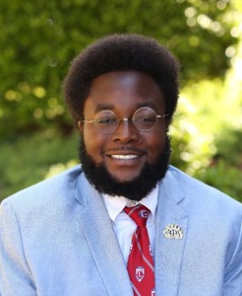 | 
Jody Ellis, MSW  Director  ABLE NRC  National Disability Institute | Edward Mitchell, MBA  Executive Director & ABLE Ambassador  Tennessee Statewide Independent Living Council | Hector Ramirez  Commissioner & ABLE Ambassador  California Commission on Disabilities

