Compressing Filled PPR Templates as ZIP File
- After completing data entry and saving your filled PPR forms, highlight your forms (files) and right-click.
- This will open a menu. {You may need to show additional options.]
- Click on “Send to” and “Compressed (zipped) folder.”
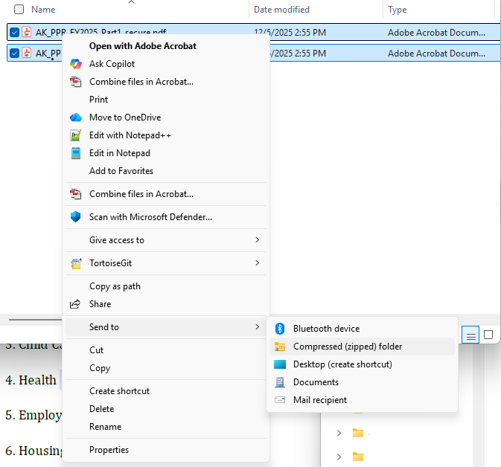
- This will create a new ZIP file (folder), which can be emailed.
