ABLE Accounts: A Pathway to Financial Empowerment
for People with Disabilities
Webinar Date: April 8, 2025 | Time: 3:00 pm to 4:30 pm Eastern Time (ET)
Presenters
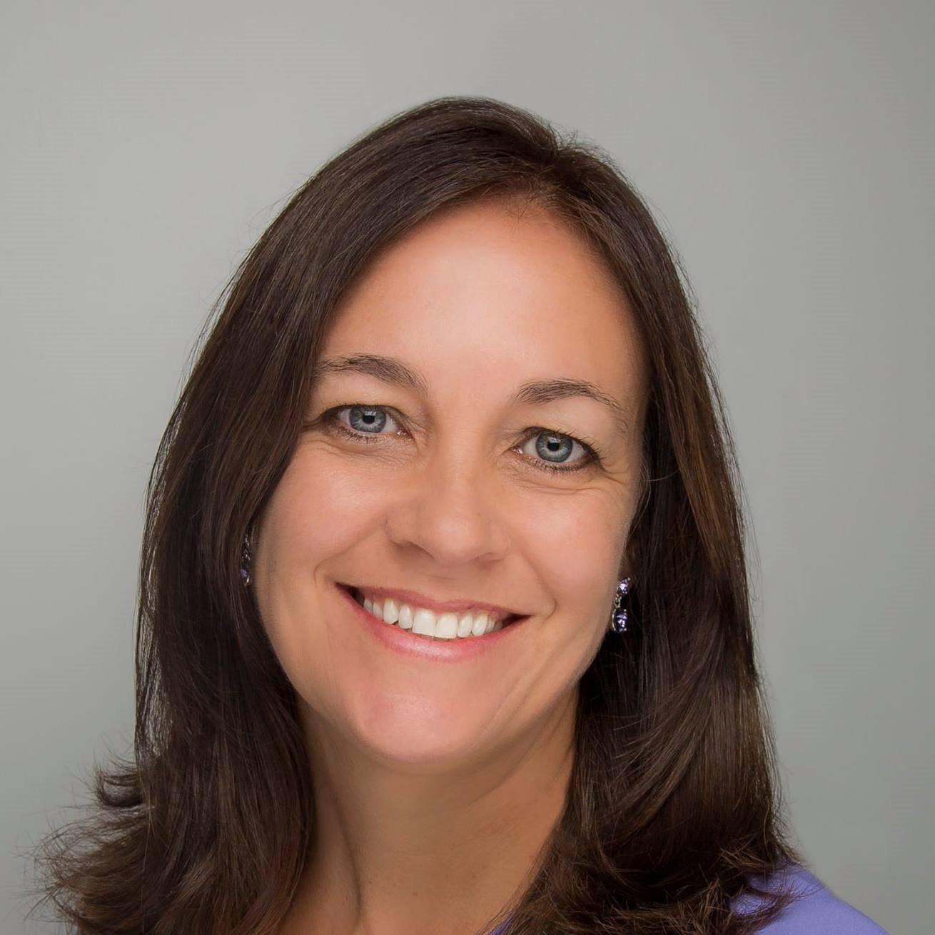 | 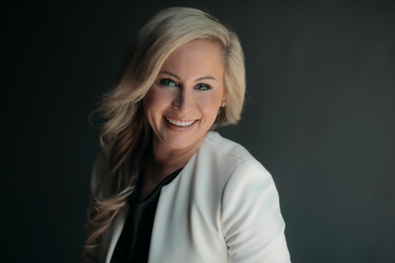 | 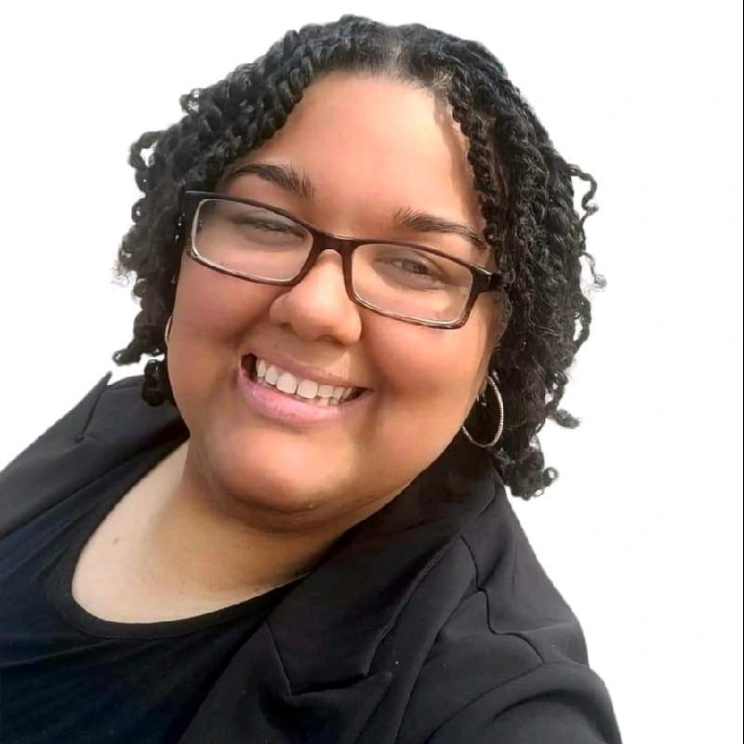
Jody Ellis  Director  ABLE NRC  National Disability Institute (NDI) | Sara Hart Weir  Executive Director  Kansas Council on Developmental Disabilities (KCDD) | Whit Downing  Vice President of Policy and Programming  KCDD
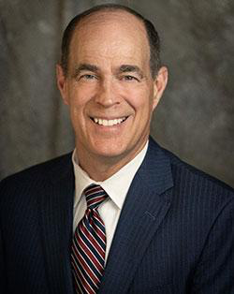 | 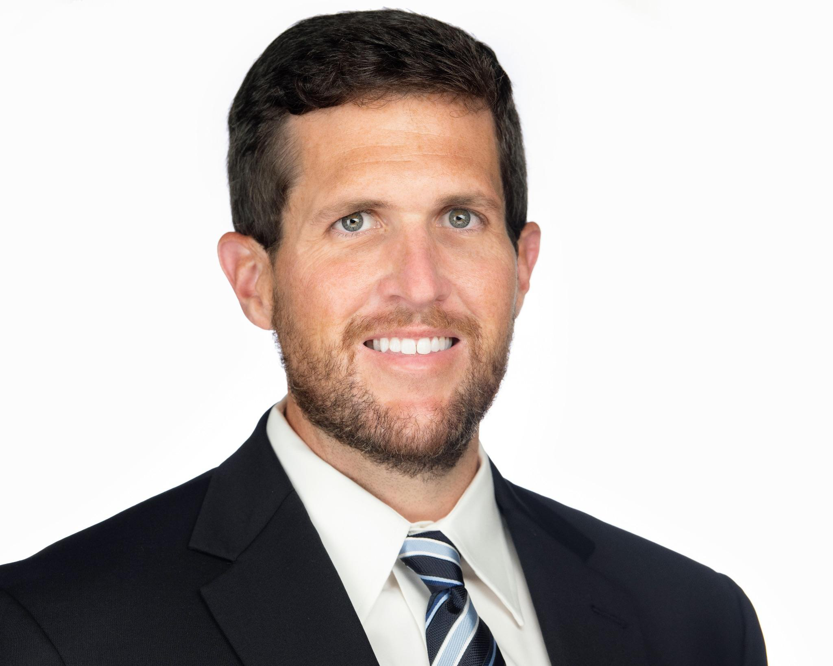 | 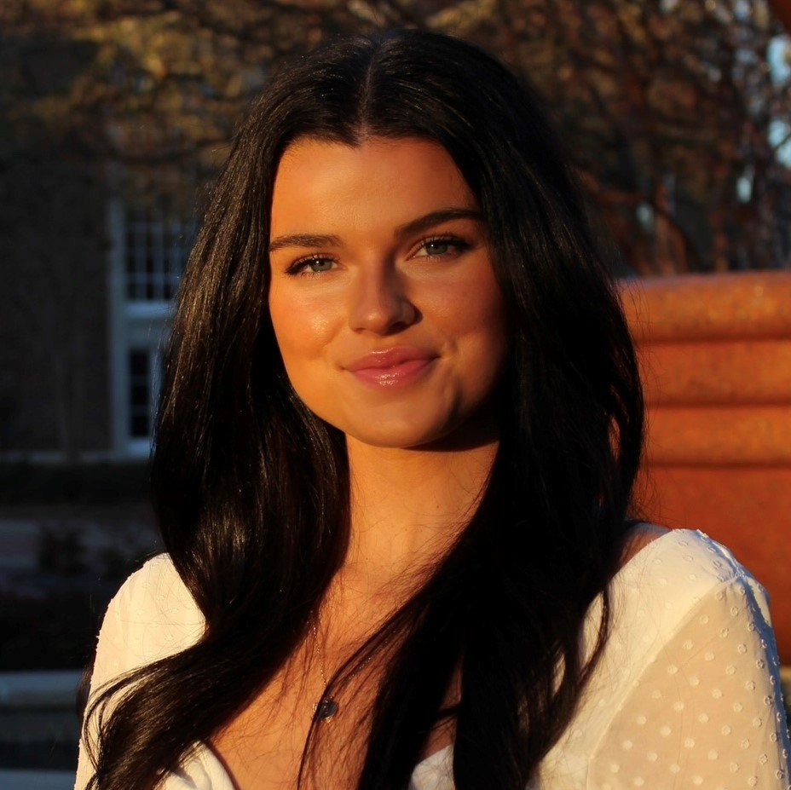
Steven Johnson  State Treasurer  Office of the Kansas  State Treasurer | Tom Treacy  Deputy Assistant State Treasurer  Office of the Kansas  State Treasurer | Allyson McCain  Deputy Director  KCDD
Register Here
https://us06web.zoom.us/webinar/register/WN_TICDnUe9Tkq5oVoN1tyQXg
April is National Financial Capability Month and #ABLEtoSave Month! Understanding how to manage money is crucial to financial independence for everyone. Come join the Disability Employment Technical Assistance Center (DETAC) to learn about Achieving a Better Life Experience (ABLE) accounts. An ABLE account is a tax-free savings and investment account owned by a person with a disability. In this webinar, the ABLE National Resource Center (ABLE NRC) will provide an overview about eligibility requirements, contribution limits, and how ABLE funds can be used. The webinar will then transition to highlight the innovative strategies the state of Kansas used to increase public awareness and adoption of ABLE accounts, which can be a model for other states. Finally, we will hear from an individual with lived experience on how she uses her ABLE account to help her succeed at work and live independently in the community.

