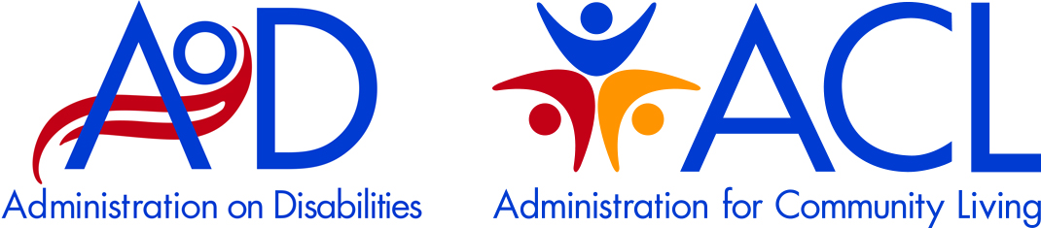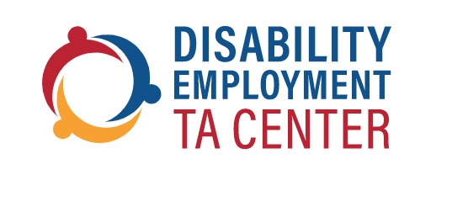

**Engaging Diverse Communities Through Financial Education and Empowerment**

**Webinar Date: April 16, 2024 | Time: 3:00 pm to 4:00 pm ET**

In April, join the AoD Disability Employment Technical Assistance Center (DETAC) for a webinar to increase awareness about National Financial Capability Month. Financial education is a key first step on the pathway towards financial health and wellbeing to live more independently in the community. The Illinois Council on Developmental Disabilities funded a three-year initiative with the National Disability Institute (NDI) called *Financial Wellness for People with Intellectual and Developmental Disabilities* (I/DD). The panel will highlight how this train-the-trainers model in Illinois provided training to individuals with I/DD and their family members to manage money, reduce debt, and use credit wisely. The training was customized based on individualized needs ranging from a short class to a 10-module curriculum. While we often focus on helping people with disabilities find jobs, this webinar will highlight a model to ensure we also provide a roadmap on the importance of making good financial decisions to further increase independence.

**Presenters**

|  |  |  |  |
| --- | --- | --- | --- |
|  |  |  |  |
|  |  |  |  |
| **Kimberly Mercer-Schleider**  Director,  Illinois Council on Developmental Disabilities | **Michael Roush**  Director,  National Disability Institute | **Tyson Bedford**  Council Member,  Illinois Council on Developmental Disabilities | **Curtis Harris**  Council Member,  Illinois Council on  Developmental Disabilities |

**Register at this link:**

<https://us06web.zoom.us/webinar/register/WN_M4FH6KMbSJ2LzhAZSJYhKA#/registration>