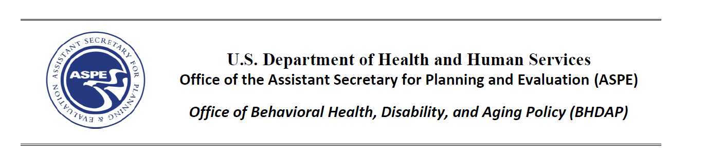
Integrated Dataset on Intellectual and Developmental Disabilities: Linking Data to Enhance Person-Centered Outcomes Research
Information Session and Question & Answer Sessions
Please join us for an information session hosted by the U.S. Department of Health and Human Services’ Office of the Assistant Secretary for Planning and Evaluation (ASPE), Office of Behavioral Health, Disability, and Aging Policy and RTI International to discuss the project, Integrated Dataset on Intellectual and Developmental Disabilities (iDIDD): Linking Data to Enhance Person-Centered Outcomes Research.
This project will build data capacity to support person-centered outcomes research for individuals with intellectual and developmental disabilities by linking the National Core Indicators, Medicaid, the Supports Intensity Scale, and other relevant data for a limited number of states. The linked data will be used to create a publicly accessible, de-identified dataset.
Following the information session, we invite you to participate in one or more Question and Answer (Q&A) sessions depending on your interests. The Q&A sessions will allow sufficient time for participants to ask questions and share their experiences directly with RTI and ASPE project staff.
Sign up for the information session and Q&A sessions of interest using the links below:
Information Session: November 7, 1-2:30pm EST: https://rtiorg.zoom.us/webinar/register/WN_KALHa_gUQui1jg3dxmEw7Q

Q&A Sessions:
November 7, 3:00-3:45pm EST – Q&A about state participation: https://rtiorg.zoom.us/meeting/register/tJYudeGpqDkjGtEpuupQldjsn3Tq-rMh07ld

November 8, 1:00-1:45pm EST – Q&A for people with lived experience: https://rtiorg.zoom.us/meeting/register/tJApceqrpzojHNxamHS5FafimCZPitBDlLc9

November 9, 1:00-1:45pm EST –Q&A about data and privacy: https://rtiorg.zoom.us/meeting/register/tJAlduygrTsvHNcUsEmok69AizTZMMTaisUs

Once you sign up, you will receive a link to join the session via your computer or a phone number to call in.
If you need accommodations to join or participate in the information session or Q&A sessions, please indicate that during sign-up and sign up before October 24, 2022. The information session will include regular breaks.
Please share this invitation with others who may be interested in joining these sessions. If you represent a national organization, please forward this information to your network, partners, or members.
For questions about the information session email IDIDD_project@rti.org.
We look forward to you joining us!

