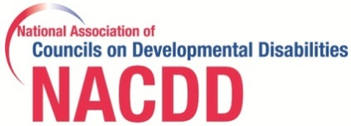
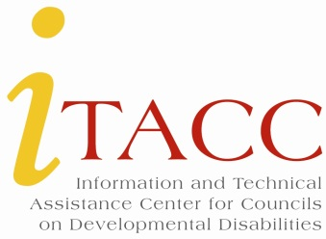

NACDD/ITACC Field Notes
October 2014
Welcome!
NACDD would like to welcome Patrick Reinhart as the new Executive Director of the Alaska Council. Please feel free to personally welcome Patrick to the DD Council network. patrick.reinhart@alaska.gov
ITACChelp.org
www.itacchelp.org has many resources to assist the Council member, Council Director and Council staff.
- PPR & State Plan Amendment Technical Assistance webinars
ITACC is hosting two webinars designed to provide Council staff with a review of the PPR and State Plan Amendment reports.
November 13, 2014 at 10:00 am Eastern
http://nacdd.adobeconnect.com/pprandspa/
November 17, 2014 at 4:00pm Eastern
http://nacdd.adobeconnect.com/pprandspa2/

- PPR Technical Assistance – Updated Guide
The 2014 guidance on writing the Comprehensive Review and Analysis section of the 5 Year State Plan is now available on the ITAAC website.
Resources & Information
- NACDD has now embarked on a partnership with 9 organizations to provide a webinar series on education and disability policy. For more information, visit higherexpectationsforall.
- Information about the new CMS home and community-based services rule continues to be posted on our joint DD network website, hcbsadvocacy.org.
Compliance Corner
- All DD Councils are required to submit a FY15 State Plan Amendment. There are 2 categories of State Plan Amendments: (1) Substantive changes; and (2) Non-substantive changes. If your DD Council had a substantive change, the due date for submission was August 16, 2014. If your DD Council did not have substantive changes, the due date for submission is January 1, 2015.

- All Councils should submit an FY 15 State Plan Amendment. At a minimum, State Plan Amendments should provide an updated DD Council membership roster, an updated DD Council staff roster, the FY 15 projected DD Council budget, and other appropriate amendments (examples are: updated evaluation plan, updated timelines to activities, updated activities or collaborators, etc.). If you need technical assistance regarding state plan amendments, please contact acastillo-epps@nacdd.org or smatney@nacdd.org
Upcoming Events and Opportunities
- 2014 “Be the Future” TASH Annual Conference - December 3rd
For nearly 40 years, the TASH Conference has impacted the disability field by connecting attendees to innovative information and resources, facilitating connections between stakeholders in the disability movement, and helping attendees reignite their passion for the full inclusion of people with disabilities in all aspects of community life. This year’s conference will cover the following topics: Research, Education, Parenting, Self-Advocacy, Supported Living and Integrated Employment. NACDD is a conference sponsor for 2014. For more information and to register, visit conference.tash.org.
- 2015 Disability Policy Seminar - April 13-15
The 2015 Disability Policy Seminar is April 13-15, 2015! It begins with two days packed full of informational and educational sessions on key issues facing the Intellectual/Developmental Disabilities (I/DD) community from experts in the fields; then finishes with participants taking their concerns directly to Capitol Hill.
- New DD Council Executive Director Orientation
Each year, an orientation meeting is scheduled for newly hired DD Council Executive Directors. Staff members from the Administration on Intellectual and Developmental Disabilities, NACDD and ITACC staff members, and DD Council representatives partner to bring newly hired DD Council ED’s the most up-to-date information on the responsibilities of a DD Council Executive Director. The 2015 Orientation is by invitation only and planned for April 16, 2015 in the offices of NACDD in Washington, DC.

Employment Opportunities
- Director of Communications
The Maryland DD Council seeks a creative, motivated individual committed to our mission to serve as our Director of Communications. The Director of Communications develops and executes a multi-strategy communications plan to provide essential information and resources to targeted audiences; raise awareness of Council priorities and initiatives; and impact and influence issues of importance to the Council. The application deadline is November 7, 2014. For more information and to apply, view Director of Communications.

- Special Projects Coordinator
The Maryland DD Council is also hiring for a new contractual position, Special Projects Coordinator, to focus on Sibling Support. The application deadline is November 14, 2014. For more information and to apply, view Sibling Support.
Due Dates
- The DD Council PPR, budget, & Non-substantive State Plan Amendments are due for all Councils on January 1, 2015. Visit the ITAAC website for informative webinars, new evaluation tools and guidance documents for completing all sections of the PPR.

This project was supported, in part by grant number 90DN0292, from the U.S. Administration for Community Living, Department of Health and Human Services, Washington, D.C. 20201. Grantees undertaking projects under government sponsorship are encouraged to express freely their findings and conclusions. Points of view or opinions do not, therefore, necessarily represent official Administration for Community Living policy.

