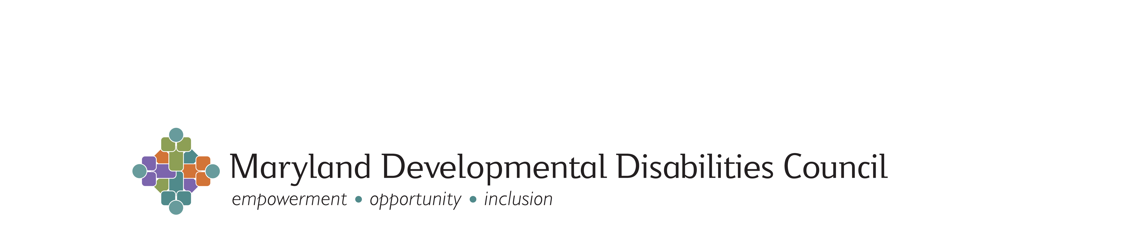
FIVE YEAR STATE PLAN GOALS AND OBJECTIVES
Status Report Since Last Council Meeting: Activities & Outcomes
FY 2014: March 6, 2014

* For more information, contact the staff person noted for each activity

Goal 1. Increase the number of people with developmental disabilities and family members statewide who are leaders and advocates active in promoting inclusion, self-determination, productivity and independence at a personal, local, State, and federal level.

1.1: Support a statewide self-advocacy organization that networks with local groups, participates in coalitions, and cultivates new leaders.

- (Angela)

1.2: Expand self-advocacy opportunities for youth with developmental disabilities in at least five counties.

(Rachel & Angela)

1.3: Develop an initiative that supports systemic advocacy and public education by parents to increase the number of students with developmental disabilities who are educated in general education classrooms.
- (Rachel)
1.4: Support the active participation of at least 100 people with developmental disabilities and family members in local and state issues important to them.

- (Brian & Rachel)

Goal 2. Increase the ability of the community to maximize the inclusion, self-determination, employability, productivity, and independence of people with developmental disabilities throughout their lives.
2.1: Support the implementation and replication of at least two innovative and/or best practices that include children and youth with disabilities in typical child care settings and after school programs.

2.2: Advocate for the implementation or improvement of at least three statewide policies and practices relating to special education and least restrictive environment issues.

2.3: Support the creation and improvement of at least 15 sustainable policies and practices that reflect innovative best practices and the inclusion of all people with developmental disabilities in their communities. *
(*Funding and advocacy activities that impact policies and practices in some distinct priority areas are noted under other objectives. Objective 2.3 in the State Plan focuses on: self-determination, deinstitutionalization, transportation, housing, health, and cultural competence.)

- (Cathy)

2.4: Advocate for the implementation or improvement of least three employment related policies, practices, and/or funding mechanisms.
- (Cathy)

2.5: Provide service providers with training, technical assistance, and support to implement sustainable organizational change in order to offer customized employment services and supports for at least 50 people with developmental disabilities.

- (Cathy)

2.6: Provide training about the use of assistive technology to 100 families, support staff, and other professionals who work with people with developmental disabilities in Western Maryland.

- (Angela)

2.7: Advocate for all people with developmental disabilities involved in the criminal justice system to be supported in the least restricted/most integrated setting with state-of- the art, progressive services.

- Completed in 2013 (Brian)
2.8: Advocate for the development and improvement of supports and services that are integrated and coordinated for children with developmental disabilities or delays.

- (Rachel)

2.9: In partnership with the Maryland Center on Developmental Disabilities, support the development of a strategic plan that leads to improved outcomes for students with developmental disabilities in inclusive postsecondary education.

2.10: Educate and inform 188 State legislators, the Governor, and public policy makers within at least five Departments about issues of importance to people with developmental disabilities and their families.
- (Brian & Rachel)

Goal 3. Promote and support improvements in the quality of inclusive community services and individualized supports for children with developmental disabilities and their families.

3.1: Advocate for at least three systemic improvements in child care, after-school care, and family supports.

- (Brian & Rachel)

Goal 4: Increase the amount of resources dedicated to inclusive community services and individualized supports for people with developmental disabilities throughout their lives

4.1: Implement at least 10 strategies that increase and maximize funding for home and community based supports and services.

- (Rachel)

Goal 5: Provide opportunities for people with developmental disabilities, their families, and other audiences to learn about the work of the Council, issues of importance, community resources, rights, and inclusive practices
5.1: Utilize seven tools for educating people with developmental disabilities, their families, policymakers, advocates, providers, and the public.

- (Angela)

5.2: Utilize at least 2 methods for disseminating information to underserved ethnic and cultural groups.

- (Angela)

____________________________________________________

OTHER:

