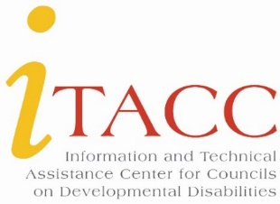

2022-2026 Information and Technical Assistance Center for Councils on Developmental Disabilities (ITACC)
NEW Communications Plan for Information, Resources and Opportunities
We would like to let you know about some upcoming changes to the way TA resources and key information will be shared to Councils.
MAILCHIMP – Email platform
Starting in November, DD Councils will receive two emails per month from the MailChimp platform.
Email 1: Technical Assistance News Brief (sent around the 15th of the month).
This brief will be a condensed version of important and timely information for DD Councils.
Email 2: FAQs from the Field and “Ask ITACC” (sent around the 30th of the month).
This email will contain frequently asked questions from the DD Councils AND answers from ITACC staff. “Ask ITACC” will be a new interactive component for readers to submit follow up questions to the FAQ, directly to ITACC staff! You will simply click on the button and type in your question. Questions will be answered monthly.
IMPORTANT: If you received the Field Notes e-newsletter directly to your inbox, you are already signed up to receive all of the emails above. If not, you can easily subscribe by visiting the itacchelp.org website’s home page, under the Announcements column.
ITACC LISTSERV --
The ITACC listserv will still be available to all subscribers to share their resources, projects, and initiatives, ask questions and brainstorm solutions, and offer opportunities to other DD Councils.
We hope these communications will be a helpful enhancement to the work you do. If you have any questions/comments about these changes, please let us know.
Sheryl Matney: 202-506-5813 ext. 148 | smatney@nacdd.org
Angela Castillo-Epps: 202.506.5813 ext. 100 | acastillo-epps@nacdd.org

