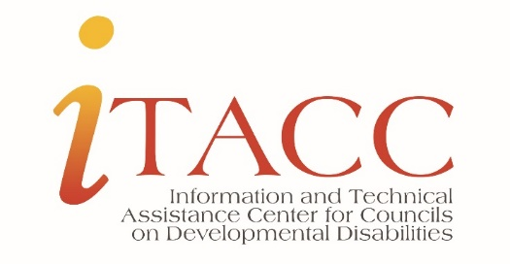

Notable Rapid Response Questions from November 2020

Funding
Can federal funds be used for advertising and public relations?
It depends on the cost. 45 CFR 75, Section 75.421 provides information on the allowable and unallowable costs associated with advertising and public relations.

Can a former grantee receive income from a former project the Council funded?
45 CFR 75, Section 75.307 (f) Income after the period of performance addresses this question.

Federal Reports
State plan update: Do we have to update our waiting list numbers?
No. There is no requirement that waiting list numbers are to be updated annually unless there is a significant change impacting the need to amend the plan later.
Program Performance Report: Is the Council financial information reporting items changing due to COVID flexibilities?
No. The Council will provide information on FFY 2018, 2019, and 2020 awards. The reporting periods include the current reporting year, and two previous reporting years. It may be helpful to review the SF-425 for information.
State plan development 2022-2026
Should we use the 1.58% prevalence rate for developmental disabilities?
Yes. Program staff at OIDD indicated 1.58% is the preferred rate. If a Council has another preferred prevalence rate, please discuss with your assigned OIDD Program Specialist.

What are the character limits for the new State plan?
We recommend using the same character limits as previously used. The character limits for the current state plan are below:
Membership rotation plan - 1,000
DSA - Direct Services - 250
DSA - roles and responsibilities - 250
CRA - Prevalence – 250
Portrait of the State – all required items 12,000; items that are not required is 8,000
Required: health/healthcare, employment, informal and formal community supports, interagency initiatives.

Analysis of the State Issues and challenges
Criteria for eligibility - 12,000
Unserved and underserved - 12,000
Assistive technology - 12,000
Adequacy of health care and other services (ICF and HCBS) - 12,000

Waiting list - if you are explaining - 4,000
Describing prioritization - 8,000
State/Territory wait list definitions - 8,000
Wait list needs and eligibility assessment - 8,000
Other wait list information - 4,000
Summary of wait list challenges - 4,000

Rationale for goal selection - 12,000
Collaboration - 12,000

Evaluation plan - 12,000

Public input and review - 12,000
Description of revisions - 12,000

Are Councils required to have a State plan goal focused on healthcare?
No. The DD Act requires the State plan be developed based on the unmet needs of people with developmental disabilities in your State/Territory and be developed through data driven strategic planning. If healthcare is an identified need the Council can address through the State plan.

Council operations
How long are we required to keep records?
Federal regulation requires 3 years of records be kept - unless there is a State law requiring records be kept longer. The 3-year policy “holds” unless you anticipate a lawsuit on a grant/contract, or the federal government has initiated an audit on your program, then you would need to keep important documents until the inquiry has completed.

Link to the regulation - https://www.govinfo.gov/content/pkg/CFR-2004-title45-vol1/xml/CFR-2004-title45-vol1-sec92-42.xml

Do we have to include the “grantee product disclaimer” and if so, what is the correct language for the product disclaimer?
Yes, all ACL discretionary grantee products must include the disclaimer on the first page or preface of all documents and webpages produced, all or in part, with ACL funding.
This project was supported, in part by grant number 90XX####, from the U.S. Administration for Community Living, Department of Health and Human Services, Washington, D.C. 20201. Grantees undertaking projects with government sponsorship are encouraged to express freely their findings and conclusions. Points of view or opinions do not, therefore, necessarily represent official ACL policy.
Councils will use the grant number found on their Notice of Award.
See “Grantee Product Disclaimer – REQUIRED” for more information.

