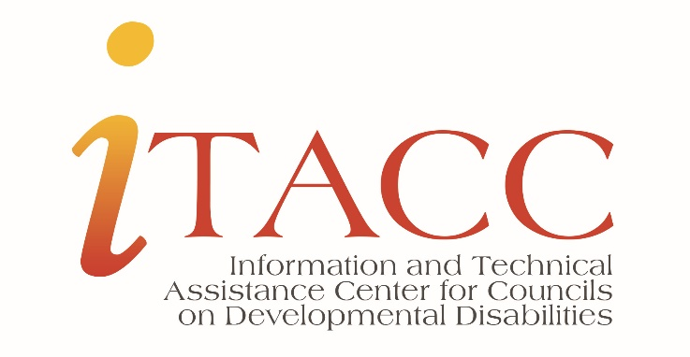
The goal of technical assistance activities is to help DD Councils:
- Improve performance, operations, and outcomes
- Help maintain compliance or achieve compliance
- Be positioned as leaders and agents of:
  - systems change
  - capacity building
  - advocacy
Summary
In coordination with ACL’s Office of Intellectual and Developmental Disabilities, the ITACC works with State and Territory DD Council programs to identify promising practices, support emerging practices among Councils, and provide technical assistance.
The ITACC provides services in three areas: General, Targeted, and Intensive. Below is a graphic with TA services identified for each area.

TA Service details
The ITACChelp.org website is to help the efforts of the ITACC to support DD Council programs. Posted information includes resources, instructions, guidance, webinar recordings, training curricula, and other information.
The ITACC Listserv is an email forum for Council staff, members, and ACL staff. The purpose of the listserv is to provide a way for quick communication about training and funding opportunities, news and developments in the field of DD, and a way to share information about how to improve the effectiveness of the Council programs. Subscribers can ask questions and seek input from other DD Network subscribers on ways to improve their programs.
Webinars are offered throughout the year on reporting and other “hot topics” in developmental disabilities.
TA Briefs contain information on topics related to Council program operation and compliance.
The ITACC Rapid Response service is for Council staff and members to get answers to their questions quickly through email or a phone call.
Peer-to-Peer (P2P) Calls are topic specific calls held among DD Council staff. This year we will hold calls to discuss:
- Data collection, evaluation, monitoring, and assessment practice issues
- 2022-2026 State plan development
Emerging Practices Groups provide dedicated time for a smaller group to exchange ideas, learn from each other to help improve practices and share the information with the larger network. This year we will facilitate groups to discuss:
- Systems Change
- Overall efforts to address the needs of culturally diverse populations
Targeted, Individualized TA efforts is available to Councils on policy, practice, and administrative issues.
Below are some examples of requests we have received from Councils:
- Training and education for the new Executive Committee
- Enhanced joint training and education for the Executive Committee and key Designated State Agency people
- Council member training and education on State plan development with highlights on tools and resources
- Council committee training on policies and laws to support allowable activities for a public policy agenda
- Training and education for Council staff on basic fiscal topics
Contact us for training and technical assistance needs or information.
Sheryl R. Matney, Director (smatney@nacdd.org); Angela Castillo-Epps, TA Specialist (acastillo-epps@nacdd.org); Robin Troutman, NACDD, Deputy Director (rtroutman@nacdd.org)

