An Electronic Publication of the Ohio Developmental Disabilities Council

December 2019 Edition | Volume 14 Issue 6
This Month: “Envisioning 2020”
- Providing Justice, Equity, and Leadership for Marginalized Populations
- Breakthrough to Inclusion
- Disabilities in Supply Chains
- Undocumented Immigrants with Disabilities

Read, Pass on to Friends, Family Members, Colleagues & Constituents

Don’t Miss an Issue!

It is the policy of the Ohio Developmental Disabilities Council
to use person-ﬁrst language in items written by staff.
Items reprinted or quoted exactly as they originally appear
may not reﬂect this policy.
“Envisioning 2020”

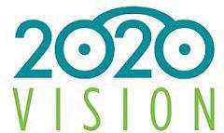
2020 marks not just the beginning of a New Year but the beginning of a New Decade. Bill Gates recently stated…

“We always overestimate the change that will occur in the next
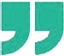
two years and underestimate the change that will occur in the next ten years. Don’t let yourself be lulled into inaction.”

As you think about a new year, often it is directed to
actions that will yield a speciﬁc result. That is a typical short-term focus. But what about the long-term? To bring about change for a decade requires thinking with a systems focus.

This December newsletter is designed to stimulate your thinking about next year in light of a decade. How can the Ohio
Developmental Disabilities Council (ODDC) ignite systems change that ensures un/underserved populations with developmental disabilities needs are met? After reading each article, you are invited to think out of the box, envision 2020. Think about what 2020 could look like with an eye to 2029.

In the spirit of systemic change,
ODDC cannot bring about change alone.

“We are better together”

When you post your vision on ODDC social media platforms, use #ODDC2020bettertogether

Providing Justice, Equity and Leadership for Marginalized Populations

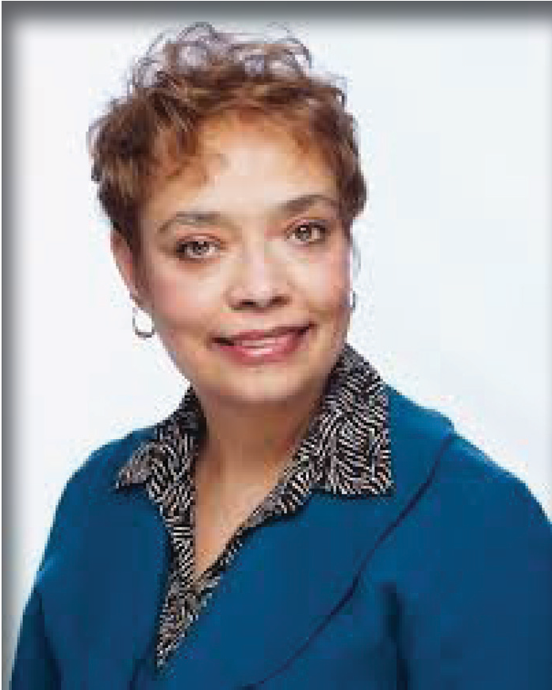Individuals with Developmental Disabilities (DD) who are African American, Asian, and Latinx/Hispanix are dying and suffering disproportionately from illnesses and diseases than their Caucasian counterparts. These populations stand to lose the most due to the illnesses and diseases that they suffer from, where they live, their economic status, education levels and other social determinants that can predict their health outcomes and life expectancy.

Charleta B. Tavares
In addition to the burden, these disparities have on individuals with preventable diseases, illnesses and premature deaths, “unaddressed health disparities historically have been a signiﬁcant driver of healthcare costs. When combined with the current fragmented program silos and funding streams, efforts to inﬂuence health disparities are stymied. Between

2003 and 2006, the combined costs of health inequalities and premature death in the United States was $1.24 trillion; thirty percent (30%) of direct medical care expenditures for African- Americans, Asians, and Hispanics were excess costs due to health inequities. In the same period, eliminating health disparities would have reduced direct medical care expenditures by
$229.4 billion.

-READ MORE-

Breakthrough to Inclusion
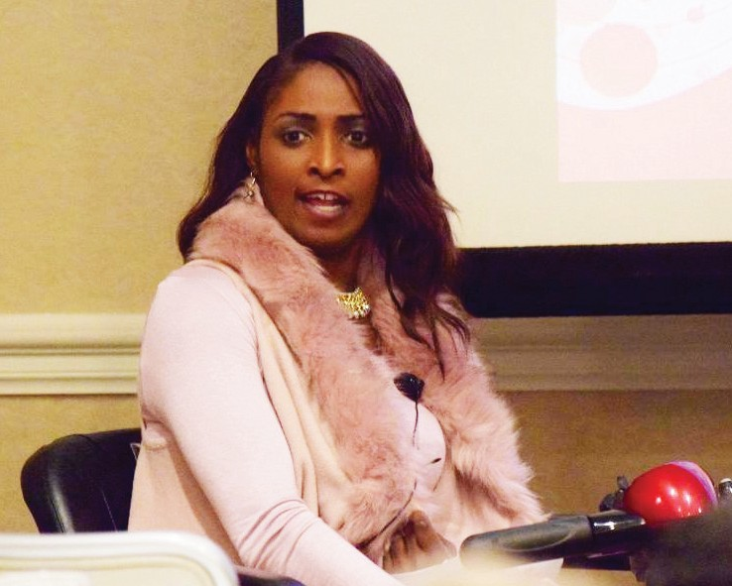
Is it hard for people with disabilities to be involved in groups and activities that have absolutely nothing to do with disabilities?
Not all things have to be disability related for people with disabilities. For many years, society has placed people with disabilities in a box, creating an inclusion barrier. When we break
out of this box and start doing things that is considered outside the “normal” disable way of living, some people have not understood us. And, as much as I hate to admit it, some people with disabilities have placed themselves in that box out of fear of rejection or scared to try something new. It may even be a fair statement to say, some people may have even been taught, by the system, to depend upon others for everything.
-READ MORE-

Disability Inclusion in Supply Chains

What is current status of Supplier Diversity?

Small businesses are recognized as a vital component of our economy. According to the
U.S. Small Business Administration, there are nearly 30 million small businesses in the United States, accounting for 99.9 percent of all U.S. businesses, and eight million of those are classiﬁed as diverse businesses. These 30 million small businesses make a signiﬁcant impact on our economy through job creation, innovation, and economic impact.
-READ MORE-

The Rights of Undocumented Immigrants with Disabilities Needs to Be a Priority
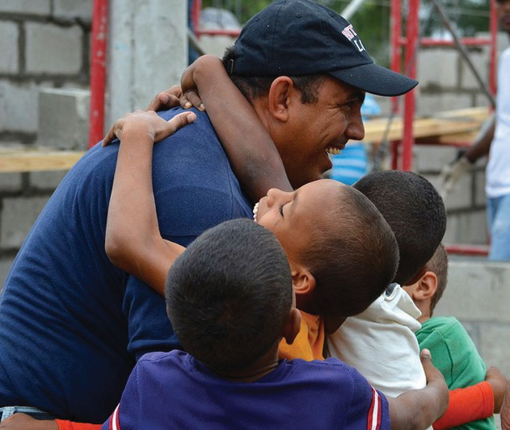
One of the mantras of the disability rights movement is that disability is not just a medical issue—it is a social issue as well. Think of it this way: it is not an injury or an illness that makes a person in a wheelchair disabled, but rather the building of architecture containing stairs without ramps. It is not the inability to hear that makes a deaf person disabled, but rather the lack of value given to sign language and the oversight of web developers to include proper captioning in their videos, etc.
Despite the fact that one out of seven of the world’s population live with a disability, people with disabilities (PWDs) for far too long have been and still continue to be
isolated and viewed and treated as objects of pity or charity rather than human beings with rights. Thus, when a society continues to deny rights to people with disabilities, PWDs often have no choice but to leave and seek opportunities elsewhere—often one of the hardest

choices a person with a disability has to make.
-READ MORE-

As 2019 comes to a close, pause, celebrate the successes and join
us now in anticipation of brighter tomorrows.
We appreciate your support this year and hope that you have received information in our newsletter that has been beneﬁcial to you. Click here and share your feedback so that we can make our 2020 Newsletters even better.

The purpose of “Reach Out” e-Diversity newsletter is to promote interagency collaboration and coordination
that result in agencies providing culturally competent services to the unserved/underserved populations in Ohio
Reach Out e-Diversity News is produced by The Outcomes Management Group, Ltd. This product is funded all or in part by the Ohio Developmental Disabilities Council.

Page 4

An Electronic Publication of the Ohio Developmental Disabilities Council
December 2019 Edition | Volume 14, Issue 6
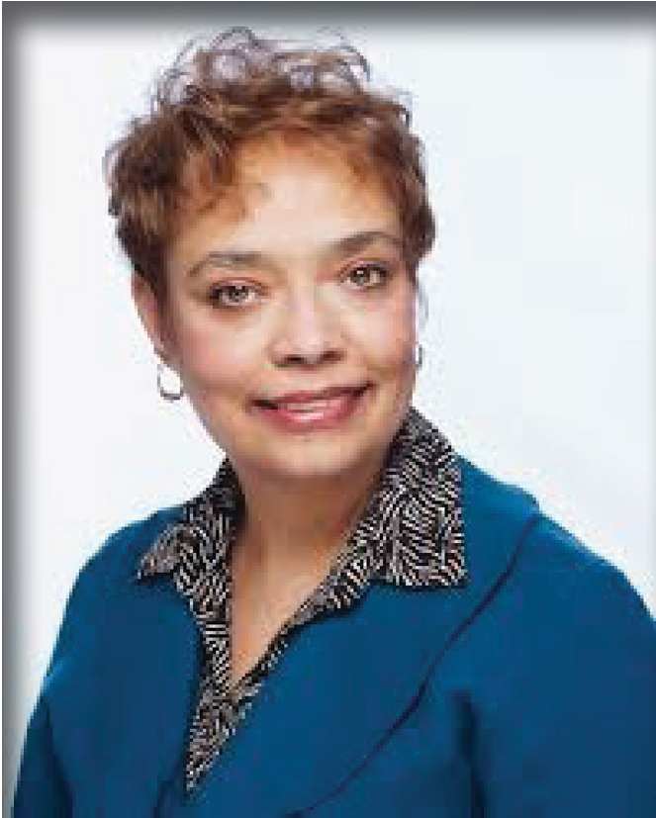Providing Justice, Equity and Leadership for Marginalized Populations

by Charleta B. Tavares, CEO PrimaryOne Health
Individuals with Developmental Disabilities (DD) who are African American, Asian, and Latinx/Hispanix are dying and suffering disproportionately from illnesses and diseases than their Caucasian counterparts. These populations stand to lose the most due to the illnesses and diseases that they suffer from, where they live, their economic status, education levels and other social determinants that can predict their health outcomes and life expectancy.
In addition to the burden, these disparities have on individuals with preventable diseases, illnesses and premature deaths,

“unaddressed health disparities historically have been a
Charleta B. Tavares

significant driver of healthcare costs. When combined with the current fragmented program silos and funding streams, efforts to inﬂuence health disparities are stymied. Between 2003 and 2006, the combined costs of health inequalities and premature death in the United States was $1.24 trillion; thirty percent (30%) of direct medical care expenditures for African- Americans, Asians, and Hispanics were excess costs due to health inequities. In the same period, eliminating health disparities would have reduced direct medical care expenditures by $229.4 billion. As the aggregate of our various racial and ethnic minorities moves toward becoming a majority of the country’s populace, addressing health disparities becomes even more critical. If not adequately addressed, everyone suffers through share loss of economic capital, loss of human intellectual and leadership capital and social instability.”1
Our community residents are being diagnosed at higher rates, at levels that are more acute and dying at significantly greater levels in the areas of Cancer, Diabetes, Cardiovascular (CHD/heart and stroke), Substance Abuse, Violence and Infant Mortality. Two startling and disturbing figures to highlight this point are below in the area of cardiovascular disease:

  - A higher percentage of African American women (37.9%) than Caucasian women (19.4%) died before age 75 as a result of CHD, as did African American men (61.5%) compared with Caucasian men (41.5%).
  - The same African American-Caucasian difference was seen among women and men who died of stroke: a higher percentage of African American women (39%) died of stroke before age 75 compared with Caucasian women (17.3%) as did African American men (60.7%) compared to Caucasian men (31.1%)2

- Thomas A. LaViest, et al, “The Economic Burden of Health Inequities in the United States.” http://www.odh.ohio.gov/~/media/HealthyOhio/ASSETS/Files/health%20equity/ economicburdenofhealthinequalitiesintheunitedstates.ashx

- The CDC Health Disparities and Inequalities Report – United States, 2011 is available online at www.cdc. gov/mmwr. For more information about this topic, please visit http://www.cdc.gov/HeartDisease/prevention. htm and http://www.cdc.gov/stroke/prevention.htm.

How did the African American community fall victim to having the highest mortality (death) rates for all of the major diseases and illnesses in America? Who is seriously addressing these health disparities? Why are these health conditions persisting in communities filled with world-renown healthcare facilities, institutions and practitioners? The answer to all of these questions is leadership or the lack thereof among the administrators, institutions, policymakers and legislators.

We are not a priority with the healthcare industry, policymakers and legislators because we are not valued, have no lobbyists, are not collectively demanding that our needs are met or that resources, programs and policies are focused on where the burden of illness and death are greatest. The lack of leadership and focused attention on addressing disparities within the majority community, as well as African American, DD and other communities of color is unequivocal within each of these sectors. There are a smattering of voices and champions however; the choir is muted and dispassionate. The statistics are shared as a “matter of fact” on a PowerPoint or bullet in a written communique´.
Some may question why? We can posit that it is historical and grounded in institutional and systemic racism. We can also theorize that it is because those with no voice, clout or leaders are marginalized, discounted and/or annihilated. However, we can also suggest
that ignorance and blatant discrimination have clouded the minds of those who profess to be fiscally conservative and “getting the most bang for the buck” with tax expenditures. In reality if they wanted to be truly fiscally prudent and economically sound in tax expenditures – they would prioritize where the disparities in premature death and disease lies – among racial/ ethnic populations and specifically African Americans and those who may be developmentally disabled.
Developing policies such as pay for performance, outcome rewards and evidence-based programs targeting African American populations would tackle the expenses associated with acute diseases and illnesses on the front end. Further, concentrating on the social and environmental determinants of health i.e., housing, toxins (such as lead and tobacco
products), poverty, employment, education etc. would advance the return on the investment of dollars at the outset and reduce exorbitant hospital costs and premature death among Ohio’s African American and DD residents.

Who are the leaders at the local, state and federal levels who are doing more than talking about or presenting the problems? Where are the advocates, community and faith members who are demanding that their leaders take action and especially those in the racial/ethnic DD communities? Who and where are we eliminating disparities or getting the best health care outcomes for racial, ethnic and DD populations in the United States? What are the successful programs, policies and funding strategies that have made a difference?

There must be a demand from within and outside of our African American, Latinx and DD diaspora to improve the health, well-being and life expectancy for all of our community members. We can each do something…for ourselves, for our family and for those who are bearing the burden of disease and illness. Each of us can use our voices to ask what our leaders are doing or have done to eliminate the premature death and disease among African Americans, individuals with DD and people of color. We can share promising practices
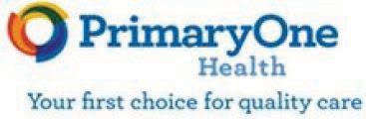
and strategies to address health care and social/environmental determinants to improve health outcomes for our people and we can hold those in leadership positions accountable by contacting their board members, leadership team and investors (for profit health care businesses, pharmaceutical companies and managed care companies). In addition, we can vote and conduct candidate forums to have those
elected/appointed and aspiring to be elected to address what they have accomplished to eliminate disparities and achieve health equity for African American, DD and residents of color.

Charleta B. Tavares is the Chief Executive Officer at PrimaryOne Health, a Federally Qualified Health Center (FQHC) system providing comprehensive primary care, OB-GYN, pediatric, vision, dental, behavioral health and specialty care at 11 locations in Central Ohio. The mission is to provide access to services that improve the health status of families including people experiencing financial, social, or cultural barriers to health care. www.primaryonehealth.org.

How do you envision the health care system in the new decade meeting the needs and expectations of un/underserved individuals with disabilities?

Identify how you will use your voice in 2020 to bring about change in the health care system. (select at least 1)
Advocate for change
□
Share promising practices and strategies Hold leaders accountable
□
□
Vote
□
Host candidate forums Other
□
□

MY 2020 VISION of OUR HEALTHCARE SYSTEM is…….

USE #2020ODDCbettertogether

SHARE Your 2020 Vision and the action you will take to facilitate change

The purpose of “Reach Out” e-Diversity newsletter is to promote interagency collaboration and coordination
that result in agencies providing culturally competent services to the unserved/underserved populations in Ohio
Reach Out e-Diversity News is produced by The Outcomes Management Group, Ltd.
This product is funded all or in part by the Ohio Developmental Disabilities Council.

Page 7

An Electronic Publication of the Ohio Developmental Disabilities Council
December 2019 Edition | Volume 14, Issue 6

Breakthrough to Inclusion
By Shari Cooper
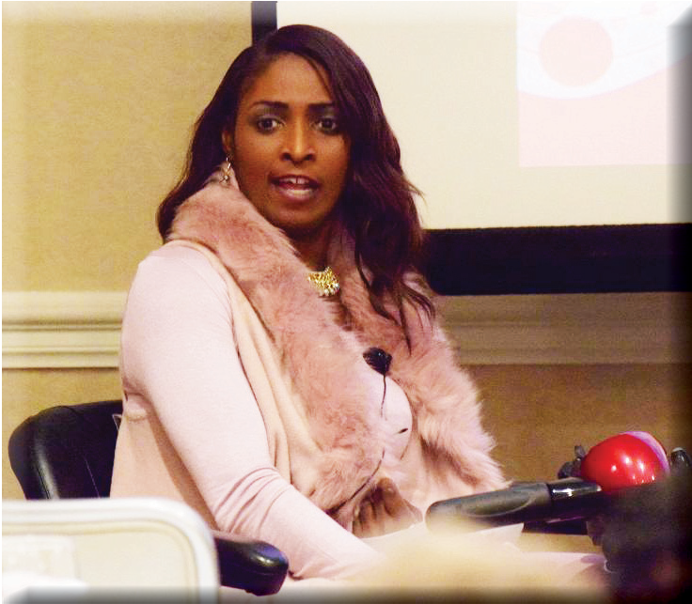Is it hard for people with disabilities to be involved in groups and activities that have absolutely nothing to do with disabilities?

I was recently selected one of the Top 25 Women to Watch by the Women in Business Network (Dayton, OH). Although, I was recognized for my advocacy efforts, this award is not restricted to women with disabilities.
Instead, it is given to any woman who meets the award criteria. I am honored to be sitting among a very elite group of women who are just as passionate to serve in all capacities as I am.

Not all things have to be disability related for people with disabilities. For many years, society has placed people with disabilities in a box, creating an inclusion barrier. When we break
out of this box and start doing things that is considered outside the “normal” disable way of living, some people have not understood us. And, as much as I hate to admit it, some people with disabilities have placed themselves in that box out of fear of rejection or scared to try something new. It may even be a fair statement to say, some people may have even been taught, by the system, to depend upon others for everything.

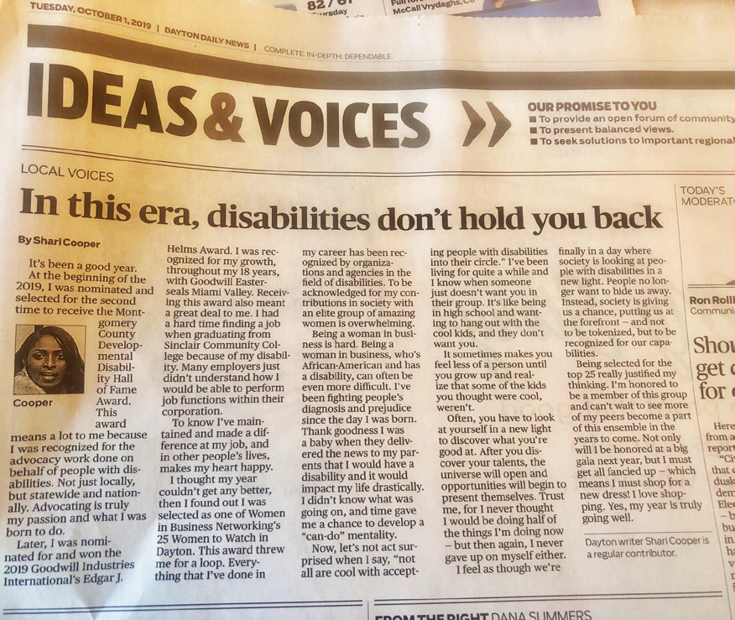There is a great beneﬁt to having people with disabilities in different circles. Inclusion is a catalyst that forces all people to interact and learn from each other. I have been in many circles, from college, to the church Women’s Day committee, where I was the only one with a disability sitting at the table.
Did I feel a little out of place or awkward? Why
yes, at ﬁrst. Then after having a positive self-chat,
I convinced myself, not only should I be there, but “why” I had just as much right to be there as anyone else. Only then was I able to share my thoughts and ideas, making it known that I was present. As a
result, people began to look at my ability and not my
disability. Page 8

I have encountered another barrier to being included when attending functions or events that some may not think “people with disabilities should do”. This barrier is impacted further by the perceptions that others have of my friends and family who are with me but don’t have disabilities. Sometimes they get looks from people as if they are saints for bringing me out.
What others don’t know is that I am the planner and nine times out of ten, the one who has selected and arranged the activities. This same reaction also happens when I am out with my love. He assists me with eating and people often tell him what a good man he is, which he is, but I am a good woman. Why do some people elevate those who like or choose to hang with people with disabilities to a holier than thou status? Perhaps, what you are witnessing are family and friends hanging out or a couple in a loving relationship.

Creating an inclusion breakthrough in 2020 requires all of us, regardless of where we are serving (e.g., boards, committees, organizations, businesses, government), to maintain an open-mindset and be willing to embrace differences, including people with disabilities. It would be great when openings become available in a group, leaders within the group, start identifying a pool of people with disabilities who have potential and passion to serve. There are many just like me who have served and are serving on many boards and are just awaiting to take on a new opportunity.

Additionally, it is important that those of us who have disabilities do not let others deﬁne and
limit us or create fear of not being accepted hinder us from seeking out new groups.

As I continue my journey, I will keep pushing to help others see disabilities as teaching tools that can help society to grow. I am hopeful that 2020 will be the dawning of a new decade that will open-up an acceptance of all. Until then, I will keep doing my job advocating to get the word out. Don’t know where this road will lead me but, got a feeling, a breakthrough is on the way!
Shari Cooper is Public Relations Assistant, Goodwill Easter Seals Miami Valley

How do you envision personally being more inclusive?

USE #2020ODDCbettertogether

SHARE Your 2020 Personal Vision of Inclusion

The purpose of “Reach Out” e-Diversity newsletter is to promote interagency collaboration and coordination
that result in agencies providing culturally competent services to the unserved/underserved populations in Ohio
Reach Out e-Diversity News is produced by The Outcomes Management Group, Ltd.
This product is funded all or in part by the Ohio Developmental Disabilities Council.

Page 9

An Electronic Publication of the Ohio Developmental Disabilities Council
December 2019 Edition | Volume 14, Issue 6

Disability Inclusion in Supply Chains

What is current status of Supplier Diversity?
Small businesses are recognized as a vital component of our economy. According to the
U.S. Small Business Administration, there are nearly 30 million small businesses in the United States, accounting for 99.9 percent of all U.S. businesses, and eight million of those are classified as diverse businesses. These 30 million small businesses make a significant impact on our economy through job creation, innovation, and economic impact.

Corporations are realizing the importance of disability inclusion in their supply chains.
Disability-owned businesses are a growing segment of small businesses. Approximately one in
five Americans have a disability, and people with disabilities are nearly twice as likely to be self-employed as people without disabilities.
The Billion Dollar Roundtable (BDR) has expanded their criteria of diverse businesses that are counted toward a corporation’s supply chain spend. Diverse-owned businesses accepted by the BDR now include certified:

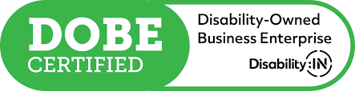
Disability-Owned Business Enterprises (DOBEs)

  - At least 51 percent of the business is owned by disabled individuals, or in the case of a publicly-owned business, at least 51 percent of the stock is owned by one or
more such individuals, i.e., the management and daily operations are controlled by
those minority group members.

  - Disability is defined as a physical and/or mental impairment that substantially limits one or more major life activities. (Download Word Doc from USBLN for an overview of disabilities)

Veteran disability-owned business enterprises (V-DOBEs)

  - All DOBE requirements plus:

  - Business is 51 percent owned, controlled, operated, and managed by a veteran, but disability was not incurred during their time of service.

Service-disabled veteran-owned business enterprises (SDV-DOBEs)

  - Be a small business.

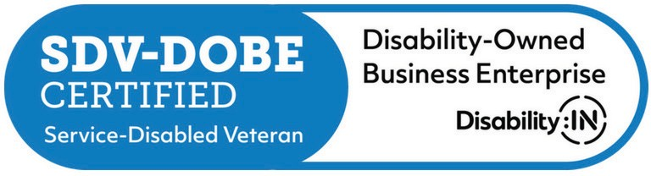
  - Be at least 51 percent owned and controlled by one or more service-disabled veterans.

  - Have one or more service-disabled veterans manage day-to-day operations and also make long-term decisions.

  - Eligible veterans must have sustained their disability during their time of service.

How do you become certified?

If you meet the requirements to be a DOBE, V-DOBE, or SDV-DOBE, your next step is to become certified. There are two types of certification, although they are not equal: self- certification and third-party certification.

While self-certification is simpler than going through a third-party, many of today’s corporations prefer the latter. Third-party certification provides corporate supplier
diversity programs the assurance that an independent, nationally-recognized agency vetted
your company and verified your disability-owned status

LEARN MORE at www.cvmsolutions.com

What challenges are Diverse Suppliers facing?

    - 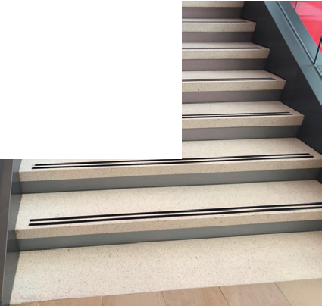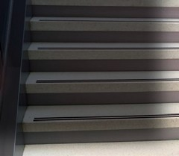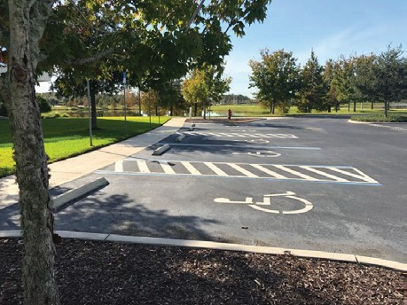Difficulty in being discovered by bigger companies
    - Purchasing, procurement, and other decision-makers not attuned to how their supplier diversity programs work
    - An underlying fixation on the bottom line rather than
diversity
    - Some comments….

“A lot of forms, registrations, and work for very little return.”

“Getting decision-makers to appreciate the importance of supplier diversity. There is a disconnect within companies’ departments who drive supplier diversity and the departments inﬂuencing purchasing decisions.”

“Finding a larger company that’s willing to offer mentoring to small companies— and not exploit them.”

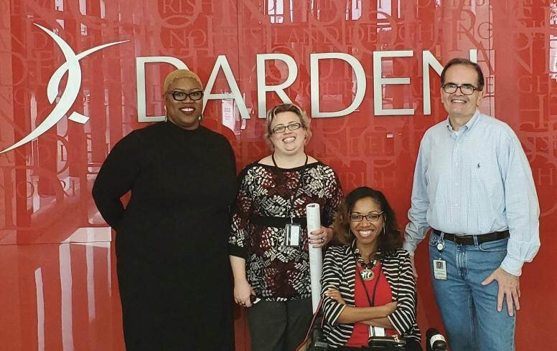Learn More www.cvmsolutions.com

Congratulations to Former ODDC Outreach Project R.E.A.C.H. Grantee

Tykiah Wright, CEO/Founder, Wright
Choice Inc

Tykiah Wright recently conducted an ADA Accessibility Audit in Orlando, FL for the
Darden headquarters thanks to Andrea H. Freeman Director of Diversity and Inclusion and Warren Lombardy, Director of Building and Campus Services.

How do you envision utilization of suppliers who are
DOBE, V-DOBE, or SDV-DOBE businesses?

USE #2020ODDCbettertogether

SHARE ON…. ODDC Social Media Platforms Your 2020 Vision of the Supply Chain.

Please identify by name and website any business that you know is owned by a person with a disability.

The purpose of “Reach Out” e-Diversity newsletter is to promote interagency collaboration and coordination
that result in agencies providing culturally competent services to the unserved/underserved populations in Ohio
Reach Out e-Diversity News is produced by The Outcomes Management Group, Ltd. This product is funded all or in part by the Ohio Developmental Disabilities Council.

Page 12

An Electronic Publication of the Ohio Developmental Disabilities Council
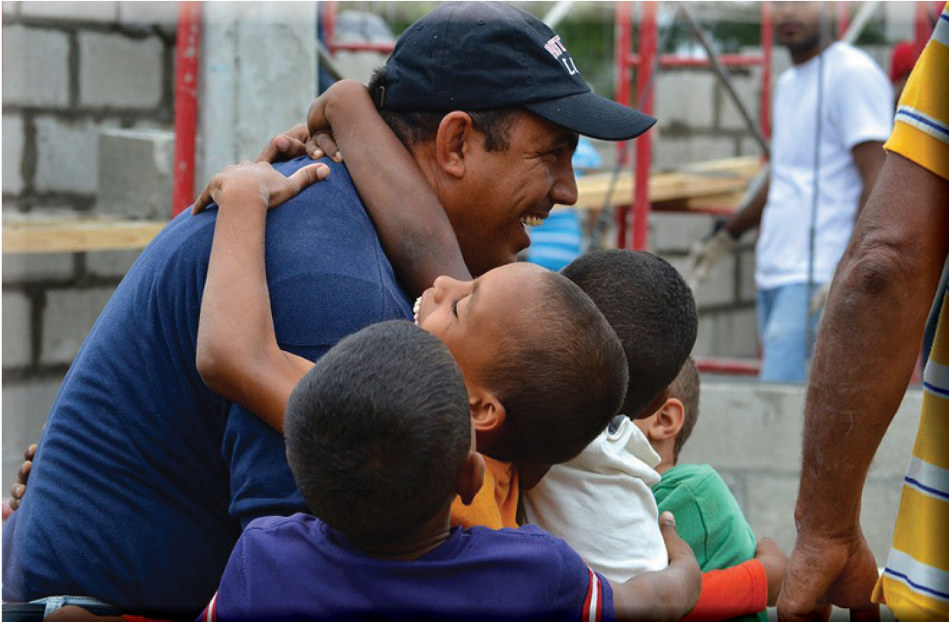December 2019 Edition | Volume 14, Issue 6

The Rights of Undocumented Immigrants with Disabilities Needs to Be a Priority
By Max Soh
This article was initially published by Cindy Knoebel, Editor-in-Chief, IMM Print

One of the mantras of the disability rights movement is that disability is not just a medical issue—it is a social issue as well. Think of it this way: it is not an injury or an illness that makes a person in a wheelchair disabled, but rather the building of architecture containing stairs without ramps. It is not the inability to hear that makes a deaf person disabled, but rather the lack of value given to sign language and the oversight of web developers to include proper captioning in their videos, etc.

Despite the fact that one out of seven of the world’s population live with a disability, people with disabilities (PWDs) for far too long have been and still continue to be isolated and viewed and treated as objects of pity or charity rather than human beings with rights.
Thus, when a society continues to deny rights to people with disabilities, PWDs often have no choice but to leave and seek opportunities elsewhere—often one of the hardest choices a person with a disability has to make.

This is especially the case for those with a lack of resources to migrate—often leaving them no choice but to cross borders in hopes of attaining asylum. Yet, to say that the process of seeking asylum in the United States for migrants with disabilities is difﬁcult could not be more of an understatement.

The Realities of Undocumented Migrants with Disabilities in America
The process of detaining migrants is cruel, and the process is especially cruel to migrants with disabilities. There have been numerous reports of disabled children and teens being separated from their parents and guardians by border patrol agents. The Texas Tribune, for instance, has reported on a 16 year-old with severe epilepsy and autism who was separated from his grandmother when the two of them arrived at the Santa Teresa Port of Entry in New Mexico seeking asylum. Despite passing the standard screenings, the two were quickly separated and have not seen each other in almost a year. The Outline recently reported on a mother being separated from her seven-year-old deaf and mute child after crossing the border. Though the mother was eventually provided with the location of her child, she had
Page 13

no means to contact him, and the child vice versa had no means of contacting her. Even if the mother was given a number to call her child, it would have made no difference as reports show that ICE facilities often are not only non-ADA compliant, but that they also provide no accommodations to individuals with disabilities in their facilities. While preparing this piece, I came across a story of a man who is deaf who was not only separated from his grandmother, but who was also then placed in handcuffs while he sits in detention—limiting the use of his hands which he relies on to communicate through sign language.

There are even reports of ICE facilities abusing disabled children. Earlier this year, Quartz reported that staff at the Shiloh, TX treatment center forced girls with
developmental disabilities to ﬁght for snacks. Such reports not only show the cruelty of the migrant detention process, but it is fair to say that such reports might be more ubiquitous than we think. Given that 14% of the world’s population have a disability, if we were to apply that to the approximate 40,000 individuals in immigrant detention centers at any given time
(a number that includes approximately 11,000 children), that places the number of detained individuals with disabilities at approximately
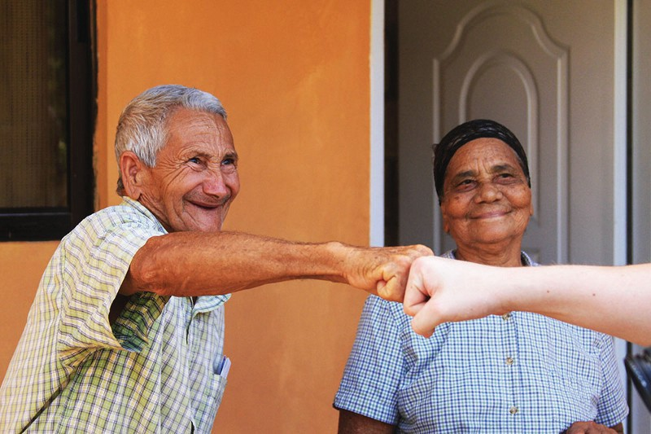5,700.

And akin to the treatment by ICE agents inside detention centers, the treatment by ICE agents outside detention centers is just as inhumane. Late last year, several media outlets began featuring the story of a ten-year-old girl named Rosamaria Hernandez whose family crossed the border from Mexico in an attempt to save Rosamaria’s life; the child was suffering
complications from cerebral palsy. However, in 2017, ICE agents followed Rosamaria’s
ambulance as she was on her way to gallbladder surgery, and waited outside her operating room—refusing to let medical staff close the doors while Rosamaria was being treated.
After her surgery, ICE agents then pulled Rosamaria from the hospital and placed her in a detention facility for children.

While Rosamaria has since been released, it should be noted that her story is by no means unique. Reports from advocates show that many undocumented migrants with disabilities constantly live in fear of approaching agencies and services (i.e. whether for issues pertaining to housing, employment, education, healthcare, etc.) because of the fear of either having their undocumented status revealed or running into ICE agents.

Yet, this is only part of the problem. Even when undocumented immigrants with disabilities are able to avoid the cruelty of migrant detention centers and the inhumane treatment of ICE agents, they are still faced with a society that gives little thought to individuals with disabilities. Undocumented immigrants with disabilities thus have to not only navigate physical, social, and institutional barriers of discrimination, but they have to do so knowing that participation in amenities such as housing, education, employment, healthcare, etc. will expose them to high risks that their undocumented status will be discovered and they will be deported to a place with even worse records for upholding the rights of people with disabilities than the United States.

Moving Forward

Including the approximately 5,700 individuals with disabilities in migrant detention centers, there are approximately 1.5 million undocumented individuals in the United States who live daily with a disability (if one applies the global 1/7 average to the approximate 11 million undocumented individuals living in the United States).

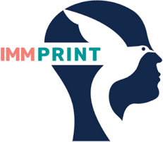
There is a need for more immigrants’ rights groups to include disabilities in their work not only due to the fact that people with disabilities comprise the largest minority group across borders, but also due to the multi-faceted discriminatory barriers that immigrants with disabilities face to attain equal rights as outlined. Even when the ﬁght to eliminate the use of migrant detention is won, advocates must ensure that immigrants
with disabilities are intentionally included and integrated into plans for alternatives to detention. Immigrants’ rights groups can begin by hiring more people with disabilities and covering
stories that explicitly and intentionally include the narratives of immigrants with disabilities and by noting the speciﬁc ways various legislation will affect the sub-population known as immigrants with disabilities.

How do you envision the needs of immigrants with disabilities being met?

USE HASHTAG #2020ODDCbettertogether

SHARE ON… ODDC Social Media Platforms Your 2020 Vision of how the needs of immigrants with disabilities are being met

Identify any groups you know that are focusing on the needs of immigrants with disabilities

The purpose of “Reach Out” e-Diversity newsletter is to promote interagency collaboration and coordination that result in agencies providing culturally competent services to the unserved/underserved populations in Ohio
Reach Out e-Diversity News is produced by The Outcomes Management Group, Ltd. This product is funded all or in part by the Ohio Developmental Disabilities Council.

