State Councils on Developmental Disabilities (DDC)

Annual Program Performance Report

ACLReporting
Grantee User Guide

January 2019

Prepared for ACL by ICF:
9300 Lee Highway
Fairfax, VA 22031

Contract Number:
HHSP233201500181W

Table of Contents
I. Introduction 2
II. ACLReporting Roles and Permissions 2
A. Registrar 2
B. Grantee 2
C. Reviewer 2
III. First Time Users 2
A. Creating New Accounts by Registrar 2
B. Login Instructions with Temporary Password 2
IV. Active Users Login and Password Changes 2
A. Log in 2
B. Forgot Your Password? 2
C. Change Your Password 2
V. Entering Report Information 2
A. Grantee and Reviewers Dashboard 2
B. Saving Information Entered in a Section 2
C. Error Messages 2
D. Section I. Identification 2
E. Section II. Comprehensive Review and Analysis 2
F. Section III. State Plan Implementation 2
G. Section IV. State Plan Implementation Progress Report 2
H. Section V. Council Financial Information 2
I. Section VI. Measures of Collaboration 2
VI. Helpful Tips & Hints for Using ACL Reporting 2
A. Save Your Work Regularly 2
B. Timeout Warning 2
C. Navigation 2
D. Roles and Permissions 2
E. Submitting a Report 2
F. Copy & Pasting 2
G. Printing a Report 2
H. PDF Accessibility 2
I. Role Permissions Matrix 2

Introduction
ACLReporting is a grantee reporting management system that allows ACL funded grantees to submit Program Performance Reports and State Plans. Programs currently using ACLReporting include State Councils on Developmental Disabilities, the Centers for Independent Living Programs (CIL), Independent Living Services (ILS), Protection and Advocacy for Assistive Technology (PAAT), Protection & Advocacy for Individuals with Traumatic Brain Injury (PATBI), Protection & Advocacy for Developmental Disabilities (PADD), and the National Assistive Technology Program (AT).

ACLReporting Roles and Permissions

Registrar
Each grant program will have staff person(s) with the role of “Registrar”. The Registrar is able to create accounts, update accounts and delete accounts.

Grantee
Each grant program will have staff person(s) with the role of “Grantee”. The Grantee is able to:
- Enter Performance Report (or State Plan) information
- Save report information
  - Once the information has been successfully saved, and all the sub-sections for that section are completed, you will be able to select “Ready for Internal Review.”
- Edit report information.
- Print report
Note: In this user guide, “Grantee” refers to the person with the role of “Grantee”.

Reviewer
Each grant program will have staff person(s) with the role of “Reviewer”. The Reviewer is able to approve the Performance Report (or State Plan) for submission by the DD Council.

Note: Users can have both the Reviewer and Grantee roles.

The Reviewer dashboard will show the completed sections for the Reviewer to review. The Reviewer will review each report section and:
- Select “Reviewed” if no changes are needed for the section
- Select “Request Revisions” if a change is necessary for the section. The Grantee will need to edit the section and resubmit the section for internal review.
- Select “Submit” to approve the report after verifying that all sections of the report are accurate and complete.

First Time Users

Creating New Accounts by Registrar
- Background and Basics
The assigned Registrar can set up additional Registrar, Grantee and Reviewer accounts for program colleagues, as needed.
If a person needs to have an account created with a username/password, the Registrar will need the following information:
- User Name
- First Name
- Last Name
- Email
- User role: Grantee, Grantee Reviewer, Registrar

Upon sending this request to your Registrar, the Registrar can create your account accordingly and will then contact you with your account information once the account set up is complete.

- Create New Account
  - Go to the https://reporting-pilot.acl.gov/#/
  - Log in with your Username and password.
Figure 1: Log in with your username (generally your email address) and password
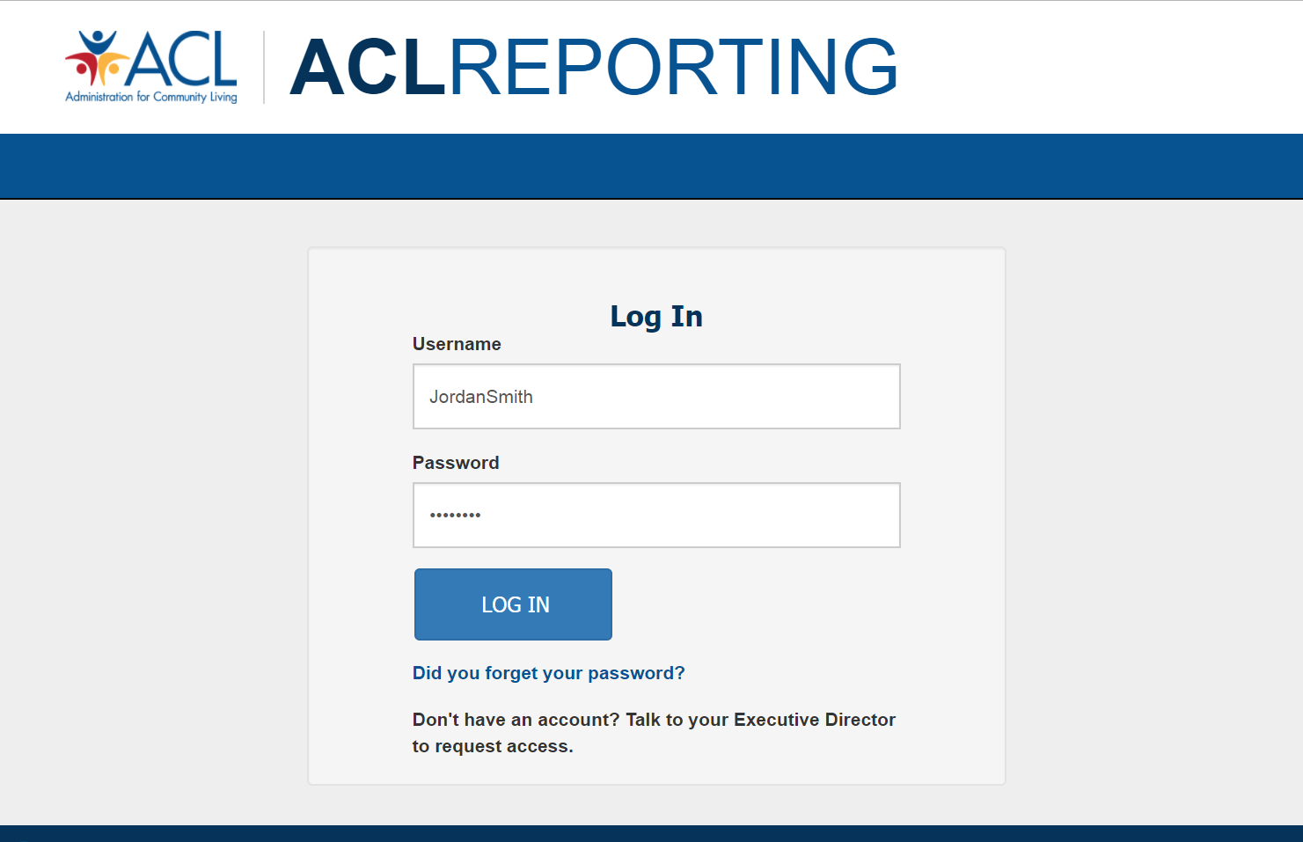

  - Select the “Administration” located in the upper right corner of the ACLReporting page and then select “User Management.”
Figure 2: Select User Management from Administration dropdown
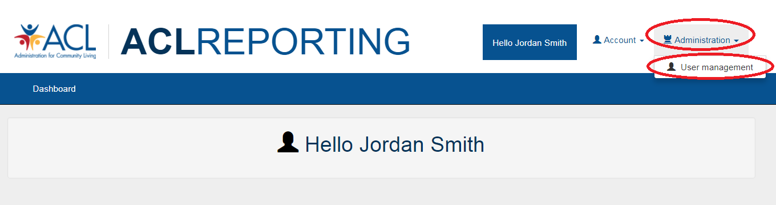

  - The “Users” screen will be displayed showing all users for the grant. Select “Create a new User” to create a new account.
Figure 3: Users screen showing all users for the grant
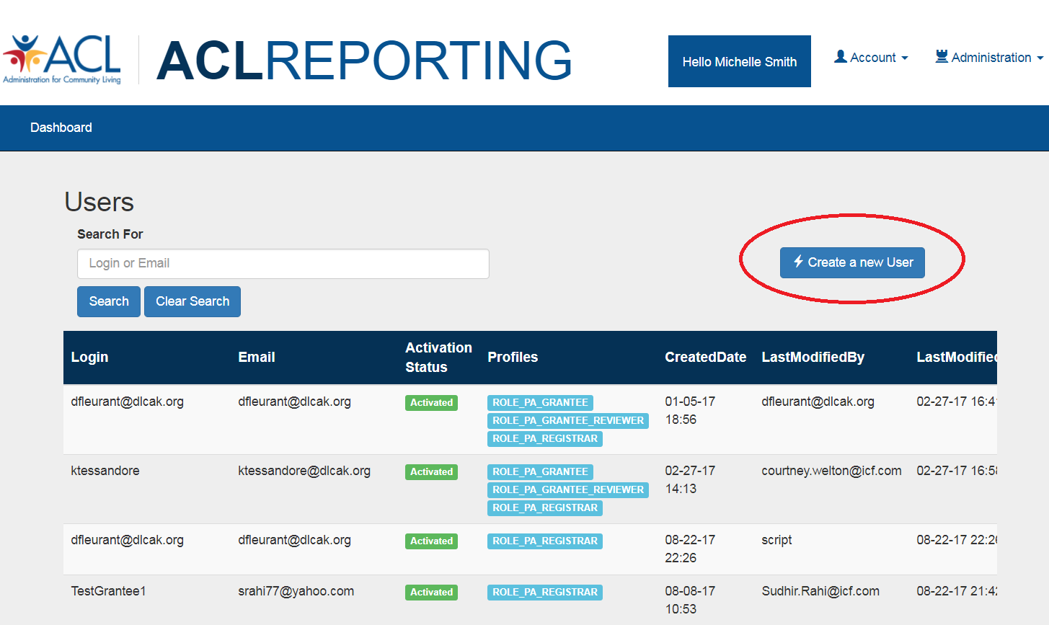

  - Enter the information provided by the new user , create password, select profile (multi-select by selecting one role, holding down the Ctrl key and selecting one or more additional roles), select grant (multi-select the necessary grants by selecting a grant, holding down the Ctrl key and select one or more additional grants) and select “Save.”
Figure 4: Create or Edit a User Screen Showing Fields That Need to be Entered
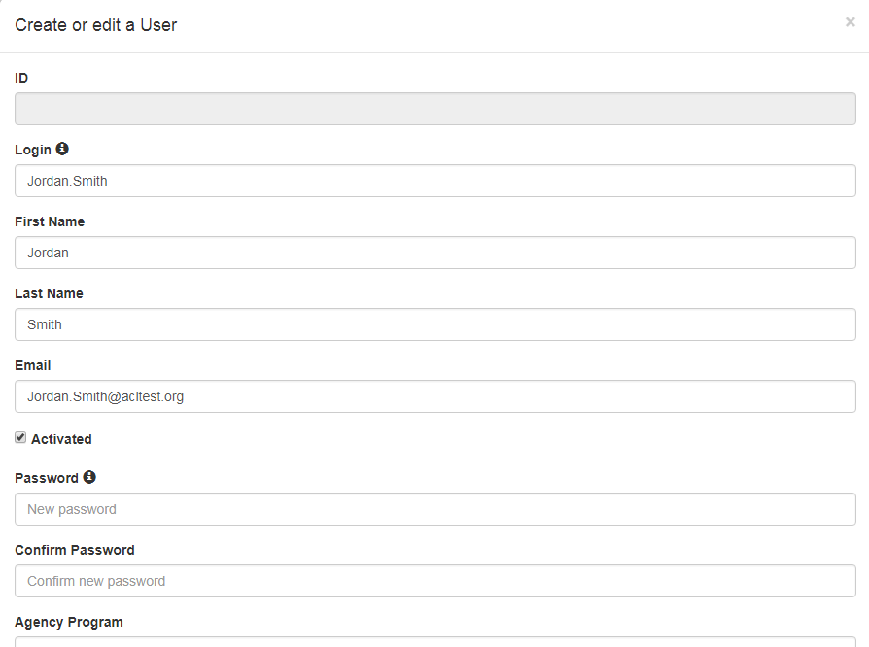

Login Instructions with Temporary Password
The following are the basic step-by-step instructions on logging into ACL Reporting for the first time.
- Go to the ACLReporting home page: https://reporting-pilot.acl.gov/#/
- Log in with your username and temporary password.
Figure 5: Log in with your username (generally your email address) and password

- The temporary password provided must be reset once you log into the system which can be found after clicking the “Account” tab on the upper right corner of the page.
Figure 6: Changing the password can be found under the Account tab
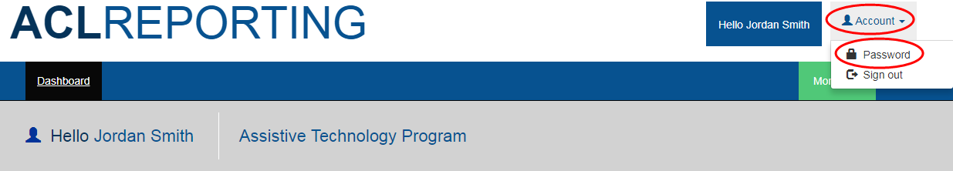

- The following page displays the form to set a permanent password. In order to meet password requirements, the new password should:
- Contain a minimum of 8 characters
- Contain at least one uppercase letter (e.g., A, B, C, Y, Z, etc.)
- Contain at least one lowercase letter (e.g., a, b, c, y, z, etc.)
- Contain at least one special character (e.g., ! @, #, $, %, ^, &, etc.)
- Contain at least one number (e.g., 1, 2, 3, 4, 5, etc.)
Failure to meet these requirements results in the system not allowing you to set your permanent password.
Figure 7: Setting a permanent password
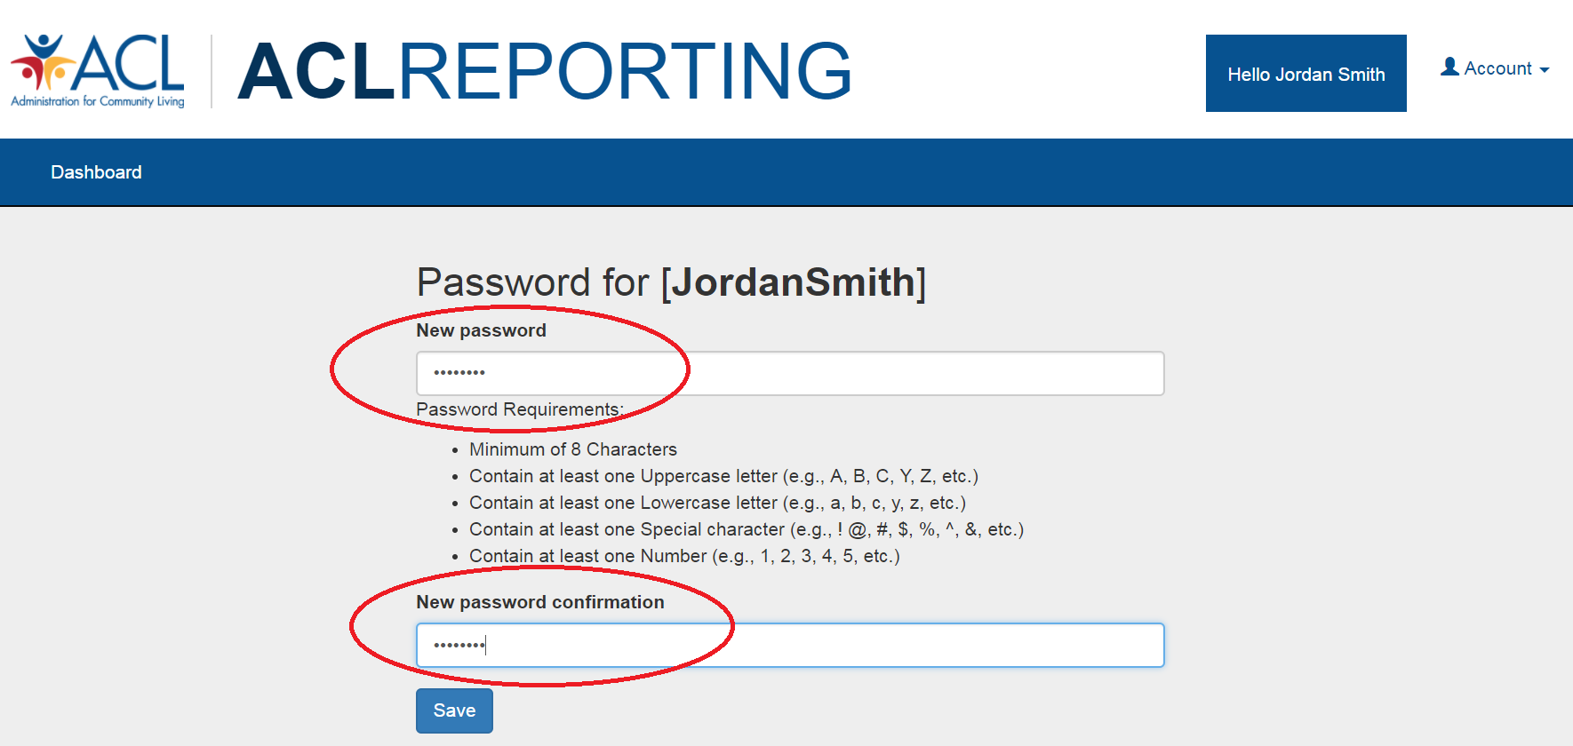

Active Users Login and Password Changes

Log in
- Go to the ACLReporting home page: https://reporting-pilot.acl.gov/#/
- Log in with your username and your provided temporary password.
Figure 8: Log in with your username (generally your email address) and password

Forgot Your Password?
- Select the “Did you forget your password?” link under the Log In button
Figure 9: Locating the "Did you forget your password" link
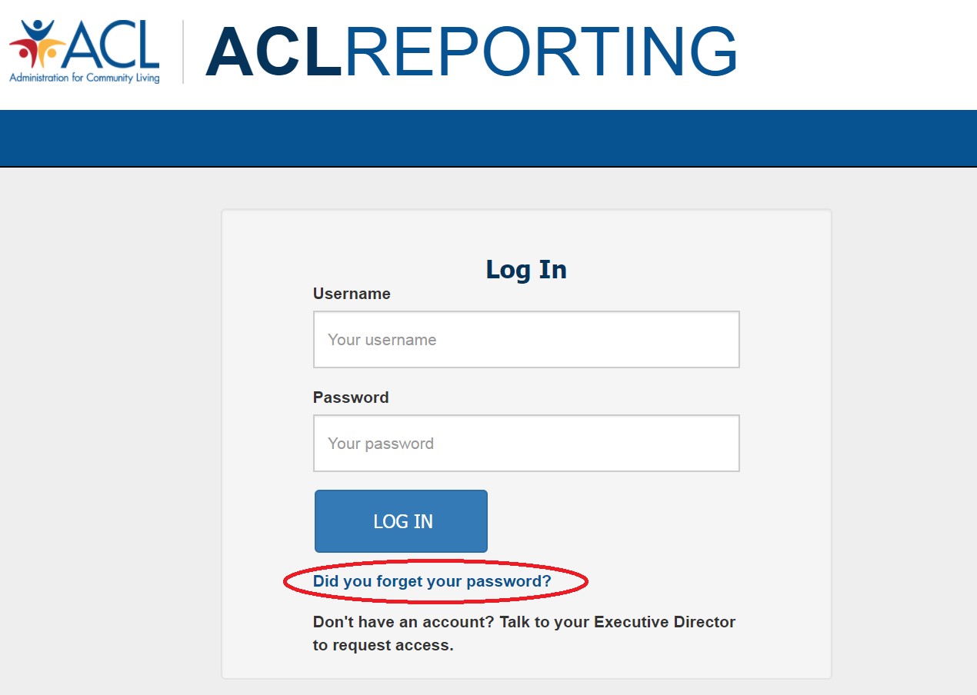

- Reset your password
Figure 10: After entering your email address, click the Register button
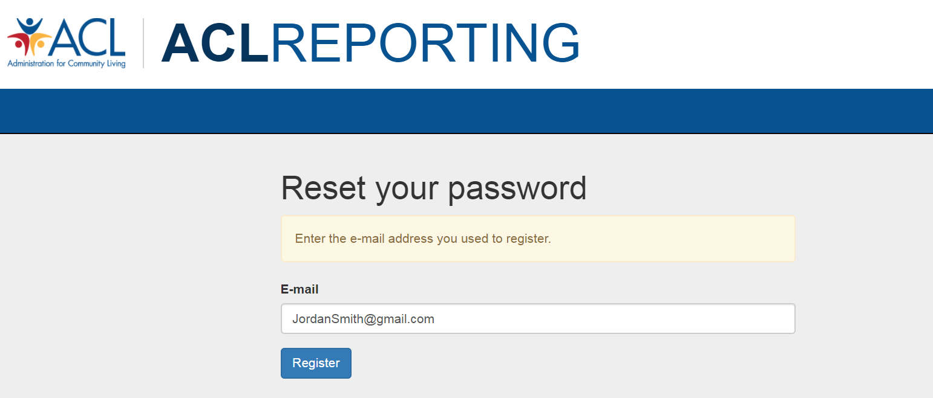

- You will see a confirmation page indicating an email has been sent to your registered email address with steps to reset your password.
Figure 11: Page displays further information to reset your password
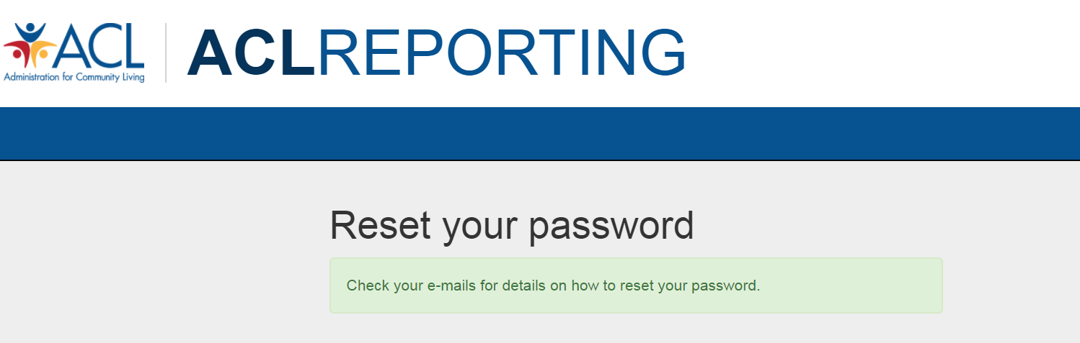

- Go to your email and select the link “Reset Password” provided in the email generated by the ACL Reporting system
Figure 12: Password reset email
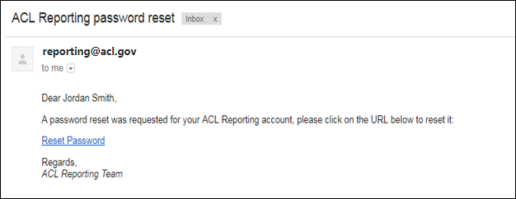

- This will open a new window in ACL Reporting so you can reset your password
Figure 13: Password reset page showing password and confirm password
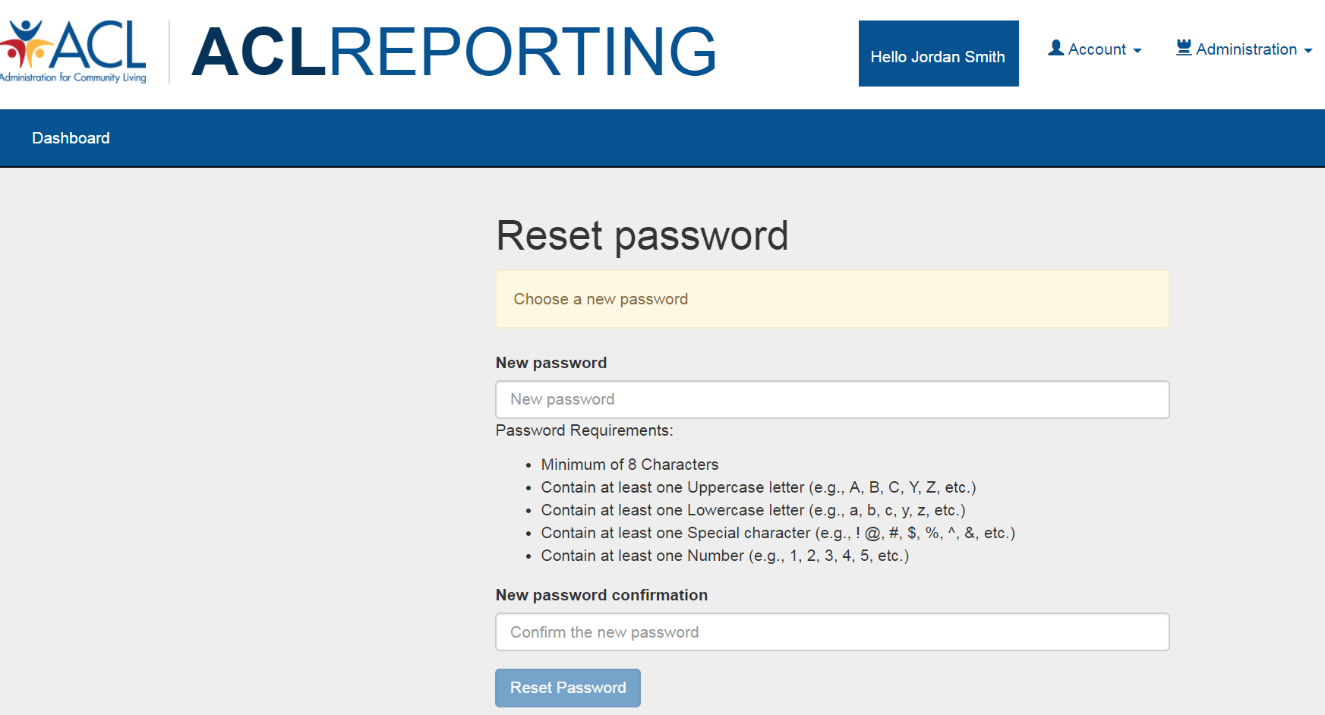

- In order to meet the password requirements, the new password must:
  - Contain a minimum of 8 characters
  - Contain at least one uppercase letter (e.g., A, B, C, Y, Z, etc.)
  - Contain at least one lowercase letter (e.g., a, b, c, y, z, etc.)
  - Contain at least one special character (e.g. !, @, #, $, %, ^, &, etc.)
  - Contain at least one number (e.g., 1, 2, 3, 4, 5, etc.)
Failure to meet these requirements results in the system not allowing you to reset your password and it will highlight the field red indicating that the requirement was not met.

- Successful password reset message will display once you meet the password requirements. To access the log in page again, select the sign in button
Figure 14: Successful password reset message displayed
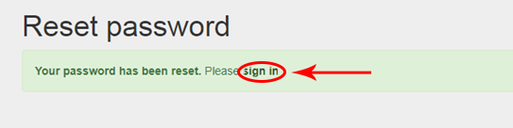

- Log in to the system with your username (generally your email address) and new password
Figure 15: Login with new password

Change Your Password
The following are the basic step-by-step instructions on how to change your password.

- Log into ACLReporting using your current password.
- Select “Account” located in the upper right corner of the ACLReporting page and then select “Password.”
Figure 16: Navigating to the password reset page

- Reset your password by entering in your new password.
Figure 17: Internal password reset page showing password and confirm password

- Once you have reset your password select “Dashboard” at the top of the screen to go back to your dashboard to begin reviewing your assigned states” grant reports.
Figure 18: Navigate back to Dashboard after password reset
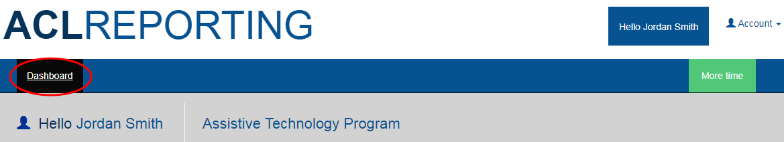

Entering Report Information

Grantee and Reviewers Dashboard
Once you have successfully logged in, you will see the ACLReporting Dashboard.
The Dashboard will show the “Select a form” dropdown which will have the two values:
- DD State Plan
  - Selecting this will display the DD State Plan dashboard.
- DD PPR
  - Selecting this will display the DD PPR dashboard.

Figure 19: Grantee/Reviewer Dashboard showing “Select a form” dropdown
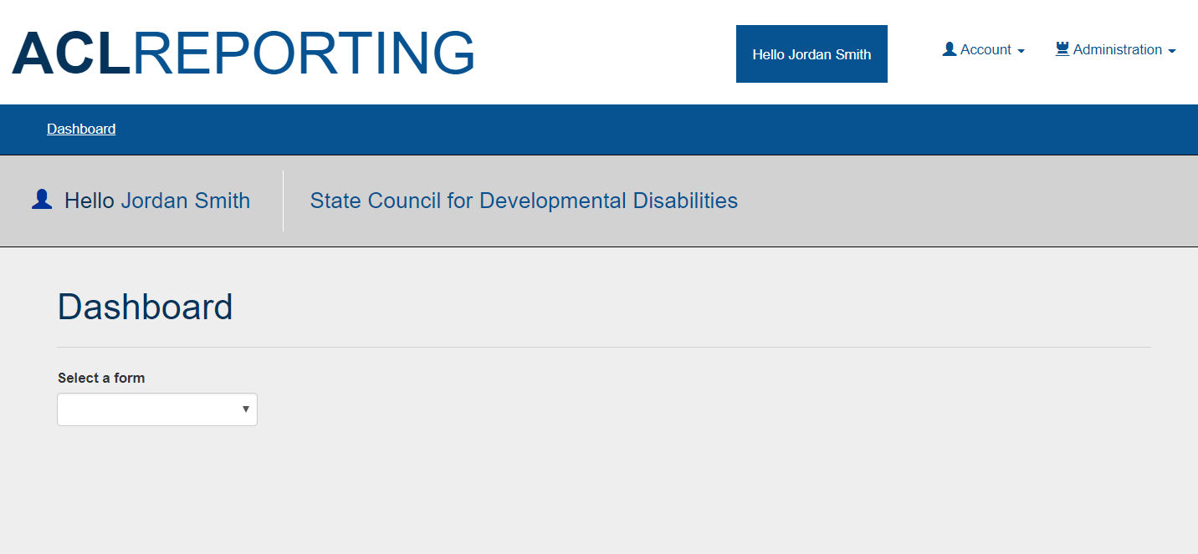

The DD PPR Dashboard will show the “Select a Federal Fiscal Year” dropdown and will show the report sections as well as the current status of the section.
The “Select a Federal Fiscal Year” dropdown will show the federal fiscal years. Selecting a year will display the report for that year.

Figure 20: Grantee/Reviewer Dashboard showing all sections as “Not Started”
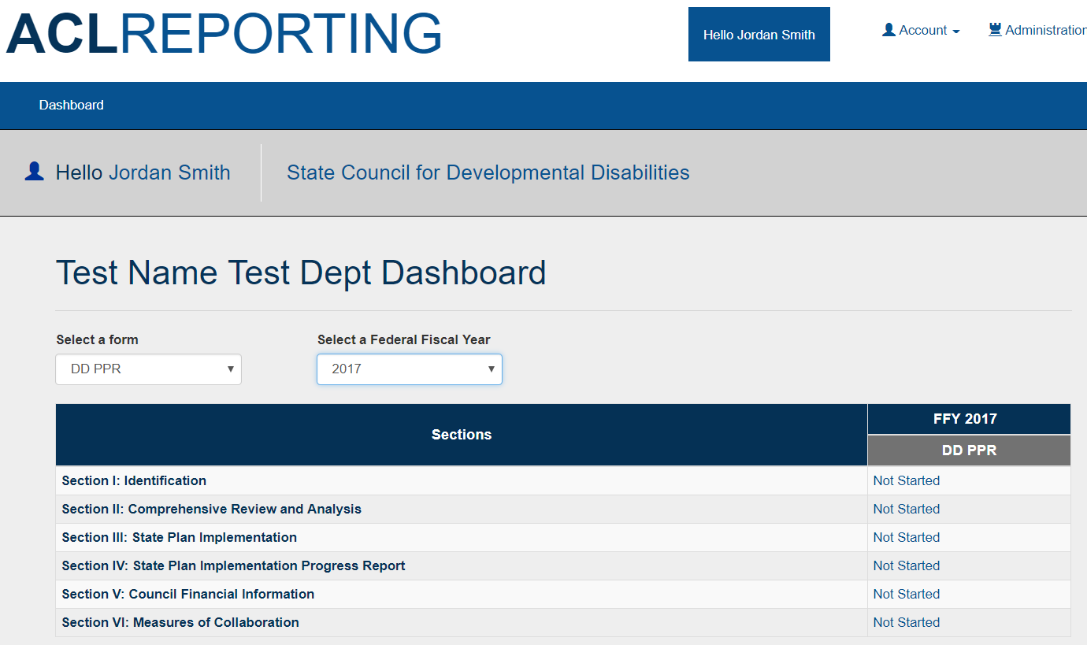

The statuses that a report section can have are:
- Not Started
  - Grantee has not entered any information in the section.
- In Progress
  - Grantee has entered and saved information in the section. Entering data into a section will change its status from ‘Not Started’ to ‘In Progress’.
- Ready for Internal Review
  - After the Grantee completes entering information in a section, the ‘Ready for Internal Review’ button will become visible and can be selected.
  - When the Grantee selects the ‘Ready for Internal Review’ button, the status of the section will change from ‘In Progress’ to ‘Ready for Internal Review’.
- Reviewed
  - The Reviewer will have the ability to review a section once it is in ‘Ready for Internal Review’ status.
  - The Reviewer only has the ability to review the form.
  - If no changes are needed in the section, they can select the ‘Reviewed’ button. This will change the status of the section to from ‘Ready for Internal Review’ to ‘Reviewed’ status.
  - If changes are needed in the section, they can select the ‘Request Revisions’ button. This will change the status of the section to from ‘Ready for Internal Review’ back to ‘In Progress’ status.
- Submitted
  - The Reviewer will review all sections of the report. After all sections in the report are in ‘Reviewed’ status, the ‘Submit’ button will appear on top of the Dashboard.
  - The Reviewer will select the ‘Submit’ button and this will cause all sections of the report to have the status of ‘Submitted’.
- Approved/Disapproved
  - The Project Officer will have the ability to review a section once it is in ‘Submitted’ status.
  - The Project Officer only has the ability to review the form.
  - If no changes are needed in the section, the Project Officer can select the ‘Validate’ button. After all sections in the report have been validated, the ‘Approve’ button will appear on top of the Dashboard. The Project Officer will select the ‘Approve’ button and this will cause all sections of the report to have the status of ‘Approved’.
  - If changes are needed in the section, the Project Officer can select the ‘Disapprove’ button. The ‘Reject’ button will appear on top of the Dashboard. The Project Officer will select the ‘Reject’ button and this will cause the disapproved section of the report to have the status of ‘Disapproved’. The process will start from Step 2 again.

Saving Information Entered in a Section
Once the Grantee has entered information in a report section, they can save the information in two ways:
- Save Button
The Grantee can save the information they have entered by selecting the “Save” button at the bottom of the screen. After they have selected the “Save” button, the date and timestamp will be updated.
Figure 21: Save Information by selecting Save button and seeing confirmation of save
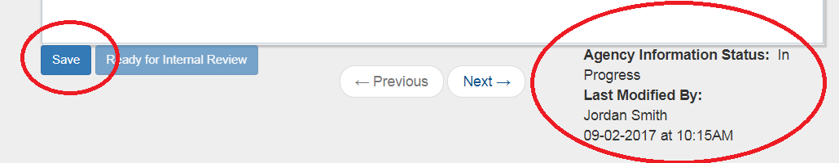

- Going to the Next or Previous Section
The Grantee can go to the next or previous section by selecting the “Previous” or “Next” button. If the Grantee has not saved the information they have entered in the form, the system will show a pop-up for the Grantee to select “OK” to save the information or “Cancel” to not save the information.
Figure 22: Going to the Next or Previous Section and being asked to save
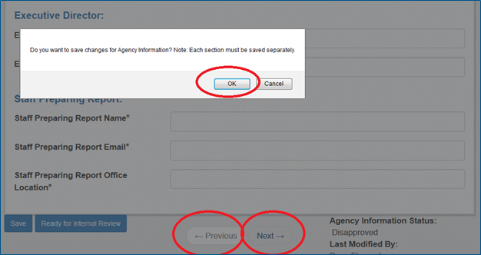

Error Messages
As you enter information into each section, you may encounter error messages. The error message will explain the reason why an error has occurred and the action needed to correct it.
Shown below are some examples of the common error messages.
- “*” indicates a required field. If a required field is left empty, the following error message is displayed: “The field is required.”
- Number fields length. The number fields have maximum lengths. For example, if a number field has a maximum length of 7 numbers, then then the following error message is displayed if you enter more than 7 numbers: “The field cannot contain more than 7 digits.”
- The phone number must be a 10 digit number. If a non-number is entered or if total number of numbers is not 10 digits then the following error message is displayed: “The field must be a 10 digit number”.
- The email address must have a valid format (abc@xyz.com). If the email address is not valid then the following error message is displayed: “This field must be a valid e-mail address.”
Figure 23: Error Message Examples

Section I. Identification
The Section I Identification screen contains the following fields:
1. State Territory
2. Federal Fiscal Year Reporting
3. Contact person regarding PPR information
4. Contact person's phone number
5. Contact person's e-mail address
6. Executive Director name (if different from contact person)
7. Executive Director’s phone number
8. Executive Director’s email address
The Grantee will be required to enter information into all fields with the exception of the “Executive Director name (if different from contact person)” field which is optional.

Figure 24: Section I: Identification
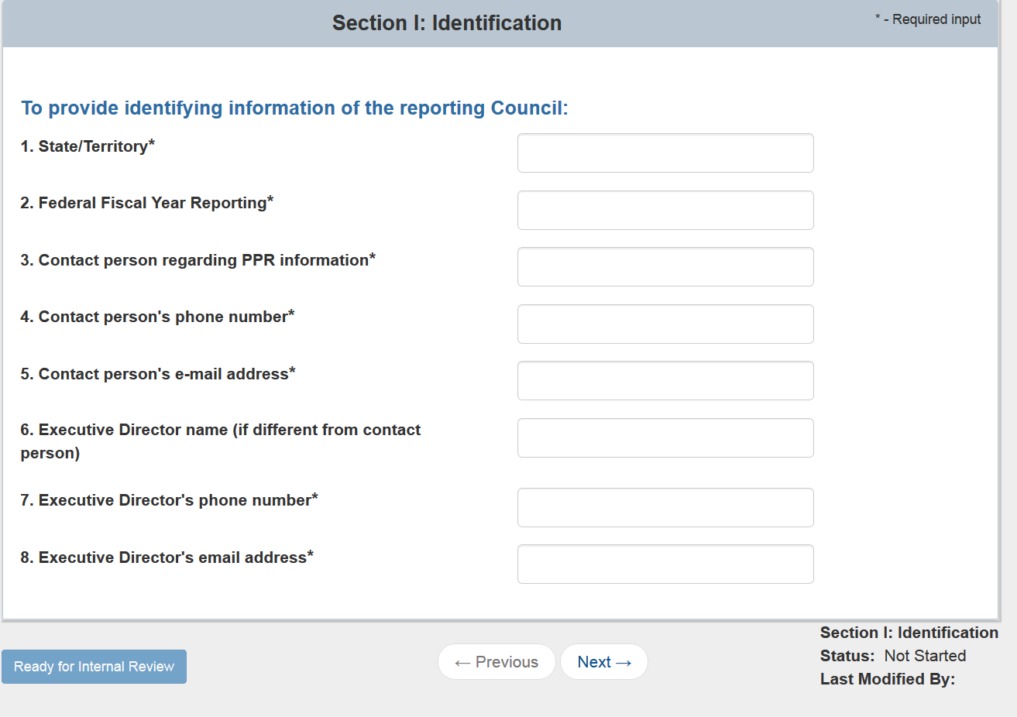
- Validations
  - “*” Indicates that a field is required. If a required field is left empty, the field is highlighted in red and the following validation message is displayed: “The field is required”.
  - The “Contact person's phone number” and “Executive Director’s phone number” fields must be 10 numerical digits only. If 10 digits are not entered, then the corresponding field is highlighted in red and the following validation message is displayed: “This field must be a 10 digit phone number”.
  - The “Executive Director name (if different from contact person)” field must have a “@” character to signify that a legitimate e-mail address has been entered. If the “@” character is not entered, then the corresponding field is highlighted in red and the following validation message is displayed: “This field must be a valid e-mail address”.

Section II. Comprehensive Review and Analysis
The “Comprehensive Review and Analysis” section contains the following 2 rich text editors which the Grantee is required to enter:
- Adequacy of health care and other services, supports and assistance that individuals with developmental disabilities in Intermediate Care Facilities (ICF) receive.
- Adequacy of health care and other services, supports, and assistance that individuals with developmental disabilities served through home and community-based waivers receive.
The Grantee can select “Edit” to open the rich text editor and enter in information. When information has been entered, the Grantee will need to select “Done”. To “View” the entered in information, the Grantee can select the “View”.
Figure 25: Section II: Comprehensive Review and Analysis
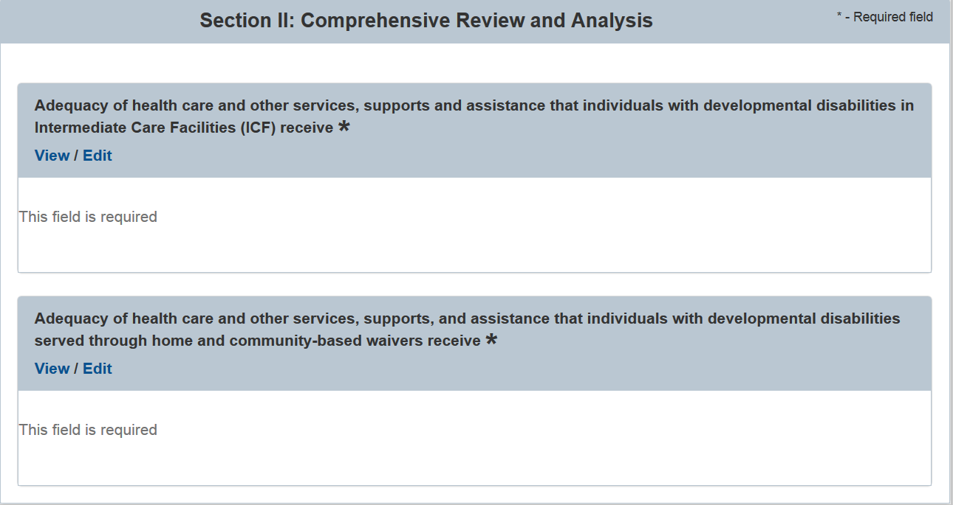
- Validations
  - “*” indicates that a field is required. If a required field is left empty, the field is highlighted in red and the following validation message is displayed: “The field is required”.
  - All characters are allowed and there is a character limit of 10,000 characters which is about 4 pages.

Section III. State Plan Implementation
The State Plan Implementation section contains 6 rich text editors which the Grantee is required to enter. The rich text editors are split into three sub-sections: A, B and C.
Figure 26: Section III: State Plan Implementation
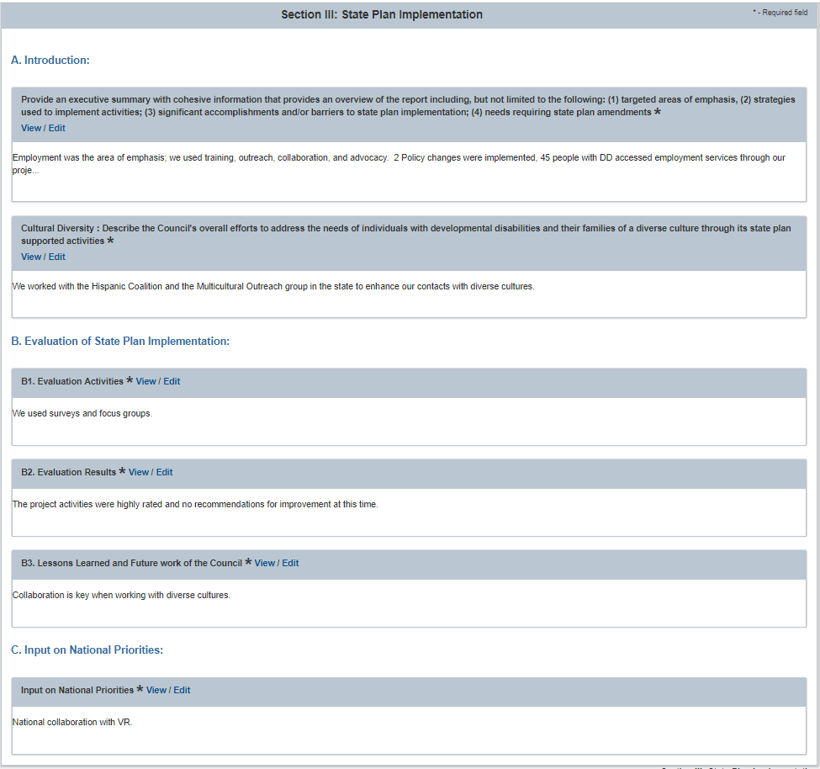

The Grantee can select “Edit” to open the rich text editor and enter in information. When information has been entered, the Grantee can select “Done”. To “View” the entered in information, the Grantee can select the “View” link.
The “A. Introduction” sub-section contains the following two rich text editors:
- Provide an executive summary with cohesive information that provides an overview of the report including, but not limited to the following: (1) targeted areas of emphasis, (2) strategies used to implement activities; (3) significant accomplishments and/or barriers to state plan implementation; (4) needs requiring state plan amendments.
- Cultural Diversity: Describe the Council's overall efforts to address the needs of individuals with developmental disabilities and their families of a diverse culture through its state plan supported activities.
The “B. Evaluation of State Plan Implementation” sub-section contains the following three rich text editors:
- B1. Evaluation Activities
- B2. Evaluation Results
- B3. Lessons Learned and Future work of the Council

The “C. Input on National Priorities” sub-section contains one rich text editor.

Validations
- “*” indicates that a field is required. If a required field is left empty, the field is highlighted in red and the following validation message is displayed: “The field is required”.
- All characters are allowed and there is a character limit of 10,000 characters which is about 4 pages

Section IV. State Plan Implementation Progress Report
Section IV. State Plan Implementation Progress Report is broken down into 3 sub-sections and are displayed as tabs for each goal at the top of the screen:
A. Section IV.A - Detailed Progress Report on Goals
B. Section IV.B - Individual & Family Advocacy Performance Measure
C. Section IV.C - System Change Performance Measures
Figure 27: Section IV: State Plan Implementation Progress Report Sub-Sections
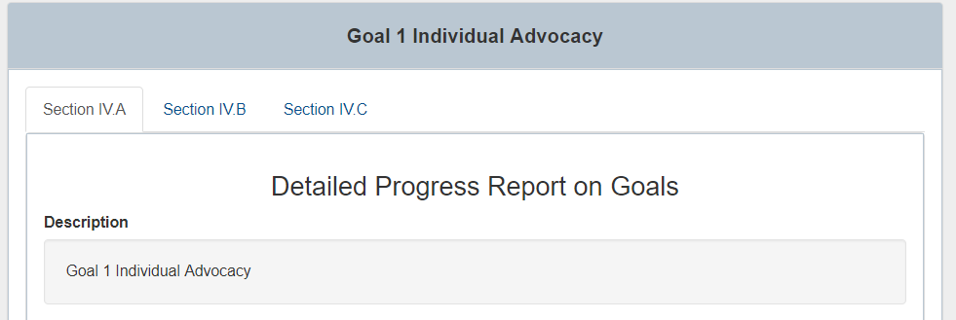

The Section IV: State Plan Implementation Progress Report section in the left hand panel will show one or more bullet points. Each bullet point will list a goal from the approved State Plan. Each goal is a link that will display the goal sub-sections when it is selected.
Figure 28: Section IV: State Plan Implementation Progress Report goals with two goals
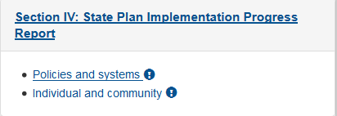

Section IV. A: Detailed Progress Report on Goals

When the Grantee selects the Section IV. A tab at the top of the screen, it is highlighted in gray, while Section IV.B and Section IV.C are still in blue.

Figure 29: Section IV.A: Detailed Progress Report on Goals Part 1
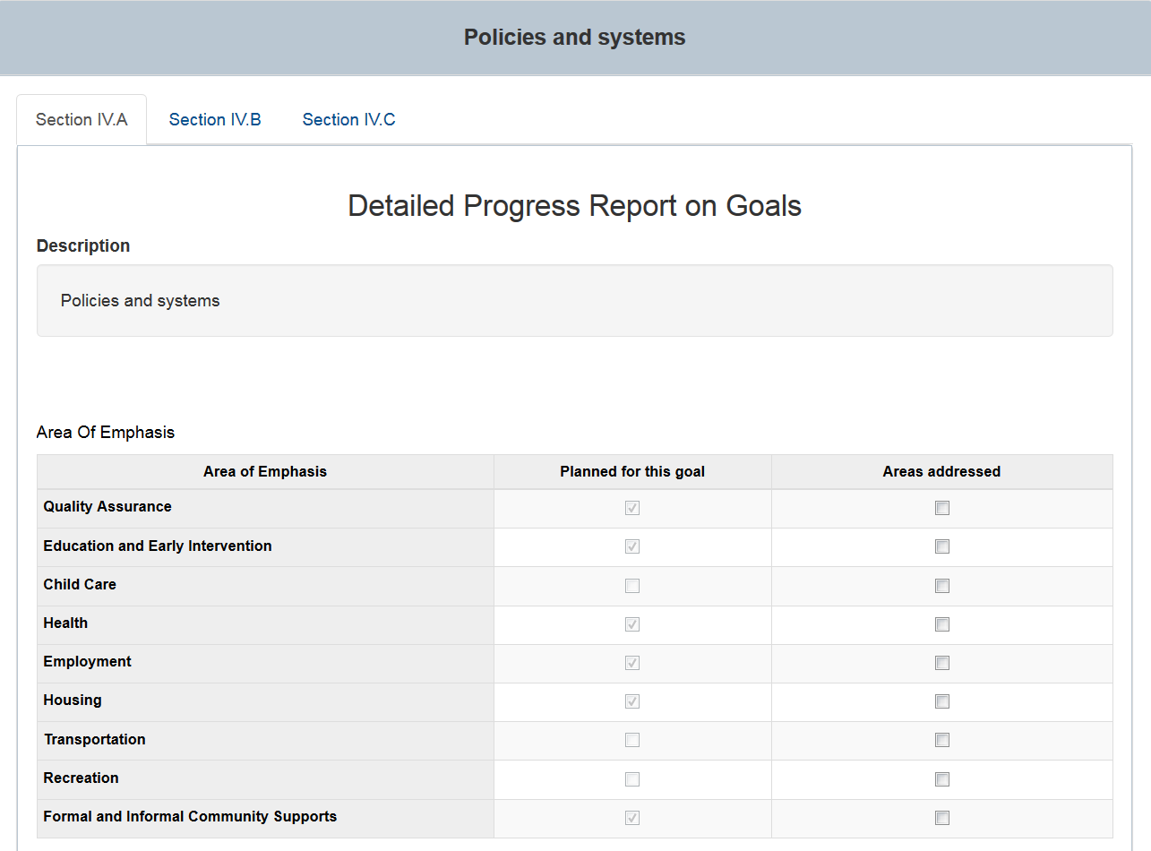

Section IV. A will contain a Description which contains a description of the goal taken from the State Plan.

The first table is titled “Area of Emphasis” and it contains the following 3 columns: “Area of Emphasis”, “Planned for this goal’ and “Areas addressed’.
- The “Area of Emphasis” column contains a list of rows taken directly from the State Plan. The rows are: Quality Assurance, Education and Early Intervention, Child Care, Health, Employment, Housing, Transportation, Recreation, Formal and Informal Community Supports
- The “Planned for this goal” column is read only and shows checkboxes. The checked and unchecked values in this column come from the State Plan.
- The “Areas Addressed” column contains checkboxes that Grantee can check. None of these are be required to be checked and are optional.
Figure 30: Section IV.A: Detailed Progress Report on Goals Part 2
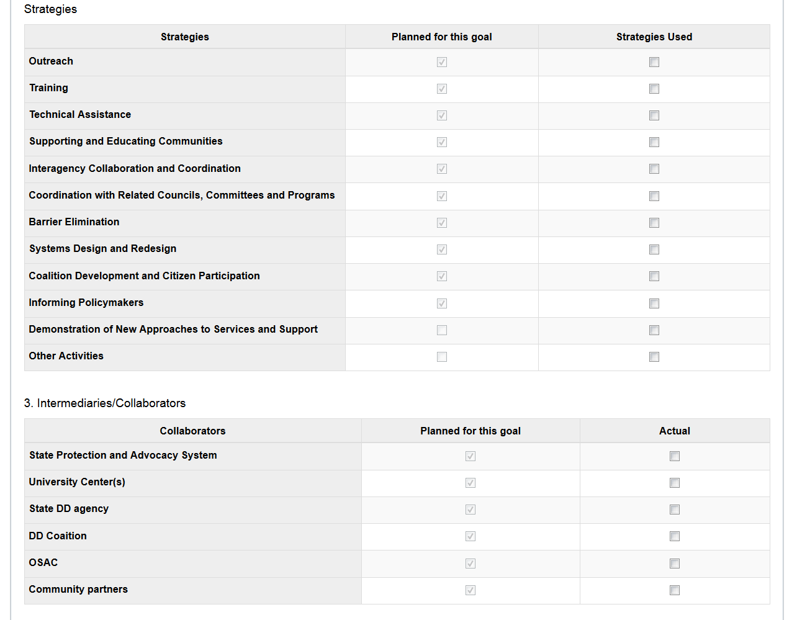

The second table is titled “Strategies” and it contains the following 3 columns: “Strategies”, “Planned for this goal” and “Actual”.
- The “Strategies” column contains a list of rows taken directly from the State Plan. The rows are: Outreach, Training, Technical Assistance, Supporting and Educating Communities, Interagency Collaboration and Coordination, Coordination with Related Councils, Committees and Programs, Barrier Elimination, Systems Design and Redesign, Coalition Development and Citizen Participation, Informing Policymakers, Demonstration of New Approaches to Services and Support, Other Activities
- The “Planned for this goal” column is read only and shows checkboxes. The checked and unchecked values in this column come from the State Plan.
- The “Actual” column contains checkboxes that Grantee can check. None of these are be required to be checked and are optional.

The third table is titled “Intermediaries/Collaborators” and it contains the following 3 columns: “Collaborators”, “Planned for this goal” and “Actual”.
- The “Strategies” column contains a list of rows taken directly from the State Plan. The rows are: State Protection and Advocacy System, University Center(s), State DD Agency, HUD
- The “Planned for this goal” column is read only and shows checkboxes. The checked and unchecked values in this column come from the State Plan.
- The “Actual” column contains checkboxes that Grantee can check. None of these are be required to be checked and are optional.

Figure 31: Section IV.A: Detailed Progress Report on Goals Part 3
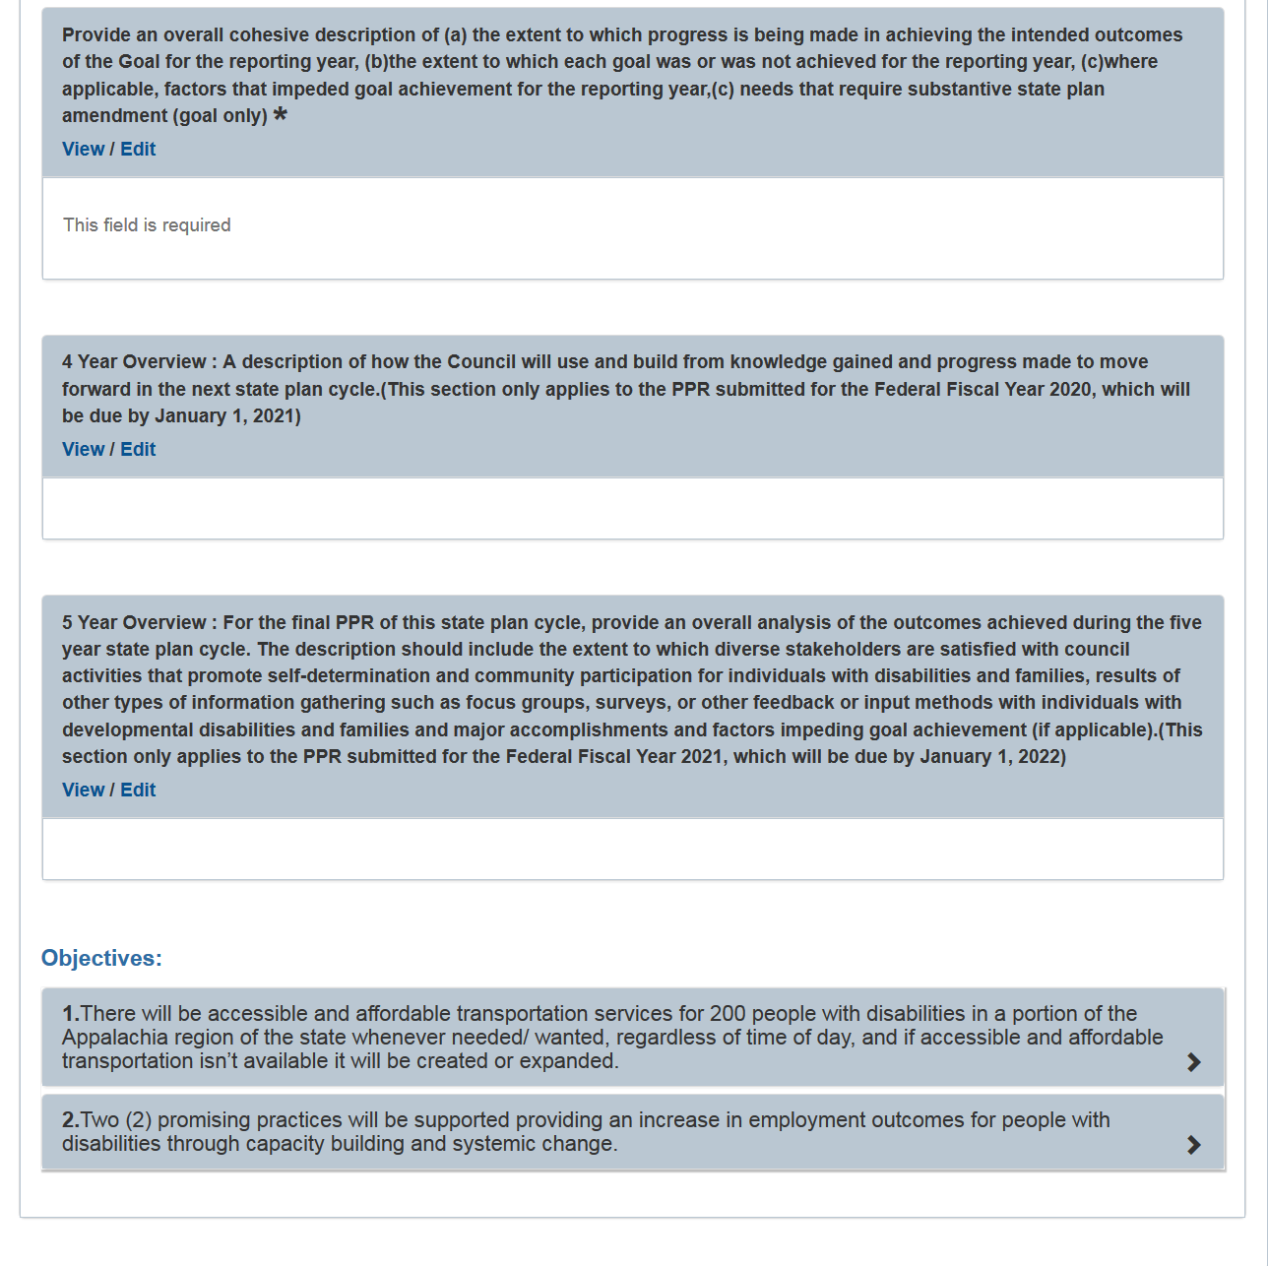

There are 3 rich text editors followed by a list of objectives.
- The first rich text editor is titled “Provide an overall cohesive description of (a) the extent to which progress is being made in achieving the intended outcomes of the Goal for the reporting year, (b) the extent to which each goal was or was not achieved for the reporting year, (c) where applicable, factors that impeded goal achievement for the reporting year, (c) needs that require substantive state plan amendment (goal only) *”. The * indicates that this rich text editor is required to have text entered into it. The Grantee can select “Edit” to open the rich text editor and enter in information. When information has been entered, the Grantee can select “Done”. To “View” the entered in information the “View” link would need to be selected.
- The second rich text editor is titled “4 Year Overview: A description of how the Council will use and build from knowledge gained and progress made to move forward in the next state plan cycle. (This section only applies to the PPR submitted for the Federal Fiscal Year 2020, which will be due by January 1, 2021).” This rich text editor is disabled and no information can be entered until 2021.
- The third rich text editor is titled “5 Year Overview: For the final PPR of this state plan cycle, provide an overall analysis of the outcomes achieved during the five year state plan cycle. The description should include the extent to which diverse stakeholders are satisfied with council activities that promote self-determination and community participation for individuals with disabilities and families, results of other types of information gathering such as focus groups, surveys, or other feedback or input methods with individuals with developmental disabilities and families and major accomplishments and factors impeding goal achievement (if applicable).(This section only applies to the PPR submitted for the Federal Fiscal Year 2021, which will be due by January 1, 2022)”. This rich text editor is disabled and no information can be entered until 2022.

- Validations
  - “*” indicates that a field is required. If a required field is left empty, the field is highlighted in red and the following validation message is displayed: “The field is required”.
  - The rich text editors have a maximum length of 10,000 characters. If more than 10,000 characters are entered, then the field is highlighted in red and the following validation message is displayed: “The field cannot contain more than 10,000 characters”.

Objectives
All Objectives that have been entered in the State Plan will be listed in the order they appear in the State Plan. The Grantee is required to enter information for each objective by selecting the “>” icon located on the right side of each objective. Selecting the “>” icon will open the objective section.
Figure 32: Section IV.A: Objective Part 1
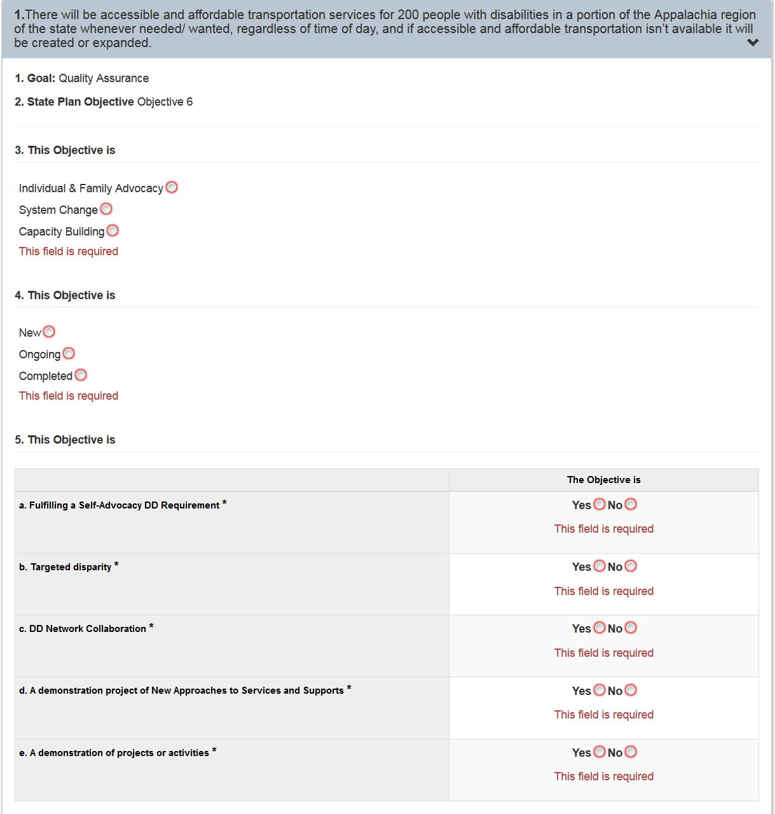

Figure 33: Section IV.A: Objective Part 2
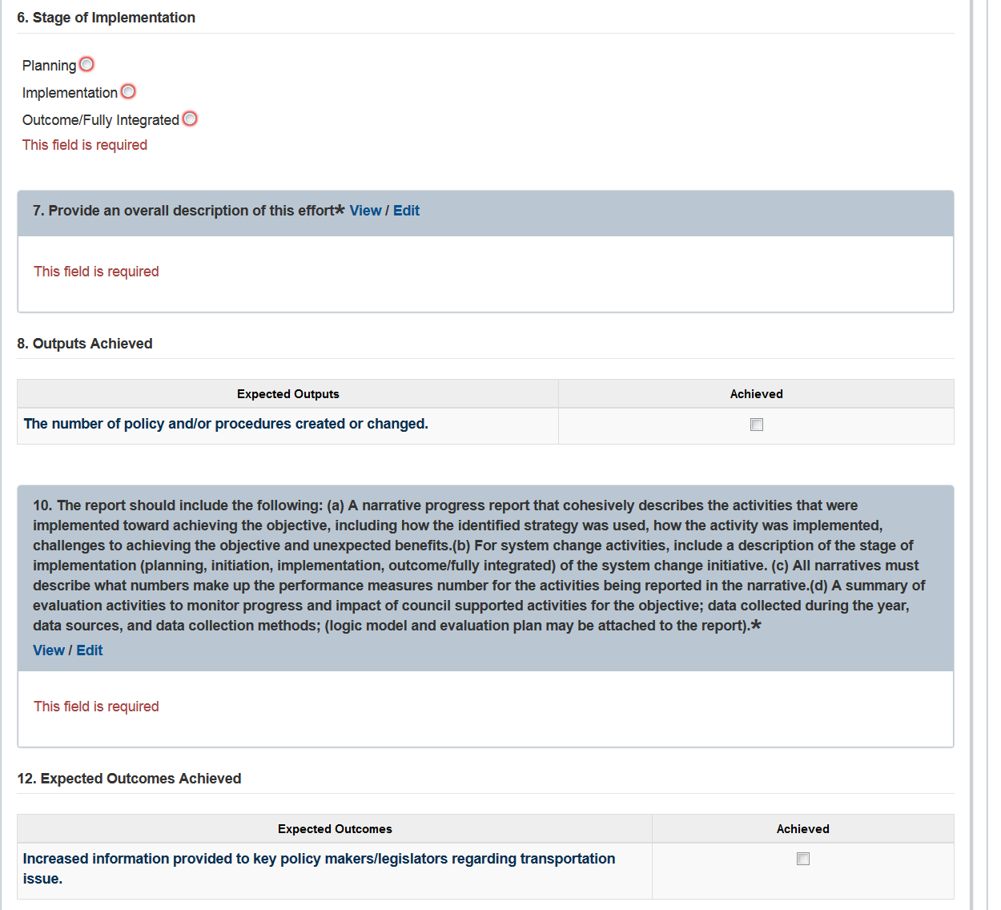

Figure 34: Section IV.A: Objective Part 3
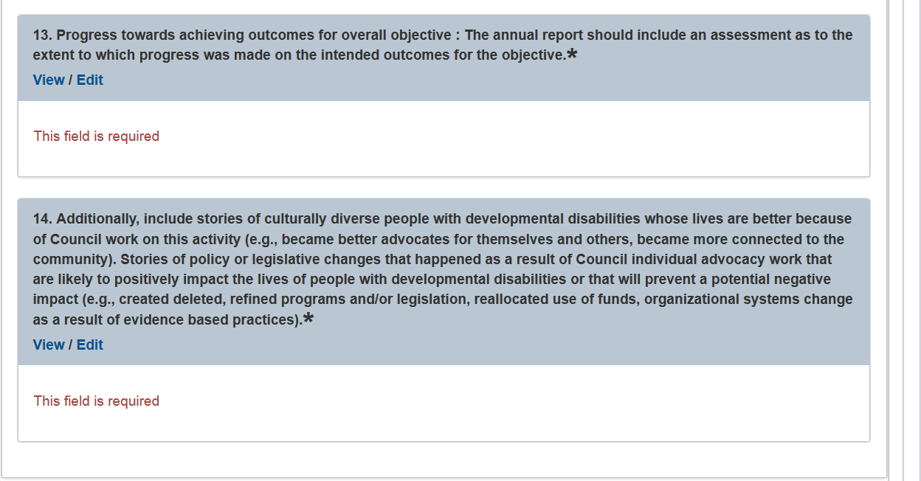

Each objective will contain the following areas of information:
- Goal: This is a read only field that contains goal description from the State Plan.
- State Plan Objective: This is a read only field that contains the objective description from the State Plan.
- This Objective is: This contains radio buttons that the Grantee is required to select one option. The radio button options are: Individual & Family Advocacy, System Change and Capacity Building.
- This Objective is: This contains radio buttons that the Grantee is required to select one option. The radio button options are: New, Ongoing and Completed.
- This Objective is: This is a table contain the following 5 rows of Yes/No radio buttons that the Grantee is required to select one option. The rows are:
  - a. Fulfilling a Self-Advocacy DD Requirement
  - b. Targeted disparity
  - c. DD Network Collaboration
  - d. A demonstration project of New Approaches to Services and Supports
    - Selecting ‘Yes’ will display two additional data entry fields that the Grantee is required to enter:
      - Project Name
      - Original Start Date: Data must be entered in MM/DD/YYYY format or selected from the calendar.
  - e. A demonstration of projects or activities
    - Selecting ‘Yes’ will display two additional data entry fields that the Grantee is required to enter:
      - Project Name
      - Original Start Date: Data must be entered in MM/DD/YYYY format or selected from the calendar.
- Stages of Implementation: This contains radio buttons that the Grantee is required to select one option. The radio button options are: Planning, Implementation and Outcome/Fully Integrated.
- Provide an overall description of this effort: This a rich text editor that the Grantee is required to enter information. There is a 10,000 characters limit.
- Outputs Achieved: This contains a table with the following two columns: Expected Outputs and Achieved. The Expected Outputs column will contains rows from the State Plan and the Achieved columns contains checkboxes. The Grantee is not required to make selections.
- The report should include the following: (a) A narrative progress that cohesively describes the activities that were implemented toward achieving the objective, including how the identified strategy was used, how the activity was implemented, challenged to achieving the objective and unexpected benefits. (b) For system change activities, include a description of the stage of implementation (Planning, initiation, implementation, outcome/fully integrated) of the system change initiative. (c) All narratives must describe what numbers make up the performance measures number for the activities being reported in the narrative. (d) A summary of evaluation activities to monitor progress and impact of council supported activities for the objective; data collected during the year, data sources, and data collection methods; (logic model and evaluation plan may be attached to the report): This a rich text editor that the Grantee is required to enter information. There is a 5,000 characters limit.
- Expected Outcomes: This contains a table with the following two columns: Expected Outcomes and Achieved. The Expected Outputs column will contains rows from the State Plan and the Achieved columns contained checkboxes. The Grantee is not required to make selections.
- Progress towards achieving outcomes for overall objective: The annual report should include an assessment as to the extent to which progress was made on the intended outcomes for the objective. This is a rich text editor that the person with the Grantee role is required to enter information. There is a 5,000 character limit, which is approximately 1.5 pages of single spaced text.
- Additionally, include stories of culturally diverse people with developmental disabilities whose lives are better because of Council work on this activity (e.g., became better advocates for themselves and others, became more connected to the community). Stories of policy or legislative changes that happened as a result of Council individual advocacy work that are likely to positively impact the lives of people with developmental disabilities or that will prevent a potential negative impact (e.g., created deleted, refined programs and/or legislation, reallocated use of funds, organizational systems change as a result of evidence based practices This a rich text editor that the Grantee is required to enter information. There is a 5,000 characters limit.

- Validations
  - “*” indicates that a field is required. If a required field is left empty, the field is highlighted in red and the following validation message is displayed: “The field is required”.

Section IV. B: Individual & Family Advocacy Performance Measure

Figure 35: Section IV.B: Individual & Family Advocacy Performance Measure Part 1
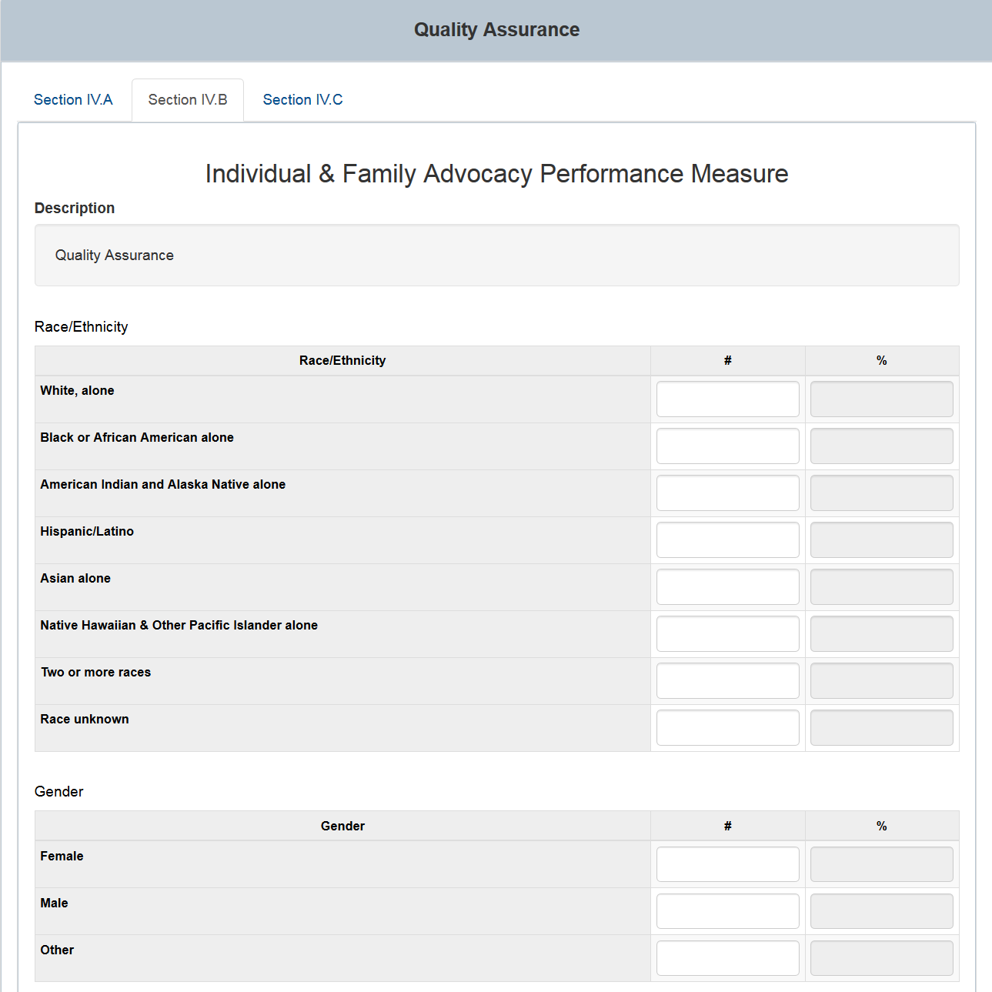

Figure 36: Section IV.B: Individual & Family Advocacy Performance Measure Part 2
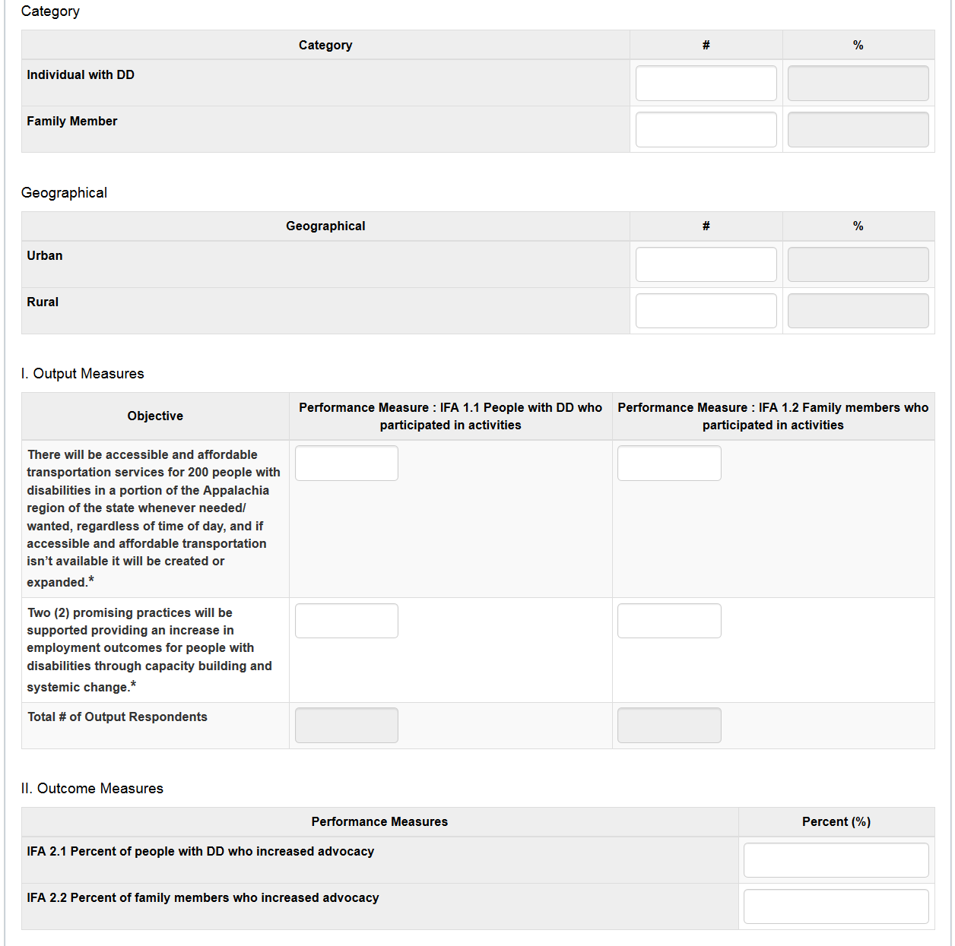

Figure 37: Section IV.B: Individual & Family Advocacy Performance Measure Part 3
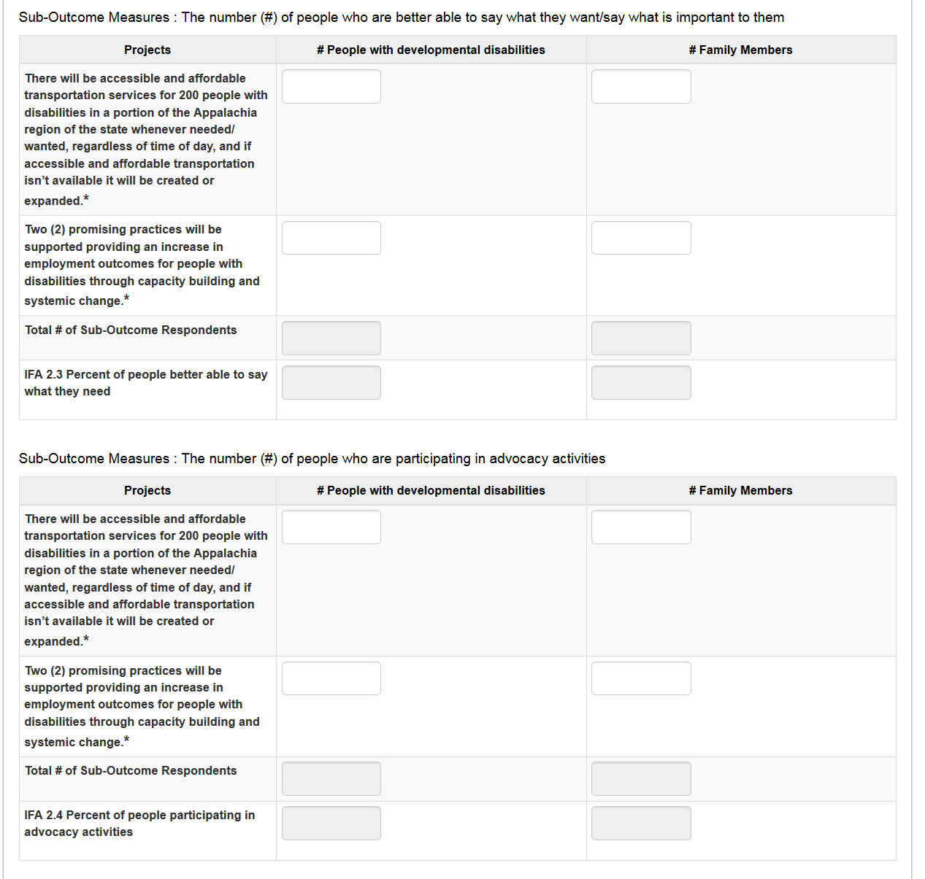
Figure 38: Section IV.B: Individual & Family Advocacy Performance Measure Part 4
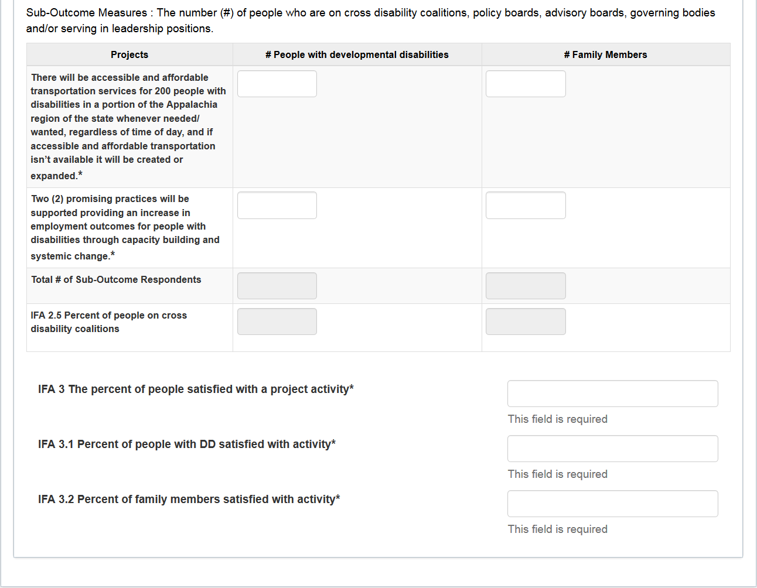

Section IV.B: Individual & Family Advocacy Performance Measure will contain the following areas of information:
- Description: This is a read only field that contains goal description from the State Plan.
- Race/Ethnicity: This is a table that contains three columns. The Grantee is not required to enter information in this table.
  - The Race/Ethnicity column has the following rows: White alone, Black or African American alone, American Indian and Alaska Native alone, Hispanic/Latino, Asian alone, Native Hawaiian & Other Pacific Islander alone, Two or more races and Race unknown.
  - The # column has data entry fields in which only numbers can be entered.
  - The % column has read only fields that displays the percentage based on the following calculation: Entered number for the field/Total of all entered numbers.
- Gender: This is a table that contains three columns. The Grantee is not required to enter information in this table.
  - Gender column has the following rows: Male, Female and Other.
  - The # column has data entry fields in which only numbers can be entered.
  - The % column has read only fields that displays the percentage based on the following calculation: Entered number for the field/Total of all entered numbers.
- Category: This is a table that contains three columns. The Grantee is not required to enter information in this table.
  - Category column has the following rows: Individual with DD and Family Member.
  - The # column has data entry fields in which only numbers can be entered.
  - The % column has read only fields that displays the percentage based on the following calculation: Entered number for the field/Total of all entered numbers.
- Geographical: This is a table that contains three columns. The Grantee is not required to enter information in this table.
  - Geographical column has the following rows: Urban and Rural.
  - The # column has data entry fields in which only numbers can be entered.
  - The % column has read only fields that displays the percentage based on the following calculation: Entered number for the field/Total of all entered numbers.
- Output Measures: This is a table that contains three columns. The Grantee is required to enter information in this table.
  - Objective column will list all objectives from the State Plan.
  - The ‘Performance Measure: IFA 1.1 People with DD who participated in activities’ column has data entry fields in which numbers can be entered.
  - The ‘Performance Measure: IFA 1.2 People with DD who participated in activities’ column has data entry fields in which numbers can be entered.
  - The “Total # of Output Respondents” row will automatically total the entered values in each column.
  - Validations
    - The fields for each Objective will have a maximum length of 7 numbers. If more than 7 numbers are entered, then the field is highlighted in red and the following validation message is displayed: “The field cannot contain more than 7 digits”.
    - If the required fields are blank, the following error message is displayed: “This field is required.”
- Outcome Measures: This is a table that contains two columns. The Grantee is not required to enter information in this table.
  - Performance Measures column has the following rows: ‘IFA 2.1 Percent of people with DD’ and ‘IFA 2.2 Percent of family members who increased advocacy’.
  - The % column has data entry fields in which only numbers can be entered.
- Sub-Outcome Measures - The number (#) of people who are better able to say what they want/say what is important to them. This is a table that contains three columns. The Grantee is required to enter information in this table.
  - Projects column will list all sub-outcomes measures from the State Plan.
  - The ‘# People with developmental disabilities’ column has data entry fields in which only numbers can be entered.
  - The ‘# Family Members’ column has data entry fields in which only numbers can be entered
  - The “Total # of Sub-Outcome Respondents” row will automatically total the entered values in each column.
  - The ‘IFA 2.3 Percent of people better able to say what they need’ row will automatically calculate the following percentage for each column:
    - Total sub-outcome respondents for # People with developmental disabilities / IFA 1.1 total
    - Total sub-outcome respondents for # Family Members / IFA 1.2 total
  - Validations
    - The fields for each Project will have a maximum length of 7 numbers. If more than 7 numbers are entered, then the field is highlighted in red and the following validation message is displayed: “The field cannot contain more than 7 digits”.
    - If the required fields are blank, the following error message is displayed: “This field is required.”
- Sub-Outcome Measures - The number (#) of people who are participating in advocacy activities. This is a table that contains three columns. The Grantee is required to enter information in this table.
  - Projects column will list all sub-outcomes from the State Plan.
  - The ‘# People with developmental disabilities’ column has data entry fields in which numbers can be entered.
  - The ‘# Family Members’ column has data entry fields in which numbers can be entered
  - The ‘Total # of Sub-Outcome Respondents’ row will automatically total the entered values in each column.
  - The ’IFA 2.4 Percent of people participating in advocacy activities’ row will automatically calculate the following percentage for each column:
    - Total sub-outcome respondents for # People with developmental disabilities / IFA 1.1 total
    - Total sub-outcome respondents for # Family Members / IFA 1.2 total
  - Validations
    - The fields for each Project will have a maximum length of 7 numbers. If more than 7 numbers are entered, then the field is highlighted in red and the following validation message is displayed: “The field cannot contain more than 7 digits”.
    - If the required fields are blank, the following error message is displayed: “This field is required.”
- Sub-Outcome Measures - The number (#) of people who are on cross disability coalitions, policy boards, advisory boards, governing bodies and/or serving in leadership positions. This is a table that contains three columns. The Grantee is required to enter information in this table.
  - Projects column will list all sub-outcomes from the State Plan.
  - The ‘# People with developmental disabilities’ column has data entry fields in which numbers can be entered.
  - The ‘# Family Members’ column has data entry fields in which numbers can be entered
  - The ‘Total # of Sub-Outcome Respondents’ row will automatically total the entered values in each column.
  - The ‘IFA 2.5 Percent of people on cross disability coalitions’ row will automatically calculate the following percentage for each column:
    - Total sub-outcome respondents for # People with developmental disabilities / IFA 1.1 total
    - Total sub-outcome respondents for # Family Members / IFA 1.2 total
  - Validations
    - The fields for each Project will have a maximum length of 7 numbers. If more than 7 numbers are entered, then the field is highlighted in red and the following validation message is displayed: “The field cannot contain more than 7 digits”.
    - If the required fields are blank, the following error message is displayed: “This field is required.”
- IFA 3 The percent of people satisfied with a project activity is a required field in which only numbers can be entered.
    - The field will have a maximum length of 7 numbers. If more than 7 numbers are entered, then the field is highlighted in red and the following validation message is displayed: “The field cannot contain more than 7 digits”.
    - If the required fields is blank, the following error message is displayed: “This field is required.”
- IFA 3.1 Percent of people with DD satisfied with activity is a required field in which only numbers can be entered.
    - The field will have a maximum length of 7 numbers. If more than 7 numbers are entered, then the field is highlighted in red and the following validation message is displayed: “The field cannot contain more than 7 digits”.
    - If the required fields is blank, the following error message is displayed: “This field is required.”
- IFA 3.2 Percent of family members satisfied with activity is a required field in which only numbers can be entered.
    - The field will have a maximum length of 7 numbers. If more than 7 numbers are entered, then the field is highlighted in red and the following validation message is displayed: “The field cannot contain more than 7 digits”.
    - If the required fields is blank, the following error message is displayed: “This field is required.”

Section IV. C: System Change Performance Measures

Figure 39: Section IV.C: System Change Performance Measures Part 1
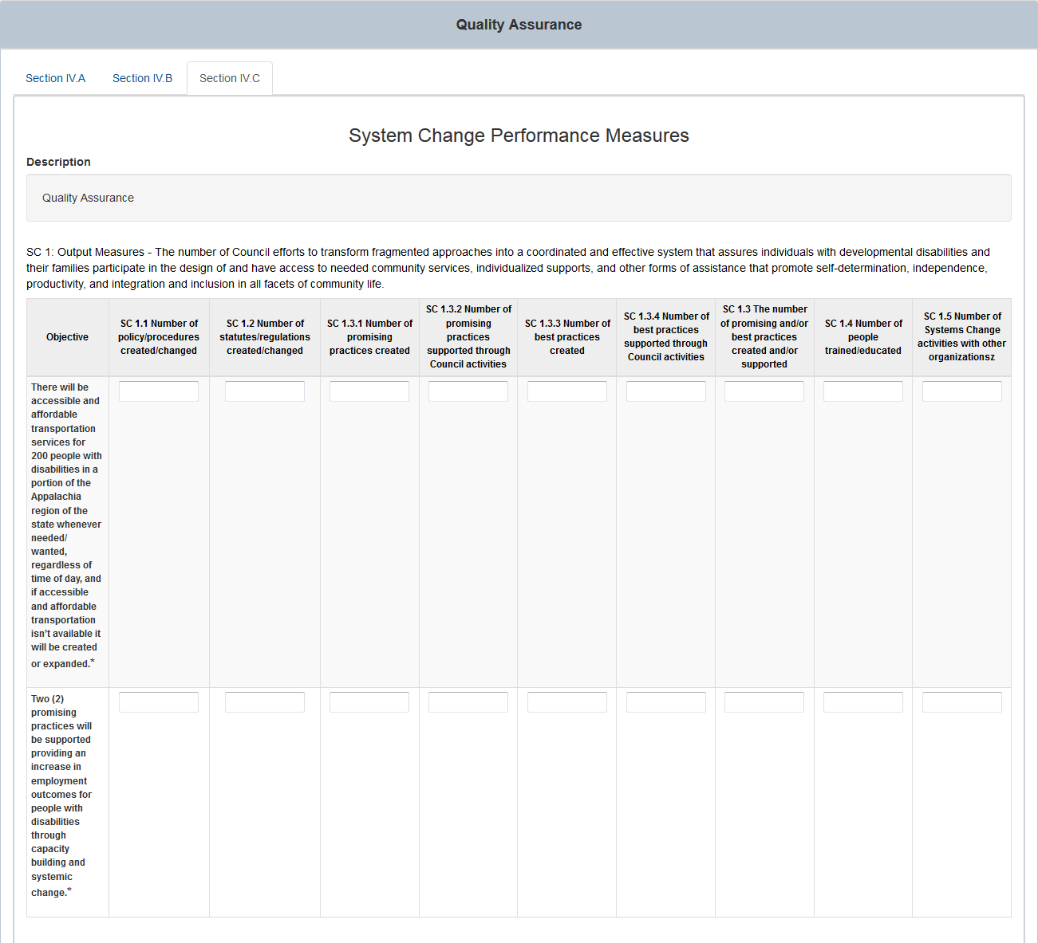

Figure 40: Section IV.C: System Change Performance Measures Part 2
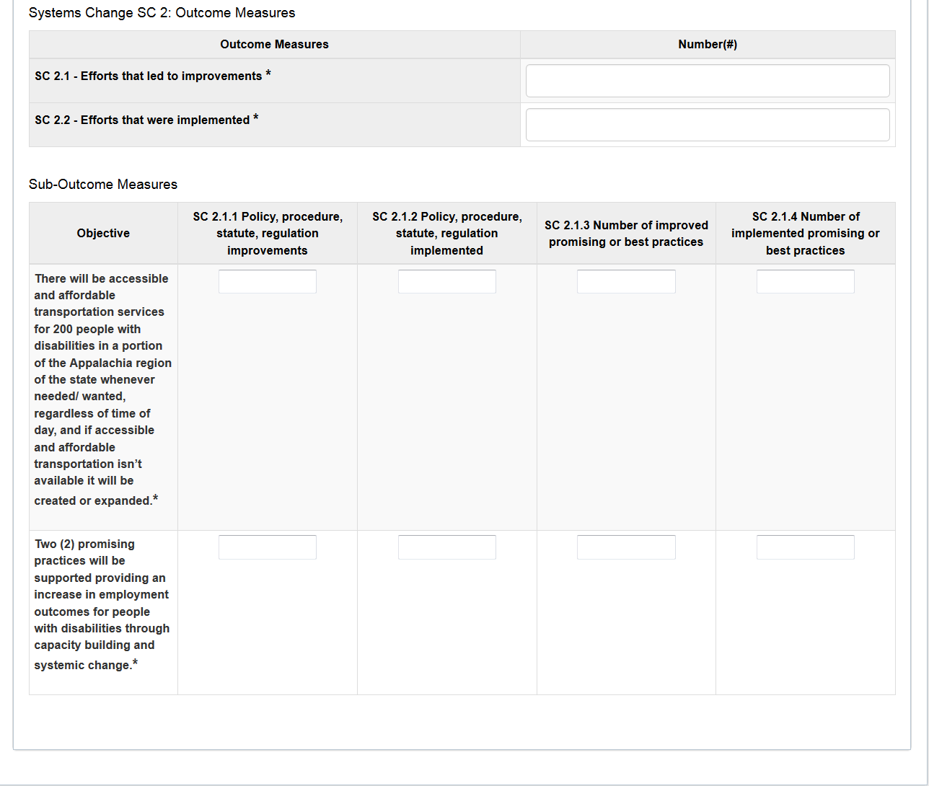

Section IV.C: System Change Performance Measures will contain the following areas of information:
- Description: This is a read only field that contains goal description from the State Plan.
- SC1 Output Measures: This is a table that contains 10 columns. The Grantee is required to enter information in this table.
  - Objective column will list all objectives from the State Plan.
  - SC 1.1 Number of policy/procedures created/changed column has data entry fields in which numbers can be entered.
  - SC 1.2 Number of statutes/regulations created/changed column has data entry fields in which numbers can be entered.
  - SC 1.3.1 Number of promising practices created column has data entry fields in which numbers can be entered.
  - SC 1.3.2 Number of promising practices supported through Council activities column has data entry fields in which numbers can be entered.
  - SC 1.3.3 Number of best practices created column has data entry fields in which numbers can be entered.
  - SC 1.3.4 Number of best practices supported through Council activities column has data entry fields in which numbers can be entered.
  - SC 1.3 The number of promising and/or best practices created and/or supported column has data entry fields in which numbers can be entered.
  - SC 1.4 Number of people trained/educated column has data entry fields in which numbers can be entered.
  - SC 1.5 Number of Systems Change activities with other organizations column has data entry fields in which numbers can be entered.
  - Validations
    - The fields for each Objective will have a maximum length of 7 numbers. If more than 7 numbers are entered, then the field is highlighted in red and the following validation message is displayed: “The field cannot contain more than 7 digits”.
    - If the required fields are blank, the following error message is displayed: “This field is required.”
- Systems Change SC 2: Outcome Measures: This is a table that contains two columns. The Grantee is required to enter information in this table.
  - Outcome Measures column has the following rows: ‘SC 2.1 - Efforts that led to improvements’ and ‘SC 2.2 - Efforts that were implemented’.
  - The ‘#’ column has data entry fields in which numbers can be entered.
- Sub-Outcome Measures: This is a table that contains 5 columns. The Grantee is required to enter information in this table.
  - Objective column will list all objectives from the State Plan.
  - SC 2.1.1 Policy, procedure, statute, regulation improvements column has data entry fields in which numbers can be entered.
  - SC 2.1.2 Policy, procedure, statute, regulation implemented column has data entry fields in which numbers can be entered.
  - SC 2.1.3 Number of improved promising or best practices column has data entry fields in which numbers can be entered.
  - SC 2.1.4 Number of implemented promising or best practices column has data entry fields in which numbers can be entered.
  - Validations
    - The fields for each Objective will have a maximum length of 7 numbers. If more than 7 numbers are entered, then the field is highlighted in red and the following validation message is displayed: “The field cannot contain more than 7 digits”.
    - If the required fields are blank, the following error message is displayed: “This field is required.”

Section V. Council Financial Information
The Council Financial Information section contains 1 set of radio buttons, 3 tables with 11 fields each, and a numeric field at the bottom which the Grantee is required to enter.
- The “Council is its own DSA” is a set of radio buttons. The Grantee will be given the option to select “Yes” or “No” by using the radio buttons on the page. It is a required field.
Figure 41: Section V: Council Financial Information Radio Button
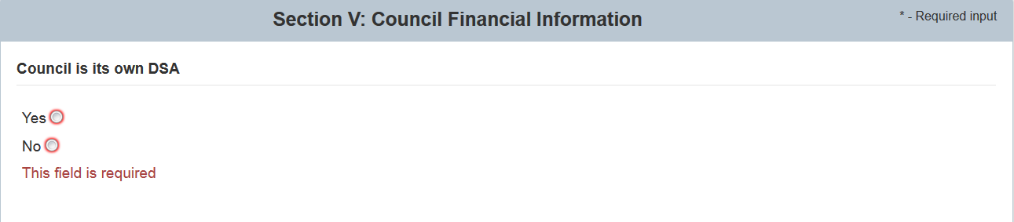
The “Fiscal Information for Programmatic Purposes ONLY” sub-section contains 3 tables with the same 11 fields that are required. Each table is for a fiscal year. The fields are as follows:
1. Fiscal Year*
2. Reporting Period - Start*
2. Reporting Period - End*
3. Total Federal Fiscal Award for Reporting Year*
4. State Funds Contributing to Council State Plan Activities*
5. Additional Council Funds Used for Other Activities*
6. Federal Share of Expenditures*
7. Federal Share of Unliquidated Obligations*
8. Unobligated Balance of Federal Funds (= Total Federal Fiscal Year Award - Federal Share of expenditures - Federal Share of unliquidated obligations)*
9. Match Required*
10. Match Met*
11. Match Unmet*

The “Fiscal Year” field is a 4 digit numeric field.
The “Reporting Period – Start” and “Reporting Period – End” fields are calendar fields. When these fields are selected, a calendar view will appear that will allow you to select dates. You may also manually enter them in MM/DD/YYYY format as well.
All other fields in the table are 7 digit numeric fields.
Figure 42: Section V: Council Financial Information First Table
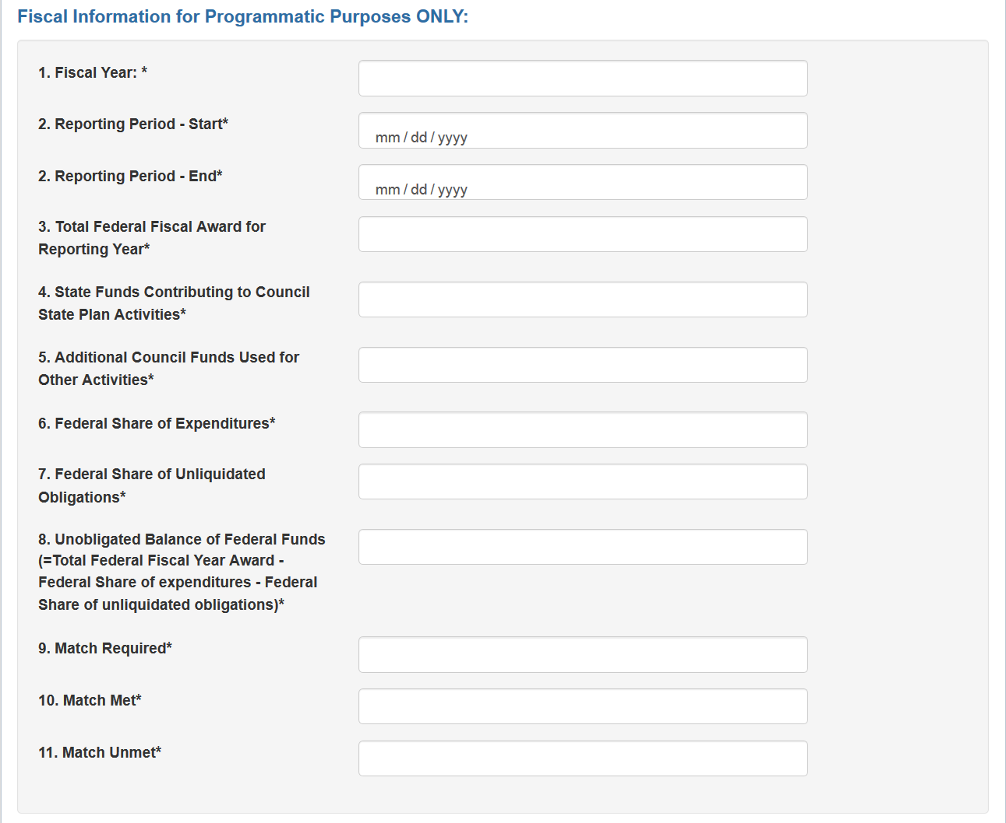
Figure 43: Section V: Council Financial Information Second Table
Figure 44: Section V: Council Financial Information Third Table

- The “Dollars leveraged for the reporting year being reported” fields is a 7 digit numeric field.
Figure 45: Section V: Council Financial Information Last Field

- Validations
  - “*” indicates that a field is required. If a required field is left empty, the field is highlighted in red and the following validation message is displayed: “The field is required”. The radio button is also required.
  - Field 1 in all 3 tables will have a maximum length of 4 numbers. If more than 4 numbers are entered, then the field is highlighted in red and the following validation message is displayed: “The field cannot contain more than 4 digits”.
  - All other fields will have a maximum length of 7 numbers. If more than 7 numbers are entered, then the field is highlighted in red and the following validation message is displayed: “The field cannot contain more than 7 digits”.
  - Both fields 2 (Reporting Period – Start* and Reporting Period – End*) will prompt a calendar to appear once the Grantee enters this field. The calendar will allow the Grantee to pick a date. The Grantee may also enter in a date numerical as long as it is in MM/DD/YYYY format.

Section VI. Measures of Collaboration
The Measures of Collaboration section contains three subsections with rich text editors which the Grantee is required to enter and checkboxes that are optional.
The first subsection contains the following rich text editor:
- Identify the critical issues/barriers affecting individuals with developmental disabilities and their families in your State that the Council and the P&A, the Council and the UCEDD, the Council and other collaborators may have worked on during the reporting period *
- The Grantee can select “Edit” to open the rich text editor and enter in information. When information has been entered and would like to proceed, the Grantee would need to select “Done”. To “View” the entered in information the “View” link would need to be selected.
The second subsection is the Identify the Area of Emphasis collaboratively addressed by DD Network and it contains the following 15 checkboxes which are optional:
- Quality Assurance
- Education and Early Intervention
- Child Care
- Health
- Employment
- Housing
- Transportation
- Recreation
- Quality of Life
- Other - Assistive Technology
- Other - Cultural Diversity
- Other - Leadership
- Other - Please specify
- Other - Please specify
- Other - Please specify
There are 3 checkboxes which contain “Other - Please specify”. When a Grantee selects one of these checkboxes, a textbox will appear. The Grantee is required to enter text in this textbox.
The third subsection is the Strategies Collaboratively implemented by DD Network which contains the following rich text editor that the Grantee is required to enter:
- The report should include a narrative progress report that cohesively describes the activities that were implemented by the Council and the P&A, the Council and the UCEDD, the Council and other collaborators.DD Network. For at least one of the issues/barriers identified above describe: (a) the issue/barrier; (b) collaborative strategies to address issue/barrier and expected outcome(s); (c) the DDC's specific role and responsibilities in this collaborative effort. Include any technical assistance expertise DD Council staff can provide to other States in this area; (d) briefly identify problems encountered as a result of this collaboration, and technical assistance, if any, desired; and (e) any unexpected benefits of this collaborative effort. *The Grantee can select “Edit” to open the rich text editor and enter in information. When information has been entered and would like to proceed, the Grantee would need to select “Done”. To “View” the entered in information, the Grantee can select the “View” link.
- The Grantee can select “Edit” to open the rich text editor and enter in information. When information has been entered and would like to proceed, the Grantee would need to select “Done”. To “View” the entered in information the “View” link would need to be selected.

Figure 46: Section VI: Measures of Collaboration
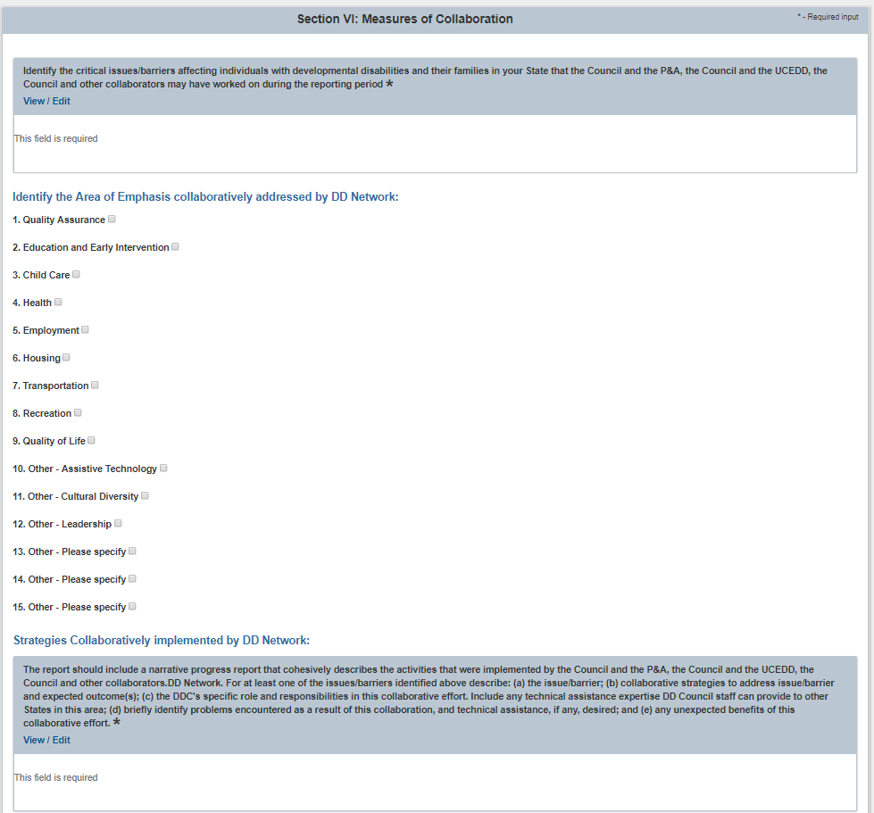
- Validations
  - “*” indicates that a field is required. If a required field is left empty, the field is highlighted in red and the following validation message is displayed: “The field is required”.
  - If the Grantee selects checkboxes 13-15, a required text field will appear. The text field will contain a character limit of 4,000 characters.

Helpful Tips & Hints for Using ACL Reporting

Save Your Work Regularly
    - You will be prompted to save before leaving each section. You may save without submitting for review if you wish to work on the sections in phases.
    - Save your work at least every 25 minutes. You will be automatically logged out after 30 minutes of inactivity and information that you have entered could potentially be lost if you did not select “Save”. As you finish each section (screen), you will be prompted to save your work. We recommend that you select “Save” each time you move to a new section.
PLEASE NOTE: As you enter information into ACLReporting, the system will recognize mouse movement and key strokes as “activity,” which will keep you from being automatically logged out after 30 minutes.

Timeout Warning
A timeout warning message will pop up after 20 minutes. If you select “Reset”, you will be provided an additional 30 minutes to enter in your information. Please note that adding additional time does not save your work.

Figure 23: Session Timeout Warning Popup
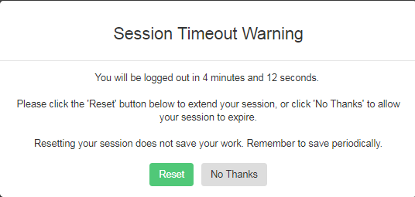

Figure 24: Session Timeout Reset Confirmation Popup
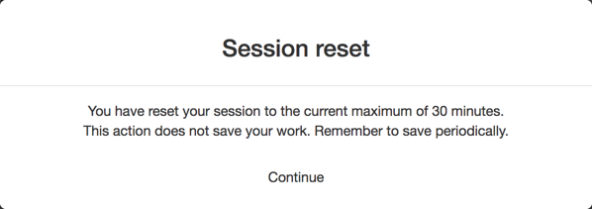

Navigation
Navigation throughout the system will be provided through the left side navigation or the Next and Previous button at the bottom of the information entry pages.

Roles and Permissions
    - A person using ACL Reporting can have one or more of the following roles: Registrar, Grantee and Reviewer (described in Section II. ACL Reporting Roles and Permissions).
  - Having a role provides the person permissions to perform the activities allowed for the role.
For example, if a person only has a Registrar role, then he or she can only perform the activities that allowed for the Registrar. If a person has Registrar and Grantee roles, then they can perform activities that are allowed for both the Registrar and Grantee roles. Finally, if a person has the Registrar, Grantee and Reviewer roles, then they can perform the activities that are allowed for the three roles.
    - In addition to above roles, there is the Project Officer role. A Project Officer (PO) is the assigned Federal staff person who has the ability to review, approve, or reject submitted Grantee reports.

Submitting a Report
    - ACL Reporting allows users to work on different sections at the same time. Only one user should be working on a section at any time. The system will save the information from the user who did the last save.
    - N/A is a valid response for any required text fields and 0 is a valid response for any required numerical fields.
    - All of the totals will be automatically calculated. Those fields will appear grayed out since the system will be providing that value and not the Grantee.
    - The Exclamation Mark Icon (!) is used to signal when a section of the report field needs information added to it to before it can be considered complete. Once it’s complete, it will disappear to signal to the user that that section is completed.
    - All of the validations for each section are provided in the individual sections of this User Guide. The rich text editors provide character counters to help you determine how much needs to be reduced if you exceed the limit and to help you stay with the limit.

    - Rich Text Editors have character limits. 5000 characters is about 1.5 pages of single spaced text.

Copy & Pasting
    - When copying and pasting information in to the rich text editors (text boxes with formatting features) be sure to right click in the field you wish to paste the information and select:
In Windows
                - In Chrome: Select the “Paste as Plain Text” or hit Ctrl +Shift + V
                - In Internet Explorer: Select “Paste” or hit Ctrl + V
                - In Firefox: Select the “Paste as Plain Text” or hit Ctrl + Shit+ V

On Macs
                - In Chrome: Select the “Paste as Plain Text” or hit CtrlShift + V
                - In Internet Explorer: Select “Paste” or hit Ctrl + V
                - In Firefox: Select the “Paste as Plain Text” or hit Ctrl + Shit+ V
You may also copy and paste into a text editor (or notepad) to remove any formatting before transferring into fields on the form.

Printing a Report
- Log in and select ‘View Report’ while in one of the sections, it will then create an HTML (on-screen) report.
- Select ‘Generate PDF Report’ on the top left corner of the screen.
- The PDF report will be generated. The PDF report can be saved to your computer.
Note: Pop-up blockers in your browser must be turned off.
Figure 47: Generate PDF Report Button
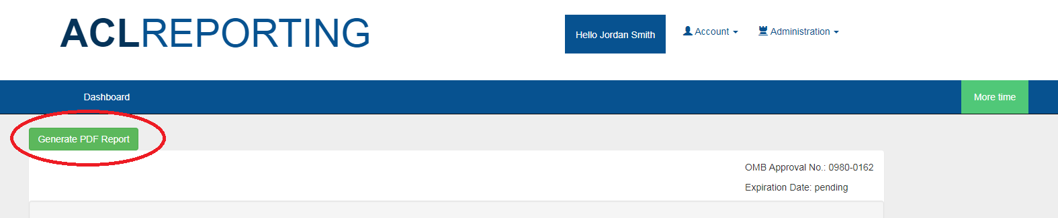

PDF Accessibility
- Adobe Reader offers a “Read Out Loud” function which provides text to speech for pdf files.
If you would like to use your own screen reading software, the PDF must be saved a Text (.txt) file. The text file will contain only text and no formatting such as tables. To do this, select ‘File’ from the top menu in the PDF and then select ‘Save as Other’.
- In the PDF, select “View” from the top menu screen and scroll down to “Read Out Loud.” Select “Activate Read Out Loud.”
Note: There is a slight delay before the reading starts.
- If you prefer not to use the menu screen options, the following options are also available:
  - Activate Read Out Loud – Shift+Ctrl+Y
  - Read This Page Only – Shift+Ctrl+V
  - Read to End of Document – Shift+Ctrl+B
  - Pause – Shift+Ctrl+C
  - Stop – Shift+Ctrl+E

Figure 48: Read Out Loud Feature
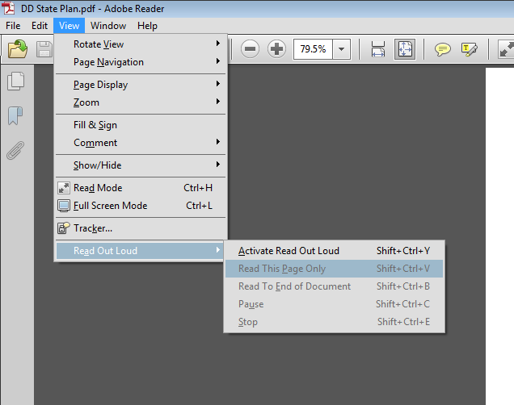
- To adjust preferences when using Read Out Loud:
  - Select “Edit” from the top menu and then scroll to the last choice “preferences.”
  - Select “Reading” from the list on the left and it will open the reading preferences options.
  - You can alter reading order, volume, voices, pitch and rate of reading.

Role Permissions Matrix
The following table depicts permissions for each role in the system.
Figure 49: Permissions by roles
Actions | Grantee | Grantee Reviewer | Project Officer | Registrar
Visit the home page | X | X | X | X
Log in through ACLReporting | X | X | X | X
Modify Own User Account | X | X | X | X
View Grantee Dashboard | X | X
Report Data Entry | X
Ready Section for Review | X
Review Section |  | X
Request Section Revision | X | X
Revise Section | X | X
Submit Data |  | X
View PO Grantee Dashboard |  |  | X
View a Grantee’s Dashboard |  |  | X
Validate Report Section |  |  | X
Disapprove Specific Report Sections |  |  | X
Reject Report |  |  | X
Approve Report |  |  | X
View Administration/Registrar Pages |  |  |  | X
Create User Accounts |  |  |  | X
Deactivate User Accounts |  |  |  | X
View Administrative Pages |  |  |  | X
Modify Any User Account |  |  |  | X

